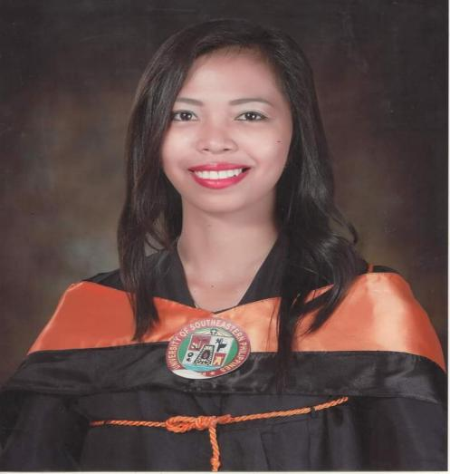
Purok 9, Brgy. Los Amigos, Davao City│

+63956-803-2234│caresystemmaeubalde@gmail.com

OBJECTIVE

- Seeking to be a part of a reputable institution and be a partner in achieving their goals.
- Employ and enhance my knowledge and skills in a Gainful position or in a related field.

PERSONAL DATA

Name : Mae Ann Christy T. Ubalde
Sex : Female
Birthdate : December 17, 1995
Age : 28 y/o
Birthplace : Brgy. Tabon, Bislig City
Home Address : Purok 9, Brgy. Los Amigos, Tugbok, Davao City
Civil Status : Single
Nationality : Filipino
Religion : Roman Catholic
Height : 5’02”
Weight : 48 Kgs

EDUCATIONAL BACKGROUND
- League of Class Mayor
- Attending 19th National Civil Engineering Student’s Conference
- Dean's Lister （1st year）
- General Secretary in Bislig Campus Student Council (BCSC)
- Auditor in Association of Civil Engineering Students (ACES)
- Member in Junior Philippine Institute of Civil Engineers, INC. (JPICE)
- Quiz bee participant in our school celebrating JPICE month Celebration
- Comelec President in Selecting new Supreme Student Government President hosting year and Convention with a participant of leaders in different Campuses.
- Graduated from University of Southeastern Philippines
BS Civil Engineering S.Y. 2012-2017
- Graduated from De La Salle John Bosco College
School S.Y. 2008-2012
- Graduated from Hill Top Elementary School
School S.Y. 2002-2008

SEMINARS ATTENDED/CERTIFICATES

- Participant, Philippine Institute of Civil Engineers, Inc. 19th National Civil Engineering Students Conference, SM Lanang Premier, J.P. Laurel Avenue, Davao City, November 19, 2019
- Participant, Junior Philippine Institute of Civil Engineers, Inc. “Grand Civil Engineering Students’ Quiz”, Bislig Campus, Maharlika, Bislig City, August 2014
- Communication Link for Emergency Assistance Networks Philippines, Inc.Hagonoy Chapter – Auxiliary Corps, USEP Bislig Campus, Maharlika, Bislig City
- Attend Precedence Diagram Method Seminar held at DPWH Cagayan De Oro City
- Attend Oath Taking Ceremony for New Civil Engineers held at Sports and Country Club, Upper Carmen, Cagayan De Oro City
- Attend Construction Safety and Health Program for Safety Officer 2
- Attend Seminar for the Driver’s License

UNIQUE QUALIFICATIONS

Below are the software’s that I have knowledge with.
- Computer Literate, Microsoft Office ( Word, PowerPoint, Excel )
- Autocad 2D
- SketchUp 3D
- Staad Pro (Basic) (Structural Analysis)
- Programmer of Buildings, Road Construction and Water System (Estimate)
Below are the qualifications that I have acknowledge with:
- Good in Handling People and a Good Leader
- I am a License Civil Engineer, Safety Officer 2 in Cosh, and has a Driver’s License

WORK EXPERIENCE

Caresystem Technology Solution Co., Inc.
Davao City
December 2020 – Present

Duties and Responsibilities
- Project Engineer (Construction of 2CL GIT Building turnovered to Municipality at Glan, Sarangani Province
- Water System – Pneumatic Drilling Air Compressor turnovered to Brgy. Kapatan, Glan Sarangani Province
- Water System – Spring Development turnovered to Brgy. Pangyan, Glan Sarangani Province
- Construction of School of Medicine Building and Academic Building (5 Storey with a Total Floor Area of 10,471.5 sq.m. and 8,910 sq.m. respectively turnovered to University of SouthEastern Philippines (USEP – Tagum Campus)
- I handle Manpower, Materials and Equipment as an Overall Engineer in this Projects.
- Assurance of the Quality of the Structural Concrete Materials used in Concrete Pouring.
- Invited to Demonstrate how to use the Pneumatic Drilling Machine using the air compressor to the People in Bayambang, Pangasinan.
- Estimator / Programmer of Bidding Documents needed in Technical Document such as Bill of Quantities (BOQ), Detailed Estimates, Gantt Chart, S Curve, Pert CPM and Cash Flow Schedule in participating Bidding Invitations to Different Agencies.
- Make Billing for our Subcons
- Checking works based on our interpretation of Plans and Specifications.
- Make Weekly Report of our Work Accomplishments and compare it according to our Work Schedule.
- Make Progress Billing Percentage according to the Item of Works Accomplished.
- Make Detailed Estimates for the Variation Order and it’s Shaft Drawings.

Monolithic Construction and Concrete Products Inc.
Davao City
November 2019 - June 15, 2020

Duties and Responsibilities
• Project Engineer (Bypass Roads, Handle Manpower, Materials and Equipment) – 5 Km. 2Lane and 4 Lane Roads, with Box Culvert and Shoulderings.
- Assurance of the Quality of the Materials used in Concrete Pouring of Roads as well as the Sub-Base Materials.
- Make Billing for our Subcons

ALGON ENGINEERING CONSTRUCTION CORPORATION
Davao City
September 2018 – May 2019

Duties and Responsibilities
• Technical Staff, doing Paper works
• Field or Site Engineer handling Construction in Concrete Revetment along Bolton River, Davao City
- Handle Manpower, Equipments and Materials.
- Check the Low Tide and High Tide Based on Schedule.
- SOUTHERN TECHNOLOGY INSTITUE OF THE PHILIPPINES
Mangagoy, Bislig City
May 2018 - September 2018

Duties and Responsibilities
• College Math Instructor in Criminology
• Science Teacher in Senior High
- Teach Computer in High School

DEPARTMENT OF PUBLIC WORKS AND HIGHWAYS
Bislig City
July 2017 - December 2017
Duties and Responsibilities
- Conduct Right of Way
- Measure the Area of a Building or lot Affected for the right of way
- Programmer of 2 and 3 Storey School Buildings

KHAN KON CHI CONSTRUCTION FIRM (OJT)
Cabantian, Davao City
April 2015 - May 2015 (320 hours)

Duties and Responsibilities
- Technical Works
- Making As-Built Plans for Transit Sheds at Davao Sasa Wharf (PPA)

CITY ASSESOR - LGU (Summer Job)
Bislig City
April 2014

Duties and Responsibilities
- Paper Works

REFERENCES:

- Arch. Glenn Dalapo
Architect II
Department of Public Works and Highways
Gingoog City, Misamis Oriental

- Engr. Joy Radaza
District Engineer
Department of Public Works and Highways
Patin-Ay, Agusan del Sur

- Engr. Annabelle Acma
Assistant District Engineer
Department of Public Works and Highways
Tandag, Surigao del Sur

- Engr. Ferdinand C. Acma
Chief – Planning and Design Section
Department of Public Works and Highways
Bislig City, Mobile No. 09478884436

I hereby certify that the above information’s are true and correct to the best of my knowledge and belief.

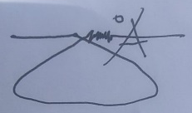

MAE ANN CHRISTY T. UBALDE

