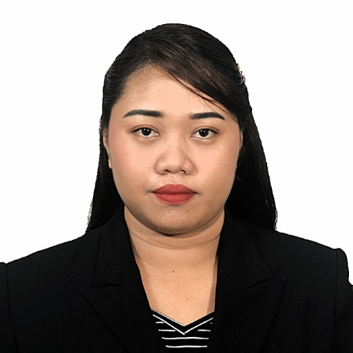
Julie Jane B. Hernandez
(Kindergarten Teacher – Elementary)

Mailing Address: 48 Abanilla Poblacion District 1 Barugo, Leyte
Email Adress: imjuliejane27@gmail.com
Cell Phone Numbers: 09753098062 (tm/globe), 09606648716 (tnt/smart)

Objectives__________________________________________________________
- To be an active, positive and diligent teacher in order to help develop the minds of my learners.
- Integrate games/fun activities in every lesson to make the topic more engaging and enjoyable, also to help develop the socio-emotional skills of the learners.
- Conduct differentiated learning activities and instruction to cater each developmental needs of my learners.
- Provide hands-on experience to the young learners to help them understand and retain what the lesson is all about.

Qualifications__________________________________________________________
- Certified licensed teacher
- Certified Outstanding Performance in Elementary Practice Teaching
- Basic Computer Literacy Training
- 5 years and 7 months teaching experience as a Kindergarten teacher in public school (Balire Primary School)
Education_____________________________________________________________
Elementary : San Isidro Elementary School
San Isidro Barugo, Leyte (2001-2007)
Secondary : Carigara School of Fisheries
Barugohay Norte Carigara, Leyte (2007-2011)
Tertiary : Leyte Normal University
Tacloban City, Leyte (2012-2016)
Course : Bachelor of Elementary Education BEED
Specialization : Pre-School Education

Work Experience_______________________________________________________
Public School Teacher – Balire Primary School (121044 School ID), DepEd Leyte Division, Barugo 2 District (May 28, 2018-Present)
Tutor- Ladder Tutorial Center at 252-A P. Burgos St. Tacloban, City
(June 2016-December 2017)

Trainings_____________________________________________________________
- 3-Day Municipal Live-Out Training for Key Stage 1 Teachers on the Implementation of Learning Recovery Curriculum (Lrc)
- Three-Day District Based Training Workshop on Comprehensive Sexuality Education (Cse) And Menstrual Health Management (Mhm)
- Limited Face To Face Three Day Live-Out Orientation Training Workshop On "The Utilization of Contextualized Teaching and Learning (Ctl) Approach in AP
- 3-Day Live-Out Training Workshop on "Educator's Coping at The Time of Pandemic"
- Virtual in Service Training for Public School Teachers
- National Webinar on Kindergarten Remote Teaching and Learning: Developmentally Appropriate Responses in The Time of Covid-19
- Three Day Live-Out Capability Building for Kindergarten Teachers and School Heads in Handling Co-Curricular Activities
- Ronald Mcdonald Read to Learn Teaching Beginning Reading: A Workshop for Educators

LICENSE______________________________________________________________
Professional Teacher
Registration No: 1477948
Registration Date: December 12, 2016
Expiration Date: July 28, 2026

LIST OF AWARDS AND ACHIEVEMENTS___________________________________
Certified Outstanding Performance in Elementary Practice Teaching

LIST OF REFERENCES:
Carmen B. Calandria
Teacher-in-Charge
Balire Primary School
Rudlin Homes Barugo, Leyte
balaiscarmen@gmail.com
09606527200

Ma. Teresa P. Alcones
Principal 1
Roosevelt Elementary School
Brgy. San Isidro Barugo, Leyte
malcones89@gmail.com
09179570376

Aiza A. Balais
Teacher 3
Balire Primary School
Brgy. Pikas Barugo, Leyte
aizabalais2017@gmail.com
09501481528

