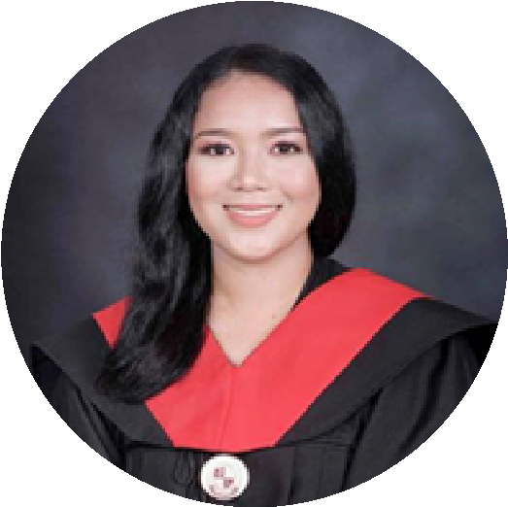
Objective
WINBELLE V. ENRIQUEZ

contact

Email:
winbelleenriquez1999@gmail.com
Mobile Number:
09948695322
Address:
San Juan Cainta, Rizal

PERSONAL INFORMATION

Date of Birth: May 20, 1999
Place of Birth: Pilar Bataan
Civil Status: Single
Citizenship: Filipino
Age: 24
Height: 5’2
Weight: 70kg

Seeking a challenging position in a reputed organization where I can learn new skills expand my knowledge, and leverage my learnings.

Education

BACHELOR OF SCIENCE IN MECHANICAL ENGINEERING Bataan Peninsula State University
Capitol Compound, Balanga City, Bataan
2016-2021

TRAININGS AND SEMINAR

Diesel engine tune up

Packaged Air (TESDA VIA ONLINE)
  - JUNE 29, 2020

Conditioner Unit

Servicing (TESDA VIA ONLINE)

JUNE 29, 2020

WORK EXPERIENCE

  - Technical Facilitator
  - (Calauag QUEZON LOCAL GOVERNMENT UNIT)
  - Dec 2021- Dec 2022

I hereby that the above information contained herein are true and correct to the best of my knowledge and beliefs.

Winbelle V. Enriquez

