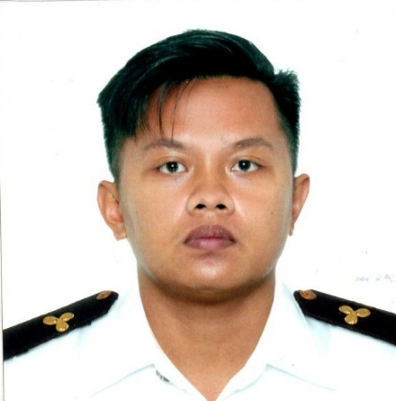
JONATHAN C. RAMONES
Mobile #: 09687581375
Email Address: jramones266@gmail.com
Address: Purok 2, Old Centro 1, San Mateo, Isabela 3318

Career Objective:
To secure a position where my existing skills and working experience can be utilized by progressive and innovative compay.

Work experience

VESSEL | TYPE | RANK | GRT | FROM | TO | ROUTE
MV Ariadne | Geared Bulk Carrier | Steward | 3304 | 01 June 2022 | 14 Nov 2022 | Worldswide
BAVE CETUS | Crude Oil/ Product Tanker | Messman | 42341 | 04 Nov 2020 | 17 Aug 2021 | Worldwide
NAVE CASSIOPEIA | Crude Oil/ Product Tanker | Messman | 42341 | 23 Nov 2018 | 23 Aug 2019 | Worldwide
PERSEUS N | Oil/ Chemical Tanker | Messman | 23350 | 07 Nov 2017 | 19 Jul 2018 | Worldwide

EDUCATIONAL BACKGROUND

College:
Isabela College of Arts and Technology
Bachelor of Science in Marine Engineering
Cauayan City, Isabela
S.Y. 2011 – 2014

Secondary
La Salette of San Mateo
San Mateo, Isabela
S.Y. 2006 – 2010

Computer Literacy:
Windows software (Word, Excel)

PERSONAL BACKGROUND

Age: 29
Date of Birth: May 21, 1994
Religion: Iglesia Filipina Independiente (IFI)
Nationality: Filipino
Height : 5’4”
LLanguage: Filipino, English

References:

Furnished upon request

