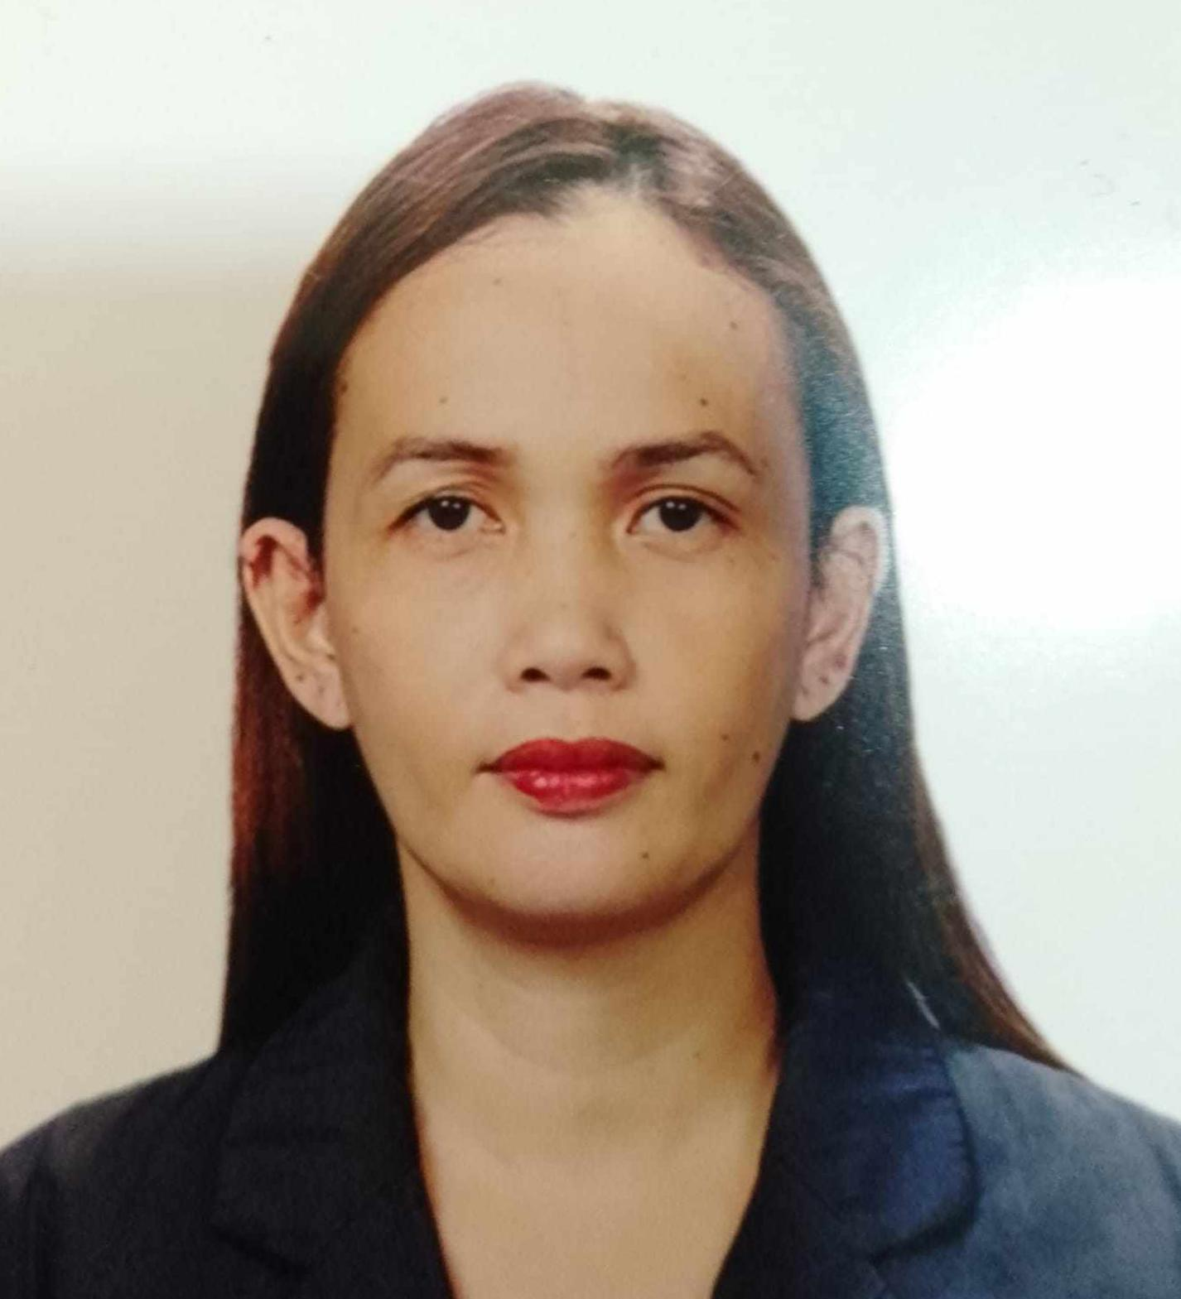
Mary Irene C. Sapalo
Address: District 1, Tiga Talisay Nasipit, Agusan Del Norte
Contact #: +974 30981160
Email Add:

Works Experiences:
- Babysitter Doha, Qatar 2023
Pre-matured Briplets Baby
- Caregiver Riyadh, Saudi Arabia 2022-2023
Bedridden, Alzheimer’s Patient
And Dialysis
- Caregiver Quezon Ave. Quezon City October 2021-2022
Dementia, Hemodialysis
- Caregiver Makati City 2020
Autism Spectrum Disorder (ASD)
- Private Caregiver Damar Village, Quezon City 2019
Bedridden with Tracheotomy
PEG, Hemodialysis
- Caregiver Marikina, Valley Hospital 2018
Brain Aneurysm, NGT
COPD with Mechanical Ventilator lol
Fem Catheter
- Private Caregiver Filinvest 1, Quezon City 2017
Bedridden, PEG
Meningitis, Ambulatory
- Trivecs Mktgs. Services Inc. Malumanay St. Quezon City 2016-2017
Brand Ambassador
Team Leader
Area Coordinator
- Private Caregiver NBP Reservation Muntinlupa City Aug. 2015-2016
Bedridden hypertensive and Bedsore
- Property Specialist NSJB .Inc March-July15, 2015
Selling Townhouses and Condo Unit
- PDN/Caregiver Concepcion, Marikina 2014
Diabetic with Colostomy and Bedridden

- Private Caregiver Pasig City 2013
Taking Care of Infant
- Private Caregiver Las Pinas City 2011
Stroke, Inject Insulin
- Encoder Nestle Philippines Cubao Q.C 2010
Nestle Encoding Products
- Brand Ambassador Nestle Philippines Cubao Q.C 2008-2009
Nestle Products

Educational Background:
Mary the Queen College of Science and Technology
- Caregiver Graduate
2011-2012
Samson College of Science and Technology
- B.S Computer Science 2007-2008
Our Lady of Fatima University
- B.S Nursing 2006-2007
Bagong Silangan High School 2002-2006
Bagong Silangan Elementary School 1996-2002

Basic Information:
- Age : 34 yrs. Old
- Gender : Female
- Birthday : July 12,1989
- Civil Status : Single
- Height : 5’2
- Weight : 85 kls.
- Religion : Christian/Catholic
- Nationality : Filipino
- Dialect Spoken/Written : English & Tagalog

Character References:
Khazna Bander Aldowesh
Employer
Riyadh, Saudi Arabia
Dr. Jun Paulino
Employer Doctor
Damar, Village Quezon City
I hereby certify that the above information is true and correct to the best of my knowledge.

_____________________ Christine S. Surio

