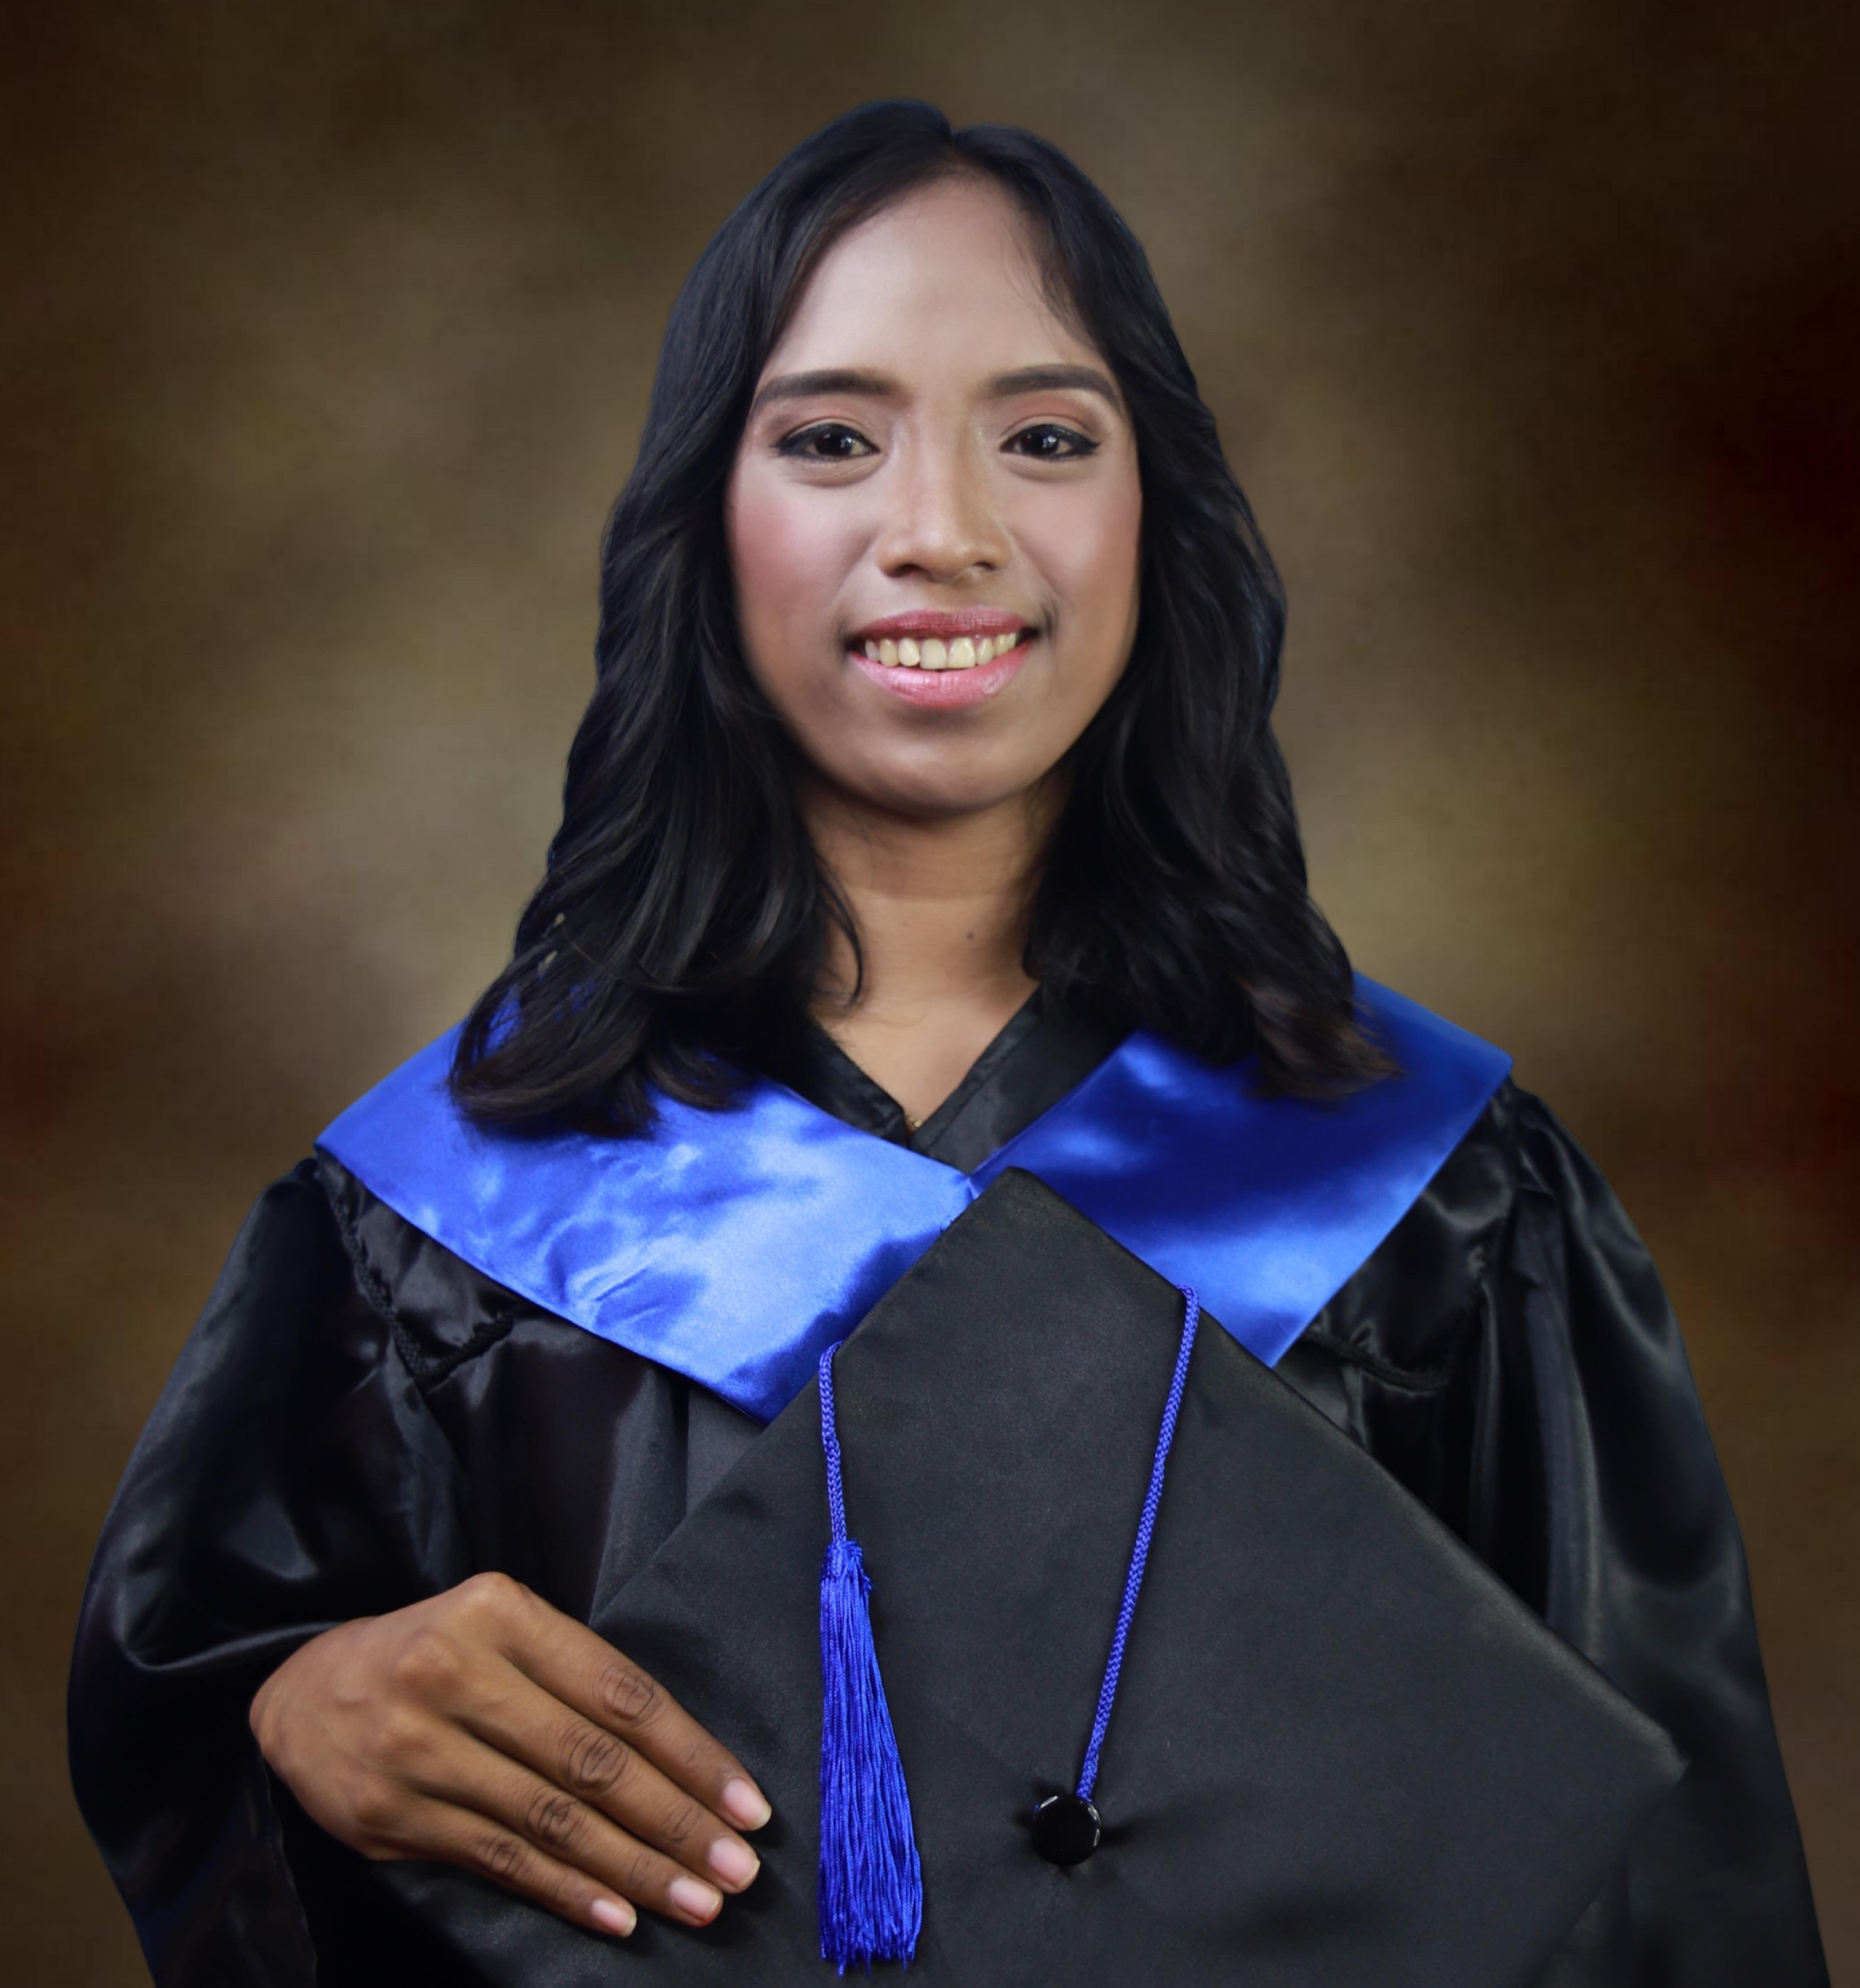
MA. ANTHONETTE LAGDAMIN

BRGY. Cubay jaro, Iloilo

09317953045

anthonettelagdamin04@gmail.com
OBJECTIVE
LOOKING FOR OPPORTUNITIES TO INCORPORATE MY SKILLS AND TRAINING TO HELP THE COMPANY GROW.
PERSONAL INFORMATION
DATE OF BIRTH: JAN. 4,1999
PLACE OF BIRTH: PASSI CITY
AGE: 25 YRS OLD
GENDER: FEMALE
CIVIL STATUS: SINGLE
CITIZENSHIP: FILIPINO
WEIGHT: 53 KG
RELIGION: ROMAN CATHOLIC
NAME OF FATHER: ANTHONY LAGDAMIN
OCCUPATION: SECURITY GUARD
NAME OF MOTHER: EMELDA LAGDAMIN
OCCUPATION: HOUSEWIFE

PERSON TO CONTACT IN CASE OF EMERGENCY: EMELDA LAGDAMIN
ADRESS: CAPUYHAN SIGMA CAPIZ
CONTACT NUMBER: 09636197342

EDUCATIONAL BACKGROUND
PRIMARY: SIGMA ELEMENTARY SCHOOL
SY 2011-2012
WITH HONOR
SECONDARY: VICENTE ANDAYA SR. NATIONAL HIGHSCHOOL
SY 2017-2018
WITH HONOR
TERTIARY: CAPIZ STATE UNIVERSITY
2018-2022
BACHELOR IN TECHNICAL VOCATIONAL TEACHER EDUCATION

LICENSED PROFESSIONAL TEACHER

WORK EXPERIENCE
Sales lady- Nolaks Botique
Summer job
Assistant/Secretary- Jong’s House Hotel Boracay
Summer job
CUSTOMER SERVICE REPRESENTATIVE - TELUS INTERNATIONAL PHILIPPINES
June 2021-DECEMBER 2023
SKILLS

FAST LEARNER
SOCIABLE AND ENJOY WORKING WITH PEOPLE
STRONG ORGANIZATIONAL SKILLS
FLEXIBLE
PATIENCE
PROBLEM SOLVING
WORK WELL AS A TEAM MEMBER AND ADAPTS EASILY TO NEW SITUATIONS

Extra Curricular activities

Sangguniang kabataan KAGAWAD- Brgy. Capuyhan

The messenger- photojournalist
Year 2018-2022

Educators Guild- photojournalist
Year 2018-2022

Capiz State University sigma satellite college- first aider
Year 2020-2022

I hereby certify that above mentioned data are true and correct to the best of my knowledge.

Ma. Anthonette Lagdamin
Applicant

