Trizia Marie D. Lacdang
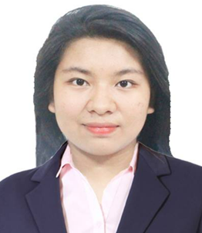

Attach Here
2x2
Colored Picture
# 131 Lot 14 Kalaw St. Nagpayong Pinagbuhatan Pasig city
Philippines,
Mobile No.: 09971338234
Email Add: tlacdang112@gmail.com

PERSONAL INFORMATION

Permanent Address : # 131 Lot 14 Kalaw St. Nagpayong Pinagbuhatan Pasig city,Philippines,
Birthdate : November 2,1998
Birth Place : Lebak Sultan Kudarat Mindanao
Height : 152.0 cm
Weight : 102 kg
Sex : Female
Civil Status : Single
Religion : Born Again Christian
Nationality : Filipino

BENEFICIARY

Beneficiary Name : Not available
Relationship :
Permanent Address :
Tel. No. :

DEPENDENTS:

Father: Rosmar Lacdang Birthday: April 10,1974
Birth Place: Calima Pola Mindoro
Occupation: Liason Officer

Mother: Jeanette Lacdang Birthday: Febuary 4,1972
Birth Place: Lambunao Ilo-Ilo
Occupation: Not avaialble

CHILDREN

Daughter: Not available Birthday:
Birth Place:
Civil Status:
Occupation:

Daughter: Birthday:
Birth Place:
Civil Status:
Occupation:

BROTHERS / SISTERS

Sister: Jeanne Rose Lacdang Birthday: September 25 1997
Birth Place: Olandes Marikina
Civil Status: Single
Occupation: Registered Nurse

Sister : Rosemarie Lacdang Birthday: January 12 2005
Birth Place: Pasig
Civil Status: Single
Occupation: Not available
Sister : Marinette Lacdang
Birthday: July 7 2007
Birth Place: Pasig
Civil Status: Single
Occupation: Not available

EDUCATIONAL BACKGROUND

Elementary Year [From] - [To]
School: Nagpayong Elementary School
Address: Centennial II Nagpayong Pasig city 2007-2013

Secondary
School: Nagpayong High School
Address: Centennial II Nagpayong Pasig city 2013-2015

College
Course: Bachelor of Science In Hospitaliy Management
School: Pamantasan Ng Lungsod Ng Pasig 2015-2019
Address: Alcalde Jose , Kapasigan Pasig City

EMPLOYMENT HISTORY

Position: Shift Supervisor ( Coffee Master and Barista Trainer)
Company: Rustan Coffee Starbucks Philippines
Address: 14 Jupiter, Makati, 1209 Metro Manila
Date: April 16, 2023- present
Reason for Leaving:

Job Description / Duties and Responsibilities:

- In Charge of the performance of the whole store such as interior and exterior cleanliness.
- Maintaining a good ambience and welcoming atmosphere.
- Cashiering accepting payments and cash handling and in charge with cash and bills in the vault of the store.
- In charge of pastries delivered and supplies of the store.
- Planning breaks of the baristas doing Non coverage tasks.
- Doing manager duties like reports of the store.
- Inventory of the items, merchandises, supplies.
- Making espresso drinks, customizing drinks on their preferences.

Position: Barista
Company: Rustan Coffee Starbucks Philippines
Address: 14 Jupiter, Makati, 1209 Metro Manila
Date: July 16, 2021- April 16,2023
Reason for Leaving:

Job Description / Duties and Responsibilities:

- Cleaning of lobby area using designated chemicals and equipment.
- Receiving of perishable items used in store either ingredients or pastry, sandwiches and cakes.
- Taking orders and settling payments of customers
- Making the espresso drinks, blended beverage and iced shaken teas.
- Serving quality drinks and pastry and giving a welcoming environment for the customers.

Position: Barista
Company: Tobistro foods
Address: Ortigas Pasig
Date: September 16,2020-July 10,2021
Reason for Leaving: Career Advancement

Job Description / Duties and Responsibilities:

- In charge and serves beverages such as coffee, tea and specialty beverages.
- Accepts payments take orders .
- In charge with sanitizing equipment and work station.

Position: Casual Chef at Banquet
Company: Extramile Agency ( Shangri-la at the Fort BGC)
Address: Harrison Pasay City
Date: July 17,2019- March 3 2020
Reason for Leaving: lay off because of Pandemic

Job Description / Duties and Responsibilities:
- Studying recipes setting up menus and prepare the dishes
- Caters Western Asian Menu buffet depends on the events.
- We catered the Star Magic Ball event of the celebrities in the Philippines for about 1000pax

SPECIAL SKILLS / INTERESTS

CHARACTER REFERENCES

Michael Vito

Store Manger
Rustan Coffee Company ( Starbucks Philippines)
09605019837

Rejean Beramo

Fomer Store Manager
Rustan Coffee Company ( Starbucks Philippines)
09663324699

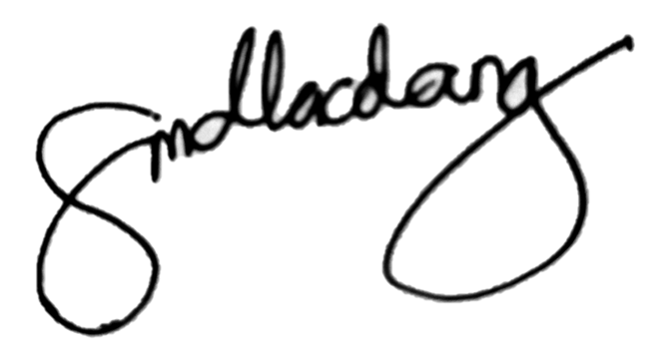
TRIZIA MARIE D. LACDANG

