Lo

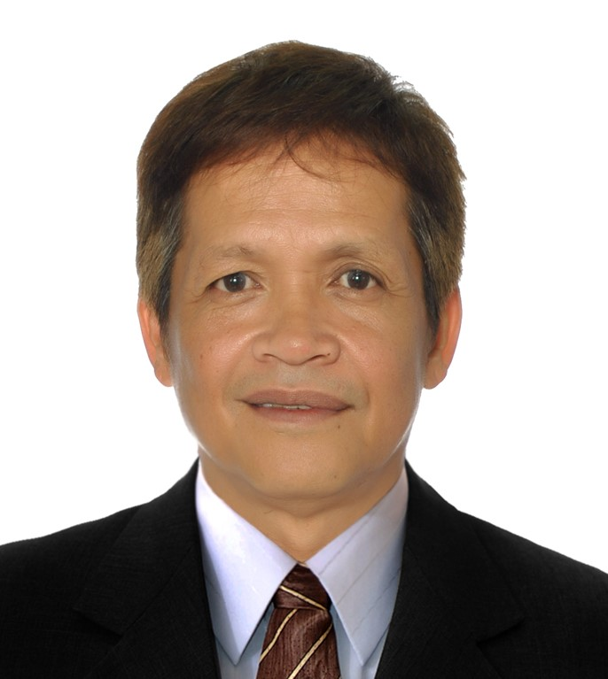

Applicant Name: Romeo Sedoriosa Rono Jr.
Position Applied: Rig Electrician/Maintenance Technician
Heavy Equipment Electrician

EMPLOYMENT INFORMATION

- Company: Nabors Drilling International Limited
Industry: Oil and Gas drilling
Address: Muscat, Oman
Position: Chief Electrician Rig 862 onshore
Date: Mar 7 2007- Sep 29 2016

Duties and Responsibilities (Job Description)

Performed preventive maintenance on all rig equipment and machine.
Troubleshoot and repair electrical faults on MCC, SCR, motor both AC and DC,
Top Drive, HVAC, Mud Pumps, Drawworks, Baylor brake control, VFD.
Repair electrical system fault of light and heavy equipment.
Report to Rig Manger day to day rig operation of machine and equipment.
Attend safety meeting and implement work permit attitude.
Calibrate and troubleshoot Fire and Gas alarm monitoring system.
Assist and trained Jr Electrician, Electrician helper.
Knowledge in electrical schematic, drawing, lay out

- Company: Pool Arabia
Industry: Oil and Gas drilling
Address: Dahran, Kingdom of Saudi Arabia
Position: Jr SCR Electrician Jack up Rig 656 Offshore
Date: Oct 19 2003 to Jan 2007

Duties and Responsibilities (Job Description)

Performed electrical and mechanical repair on all rig equipment.
Troubleshoot system electrical faults on Top Drive, Mud pump motor control.
Repair AC and Dc traction motor.
Service repair power generator, HVA, air compressor welding machine.
Troubleshoot and repair mess hall, kitchen electrical equipment, lighting system.
Performed torque check on jacking motor before and after rig move.
Report to Chief Electrician day to day status of all rig equipment and machine.
Assist Barge Captain in pre rig move checks and during jack up and jack down operation.

- Company: Kanoo Machinery

Industry: Dealer Grove Crane and Heavy Equipment
Address: Dammam, Kingdom of Saudi Arabia
Position: Heavy Equipment Electrician
Date: Oct 15 2001 to Sep 16 2003

Duties and Responsibilities (Job Description)

Performed electrical and mechanical repair to light and heavy equipment.
Install and commission PAT, Kruger, Loadwise LMI safety system.
Repair starter motor, alternator, control valve and electronic control module.
Performed after sale service and training.
Troubleshoot repair electrical system fault of power generator.

- Company: Arabian Cement Company
Industry: Cement manufacturing
Address: Yanbu, Kingdom of Saudi Arabia
Position: Auto Electrician, Heavy Equipment Electrician
Date: Oct 2 2000 to Aug 8 2001

Duties and Responsibilities (Job Description)

Performed preventive maintenance of light and heavy equipment.
Repair troubleshoot welding machine, air compressor, generator set.
Check material needed and audit parts in stock.

- Company: Guzent Incorporated
Industry: Sales and Rentals light and heavy equipment
Address: EDSA, Quezon City, Philippines
Position: Service Technician
Date: Feb 1998 to Dec 1999

Duties and Responsibilities (Job Description)

Service, troubleshoot electrical system of telescopic and lattice boom crane.
Service and maintain power generating set, welding machine, air compressor.
Service, repair window type, split type and centralized AC unit.

- Company: SOMC- SOCP
Industry: Service and Maintenance Company
Address: Khamis Musyat, Kingdom of Saudi Arabia
Position: Power Generator Repairman
Date: May 14 1995 to Dec 16 1997

Duties and Responsibilities (Job Description)

Work with assist and provides on the job training to designated personnel.
Perform direct and general support maintenance on utility and precise power
Generator set, engine driven electric welder, switch gear, electrical load banks.
Repair electric forklift, AC and Dc regulator, exciter, stator, wiring harness.

- Company: Acewell Corporation
Industry: Sales and Rental Power Genset and Heavy Equipment
Address: EDSA, Quezon City, Philippines
Position: Service Technician
Date: 1994 to 1995

Duties and Responsibilities (Job Description)

Perform service, repair of rented machine and equipment.
Perform wiring installation for both AC and DC circuit.
Perform repair and maintain on HVAC unit.
Assist, advice costumer in what equipment they will need for the job.

- Company: Yosuf Bin Ahmed Kanoo
Industry: Sales and Rental Power Genset and Heavy Equipment
Address: Jeddah Kingdom of Saudi Arabia
Position: Heavy Equipment Electrician
Date: 23 June 1992 to 25 Feb 1994

Duties and Responsibilities (Job Description)

Perform field service, repair, maintenance of cranes, lift trucks.
Troubleshoot LMI safety system.
Perform commissioning and load testing of overhead crane.

- Company: Al Jomaih Company
Industry: Sales and Rental Power Genset and Heavy Equipment
Address: Jeddah Kingdom of Saudi Arabia
Position: Heavy Equipment Electrician
Date: Feb 1990 to March 1992

Duties and Responsibilities (Job Description)
Perform pre- delivery inspection of machine, GMC truck.
Install and commission power generating set.
Service and repair agricultural and earth moving equipment.

- Company: Wip Incorporated
Industry: Sales Welding products
Address: Makati City, Philippines
Position: Building Electrician
Date: 1986 to 1990

Duties and Responsibilities (Job Description)

Perform preventive maintenance of building machines and equipment.
Troubleshoot and repair instrument control of centralized air condition unit,
Repair and fix lighting system, standby generator set and switch gear.

- Company: Ronson Engineering
Industry: Service and Repair HVAC
Address: Pasig City, Philippines
Position: Service technician
Date: 1984 to 1986

Duties and Responsibilities (Job Description)

Service, repair window type AC, split type AC, and centralized AC unit.
Troubleshoot and repair motor control, overload relay, circuit breaker and contactor.

MACHINES / TOOLS / EQUIPMENT

Grove crane and manlift, Kone overhead crane, Demag crane, Tadano crane
CAT 3512, CAT 3456, Cat D3516, Munrad Tech, Kubota, Leroy Somers genset
Rosshill SCR system, GE MCC, Allen Bradley, Baylor Brake system, Canrig drillers console.
Top Drive unit, Ideco Drawworks, GE 752 traction motor. Omron VFD control.
TCM forklift electric and engine driven, Fiat Allis tractor, Aifo genset, MAN truck.
Fluke multi meter, Fluke megger, Fluke ampere meter, CAT ET laptop, Gas tester
GMC, Hyster forklift, Cat wheel loader, Cat 796,798 dump truck and D9 bulldozer.
Fluke Oscilloscope, Fluke Heat sensor gun, soldering gun, hand drill, screw driver, side
Cutter plier, long nose plier, plier, pipe wrench, monkey wrench, hydraulic crimper,
Crimping tools, splicer.

PERSONAL INFORMATION

Birthday: 13-Feb-1962 Birth Place: Manila Age: 57
Height: 5’6 ½” Weight: 130 lbs Gender: Male
Civil Status: Married Religion: Catholic
Passport #: P0074152B Date Issued:02 Jan 19 Expiry Date: 01 Jan 29

EDUCATIONAL INFORMATION

Education | Inclusive Year/s Attended | Name of School/College  & Address | Course
Tertiary | 1979- 1983 | Far Eastern University, Recto Ave, Manila | BSEE Undergraduate
Vocational
High School | 1974- 1979 | Ramon Magsaysay Cubao High School, Cubao Edsa Ave, Quezon City | High School graduate
Elementary | 1969- 1974 | Plaridel Elementary School Plaridel Bulacan | Elementary Graduate

TRAININGS & SEMINARS
Date | Training / Seminar Title | Presided By
19 to 21 May 2002 | Hyster SEM Single/Dual Traction Motor Controllers | Michiel Draaijer
Jan 2002 | Grove PAT Level 1 | Steve Rowe
Apr 2002 | Grove GMK5130 Level 1 and EKS Basics | Steve Rowe
8 to 12 Feb 2003 | Inspection and Load Testing of Overhead Crane | Edward Mc Donald
15 to 19 Feb 2003 | Inspection and load testing of Mobile Crane | Edward Mc Donald
28 Oct 2007 | Advance Safety Audit
18 Dec 2012 | HSE Leadership | Sahnoune Oucif

13 Oct 2005 | Electrical Training Level 1 | Mark Woodstrom
10 Sep 2008 | Electrical Maintenance Systems Training
10 Sep 2008 | Electrical Maintenance for Top Drive

TRADE TEST CERTIFICATE

29 Jun 2000 | Electrical Technician (H.E.) B+ | Robert T. Raymundo

HIGHLIGHTS OF QUALIFICATION / CAREER RELATED SKILLS

I started as service Technician servicing oil and gas drilling companies like
Aramco offshore platform oil and gas plant, Pool International, Nabors
Drilling Company, Schlumberger, Parker, Saipem, National Oil tools Hali-
Burton. Most of my experience are in Power Generators, Light and Heavy
Equipment. Computer literate in reporting and monitoring equipment control.

KNOWN LANGUAGES

Language | Speak | Read | Write
English | Yes | Yes | Yes
Arabic | Little
Others: (Please specify)  Filipino | Yes | Yes | Yes

CONTACT DETAILS

Mobile #: 306 502881
Mobile #:
Email Address: joshonor213@gmail.com
Present Address: 1159 Garnet St Regina, Sasketchewan, S4T2X9
Permanent Address: 38 Chestnut St West Fairview, Quezon City, Phils 1118

9

