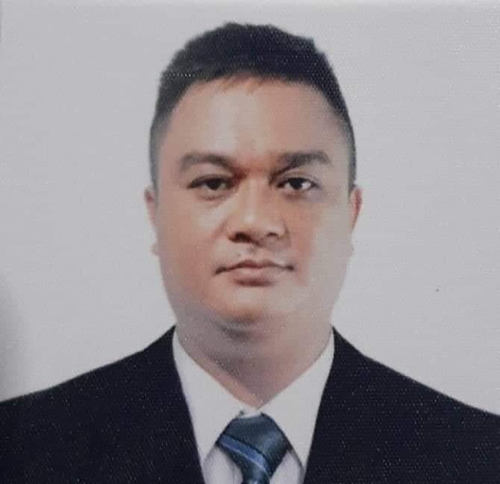
DENVER JAY MONTA NAVAS
BRGY. BATANG INFANTA PANGASINAN
CONTACT #: +639485127213
EMIAL: djciasi@gmail.com

CAREER OBJECTIVE:
To seek for a job wherein I can apply my knowledge and further test my skills provides an opportunity to attain growth enhancement to the near future.

PROFESSION: REGISTERED ELECTRICAL ENGINEER
REGISTERED MASTER ELECTRICIAN

PERSONAL ATTRIBUTES:
- Willing to undergo training
- Has the ability to do hard work
- Easy to train and follow instructions
- Has the ability to communicate with others

EDUCATIONAL ATTAINMENT:

TERTIARY : Bachelor of Science in Electrical Engineering
(2005-2010) Virgen Milagrosa University Foundation
Dr. Martin P. Posadas Avenue San Carlos City Pangasinan

VOCATIONAL : ELECTRICAL INSATALLATION AND MAINTENANCE NC II
Pangasinan School of Arts and Trades
Alvear St. Lingayen, Pangasinan
November 2012

SECONDARY : BAYAMBANG NATIONAL HIGH SCHOOL
(2001-2005) Bayambang Infanta, Pangasinan

PRIMARY : MACALANG ELEMENTARY SCHOOL
(1995-2001) Macalang Dasol, Pangasinan

WORK EXPERIENCED:
BUILDING WIRING INSTALLER(Self Employed)

ELECTRICAL MAINTENANCE @ FOOD SERVICES COMPANY (OPERA)
DOHA QATAR
SEPTEMBER 16, 2014 TO AUGUST 31, 2018

SEMINARS AND TRAININGS ATTENDED:

Webinar on INTRODUCTION TO ENERGY MANAGEMENT SYSTEM
March 6, 2021

Webinar on SWITCHGEAR TESTING EQUIPMENT SIMULATION PART 1
AC HIPOT TESTER; INSULATION RESISTANCE TESTER & CONTACT RESISTANCE TESTER
March 13, 2021

Webinar on HIGH VOLTAGE SWITCHYARD SAFETY OPERATIONS
January 17, 2022

Webinar on LOAD SCHEDULE and VOLTAGE DROP CALCULATION
August 11,2022

BASIC OCCUPATIONAL SAFETY AND HEALTH(40HRS.)
El Jardine Hotel and Restaurant, Lingayen Pangasinan
February 14-17, 2013

On the Job Training(240hrs.)
El PescadorBolinao, Pangasinan
December 10, 2012 – January 10, 2013

PEC Updates and Electrical Safety
Villa Restaurant, Narciso Ramos Compound, Lingayen Pangasinan
December 19, 2009

Overhead and Underground Distribution System
VirgenMilagrosa University Foundation
February 28, 2009

Substation Engineering and Design
University of Pangasinan, Arellano St. Dagupan City
August 29, 2008

CHARACTER REFERENCES:

CRISTINO M. VIDAL RME
Officer IIEE Pangasinan Chapter
09989937528

JOSEPH BALAGTAS
SCAFFOLD SUPERVISOR
Al Yamama Contracting Company

CONCHITA A. SILVESTRE
Teacher
09102575435

PERSONAL INFORMATION:
AGE : 34
DATE OF BIRTH : SEPTEMBER 12, 1989
PLACE OF BIRTH : INFANTA PANGASINAN
HEIGHT : 5’5
WEIGHT : 75 kgs.
CIVIL STATUS : MARRIED
CITIZENSHIP : FILIPINO
RELIGION : ROMAN CATHOLIC
DIALECT : ENGLISH, TAGALOG, ILOCANO
FATHERS NAME : MAXIMINO ANCHETA NAVAS JR.
MOTHERS NAME : GEMMA MONTA NAVAS
SPOUSE : MARY GRACE GONZALES NAVAS

I hereby certify that the above informations are true and correct according to the best of my knowledge and belief.

DENVER JAY M. NAVAS
Applicant

