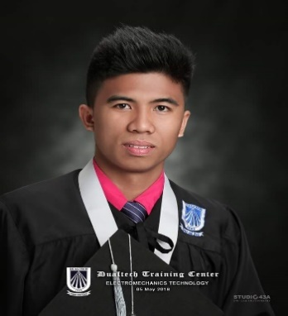
Jomar S. Mahumot
mahumotjomar@gmail.com
+639353582267

Present Address:
Bugtong na Pulo, Lipa City, Batangas 4217, Batangas, Philippines

Permanent Address:
Purok 6 Mahayag, San Miguel 6323, Bohol, Philippines

BASIC INFORMATION

Age | : 25 years old
Date of Birth | : April 28, 1998
Height | : 175cm
Weight (kg) | : 71 kg
Gender | : Male
Civil Status | : Single
Nationality | : Filipino
Religion | : Roman Catholic
Language Spoken | : Filipino and English

WORKING EXPERIENCE

Hard working CNC Machinist with 6 years of experience in the trade, able to cut and shape metal and plastic for various types of manufacturing. This includes the ability to read blueprints and utilize computer programming skills and experience with computer-aided manufacturing programs.

Sept. 2019-Present Machinist
Littelfuse Philippines Inc. (Batangas PHL)
- Works from work orders, routings, drawings, layout sheets, and written and verbal instructions.
- Calculates and sets controls to regulate machining factors such as speed, feed, coolant flow and depth of cut.
- Accurately, safely and efficiently operated all CNC mills and EDMs as required per assignment.
- Create program either manual programming or by using CAD software.
- Accurately used and interpreted measuring equipment like caliper, micrometer, height gauge, dial indicator and profile projector Inspecting parts visually and dimensionally to maintain accurate and quality works.
- Ensuring job efficiency, checking work quality, and overseeing machine maintenance
- Computer literate in using Microsoft Excel and Microsoft Word etc.,
- Perform 6’s on working area and machine.

List of software used:
- Autodesk (Feature CAM Ultimate)

List of machines handled:
- CNC Milling | HAAS -DT1
- CNC Milling | FANUC -ROBODRILL- T10C
- CNC Milling | DMG MORI – MILLTAP 700
- CNC Milling | LITZ – TV 700
- CNC Wire EDM | CHMER G325
- CNC Sinker EDM | CHMER 434C
- Manual Milling
- Manual Lathe
- Manual Grinding
Sept. 2018 - Aug 2019 Machinist
ATEC Phils., Inc
- Operates and maintains lathe, milling and grinding machines. Reviews drawings, instructions, blueprints or samples to ensure accurate machining.
- Responsible for repair of dambar die, punch and other tool and die parts
- Maintains a safe and clean workstation.

Cnc Machinist (On the job training 18months) Primatech Phils., Inc
Calamba, Laguna
- Handling and operating Wire Cut EDM and Sinker EDM machines in manufacturing of precision mold.
- Calculate dimensions and tolerances using knowledge of mathematics and instruments such as caliper, micrometer, height gauge and profile projector.
- Observe orderliness and safety in all phases of work area.
- Maintain machine maintenance lubrication oil, grease, coolant.
List of software used:
- Autodesk (AutoCad)
- Siemens NX

Skills
- Experienced Machinist – Machining tight tolerance, hardened metal and different types of materials. Strong problem-solving and multi-tasking skills. Attention to detail, accuracy, and safety.

EDUCATIONAL ATTAINMENT

Oct 2015 - May 2018 Dualtech Training Center
Vocational Diploma
Electromechanics Technology

GOVERNMENT DOCUMENTS

Passport ID Number: P2408322C
Place of Issue: DFA SAN PABLO
Date of Expiration: Nov 16, 2032

CHARACTER REFERENCE

Marco Fulo
Former Cnc Supervisor (JM Precision)
fulomarco08@gmail.com
0432 922 790

I hereby certify that above information is true and correct to the best of my knowledge and belief.

Jomar S. Mahumot
Applicant

