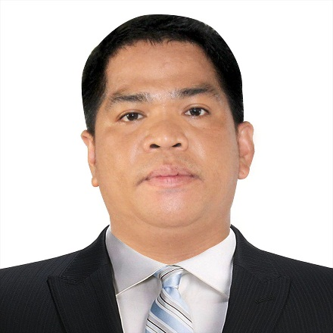
ARNEL BESARRA JR.

BRGY. LOOC CASTILLEJOS ZAMBALES
Arnelbesarrajr.@yahoo.com
09617774202

OBJECTIVE:
Seeking for a position in your company wherein I can use all my knowledge,
Skills, ability and capability to work according to the company rules, regulation, safety, security, and company standards.
PERSONAL INFORMATION:
DATE OF BIRTH : January 09 1985
AGE : 36
PLACE OF BIRTH : BRGY. Looc Castillejos Zambales
GENDER : Male
CIVIL STATUS : Married
NATIONALITY : Filipino
RELEGION : Roman Catholic
LANGUAGE : English, Tagalog, Japanese (Nihongo)
SKILL : Welding (Flat, Vertical Horizontal and Overhead)
EDUCATIONAL BACKGROUND
COLLEGE
- Central Luzon College of Science and Technology
- Olongapo City
- BS Criminology
- Undergraduate
SECONDARY
- Jesus F. Magsaysay National High School
- Brgy San Roque Castillejos Zambales
- SY 2002-2003

PRIMARY
- Balaybay Resettlement Elementary School
- Balaybay Resettlement Castillejos Zambales
- SY 1997-1998
WORK EXPERIENCE:
GRANDE ISLAND RESORT
SBMA Subic Bay Freeport Zone Olongapo City
MAINTENANCE
2005-2006

TRACTION BUILDERS INC (TBI)
Quezon City, Philippines
STEELMAN
2006-2007

HANJIN HEAVY INDUSTRIES AND CONSTRUCTION CO. Ltd.
Brgy. Cawag Subic Zambales
CARPENTER
2007-2008
HANJIN HEAVY INDUSTRIES AND CONSTRUCTION CO. Ltd.
Brgy Cawag Subic Zambales
WELDER
2008-2012

TS MACHINE INC
Pamatawan Subic Zambales
SHIPWELDER
2013

AKEMI TEC. CO.,Ltd
22 Akemi Toyohashi-shi Aichi-ken Japan 441-8577
Toyohashi Japan
WELDER
2014-2020

TRAINING/SEMINAR:
SUBIC SHIPYARD KEPPEL TS MACHINE
SHIPWELDING
MR. KIM
120 HRS

CHARACTER REFERENCE:
HON. EDDIE MAC GUTIERREZ
Brgy Looc Castillejos Zambales
Brgy Captain
09293756764

MS. RICA ABAD
Brgy Looc Castillejos Zambales
Brgy Secretary
09498703249

MR. RHOLAND BESARRA
Brgy San Diego Castillejos Zambales
NBI, Olongapo City

I hereby certify that the above information are true and correct to the best of my knowledge.

ARNEL E. BESARRA jr.
Applicant’s Signature

