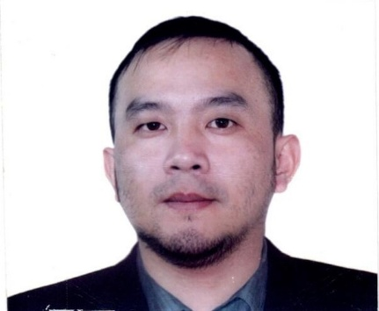
CURRICULUM VITAE

MANDO C. VALLE
Nalicob Balili, Mankayan
Benguet, Philippines
Contact Number: +639120005273
Email: mandycvalle0130@gmail.com

To gain a market increase in the turnover of the organization by enhancing the agricultural output using my energy, enthusiasm and expertise in the field of agriculture.
Seeking an opportunity to use my strong organizational skills while managing daily tasks related to farming activities such as harvesting or planting crops.
To be an asset for the company in providing excellent services.

POSITION DESIRED: Farm Worker

PERSONAL INFORMATION:

Birthdate: January 30, 1991
Birthplace: Mankayan, Benguet
Age: 32
Height: 5’5”
Weight: 65
Civil Status: Single

EDUCATIONAL BACKGROUND:
Vocational :
Shielded Metal Arc Welding (SMAW)
NCI NCII
Name of School: Kings College of the Philippines
Date: July 2019- February 2020

Secondary:
Name of School: Mt. Data National High School
Address: Bauko, Mt. Province
Year Graduated: March 26, 2010

Elementary:
Name of School: Sinto Elementary School
Address: Sinto, Bauko, Mt. Province
Year Graduated: March 2003

TRAININGS AND SEMINARS ATTENDED:

OYSTER MUSHROOM PRODUCTION
Pula Poblacion, Tuba, Benguet
March 08-09, 2023

ORGANIC FARMING
Pula Poblacion, Tuba, Benguet
March 06, 2023

ORGANIC AGRICULTURE PRODUCTION
Tadayan, Pudong, Kapangan, Benguet
March 02, 2023

COMPOST PRODUCTION
Balili Composting Area, La Trinidad, Benguet
February 14, 2023

SERVICE CREW
3190 New Panaderos St. Ext. Sta Ana, Manila
April 24-28, 2012

WORK EXPERIENCE:

Company: Highland Vegetables Production
Date of Employment: April 5, 2018- Present
Position: Farm Worker
Address: Nalicob Balili, Mankayan, Benguet
Job Description: Manually plant, cultivate, and harvest vegetables. Use hand
tools such as shovels, trowels, hoes, tampers, pruning hooks, shears, and knives. Duties may include tilling soil and
applying fertilizers; transplanting, weeding, thinning, or pruning crops; applying pesticides; cleaning, packing and loading harvested products. May construct trellises, repair fences and farm buildings, or participate in irrigation activities.

Company: Morning Bloom Welding Shop
Date of Employment: January 6, 2015 - February 8, 2018
Position: Welder
Address: FA 154 Lubok, Balili, La Trinidad, Benguet
Job Description: Uses plans, diagrams, blue prints and work requests to determine project dosage and works with requester to ensure needs are met.

Company: Awni and Bashar Shaker Co. Ltd
Date of Employment: June 10, 2012 – September 25, 2014
Position: Service Crew
Address: Jeddah, Saudi Arabia
Job Description: Prepared and serve food. Process customer payments and
provide customer service.

Company: McConnell Dowell
Date of Employment: June 12, 2010 – April 14, 2012
Position: Miner/Grouter
Address: Ambuklao, Bokod Benguet
Job Description: Extracting underground resources safely and efficiently.
Correct steaming and distributing delays as prescribed by
blasting supervisor.
Extracting underground resources safely and efficiently.
Performing underground activities like excavating, drilling,
charging, rock support, grouting and others.

CHARACTER REFERENCES:

TONY C. UGALDE
Brgy. Chairman
Nalicob Balili, Mankayan, Benguet
+639127250886

CHRISTOPHER LETAC
Highland Vegetables Production
Nalicob Balili, Mankayan, Benguet
+639108858137

BASHAR SHAKER
Manager
Awni and Bashar Shaker Co. Ltd
Tel No. 6674078

ADRIAN BROWSKILL
Project Manager
Tunnels and Underground
McConnell Dowell
Tel No. +6328096328

I hereby certify to the truthfulness of the above information.

MANDO C. VALLE
Applicant

