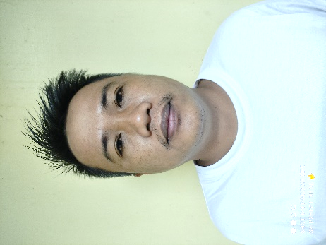
ROGEL ACERIT CASTILLO
rogelcastillo68@gmail.com
D.C go street, Zone-03 San Mariano Isabela.
Contact Number: 0919253463/090585453

CAREER OBJECTIVES

To be a part of a company that will enhance my skills and knowledge through its program and activities. To apply my knowledge and skills to learn more about the field of choice.

PERSONAL INFORMATION

Date of Birth : October 27, 1984
Birth Place : San Mariano, Isabela
Age : 37
Gender : Male
Weight : 69kls.
Height : 5’4”
Language : Tagalog, English, Ilocano
Nationality : Filipino
Father’s Name : Jose B. Castillo
Occupation : Farming
Mother’ Name : Carmen A. Castillo
Occupation : House Wife

EDUCATIONAL BACKGROUND

Elementary School : San Mariano Central School
Zone 2, San Mariano, Isabela
1991-1997

Secondary : San Mariano National High School
Zone 3, San Mariano, Isabela
1998-2002

Tertiary : Isabela State University (San Mariano Campus)
(Associate in Computer Technology)
Sta. Filomena, San Mariano Isabela
2004-2006

Tesda : Slaughtering Operations (swine)
Northeast Luzon Skills and Technical School, Inc.
Maharlika Highway, Brgy. San Placido, Roxas, Isabela
November 2019-2020
EMPLOYMENT INFORMATION

GREEN FUTURE INNOVATION INC. (GFII)
Sta. Filomena, San Mariano Isabela
Cane Analyzer, Weight scale Operator
March 12, 2012 to present

SKILLS AND QUALIFICATIONS

Computer literate
- Microsoft Office
- Basic Troubleshooting
- Cane Analyzer Infracana (via computer system) as Cane Analyzer Operator
- Weighing Scale (via Mettler Toledo with computer system) as weighing scale operator

CHARACTER REFERENCES

GLADYS B. LICAYAN
Distillery Supervisor@GFII
Sta. Filomena San mariano Isabela
09178100448

ROGEL A. CASTILLO
Applicant

