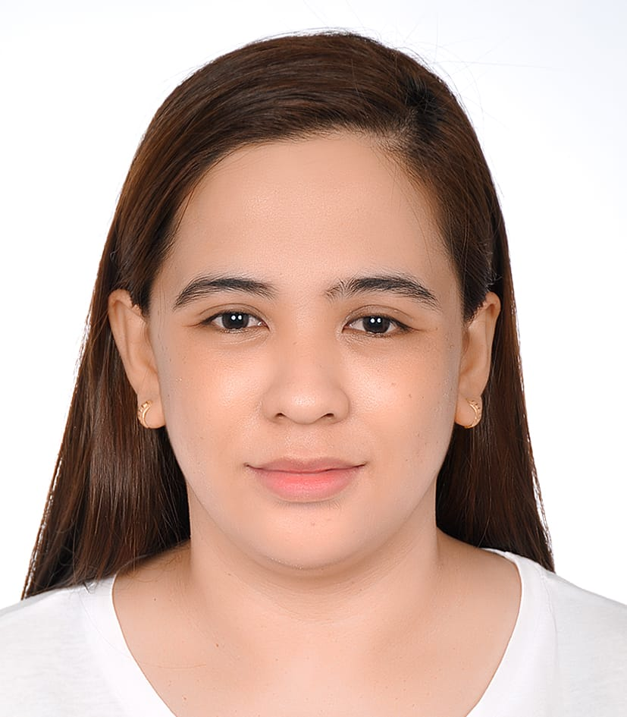
SANCHEZ, GENEVIVE MAE GAETOS
Othman Bin Affan street, Al Murabaa, Building 12, 4th floor room #6
Contact No. +971568769717
Email Address: genevivemae@gmail.com

CAREER OBJECTIVE:
To gain employment with an Institute that offers a consistently positive atmosphere to learn innovations in Health Care which can enhance my skills in providing total care for ill and non-ill patients.
PERSONAL QUALIFICATION:
- Can establish rapport easily
- Communicates and get idea across to others easily
- Dedicated individual
- Can work independently without being consistently supervised
- Makes good judgement in what to do in time of difficulty
- Can carry out many different responsibilities effectively and efficiently
- Hardworking and systematic
- Thinks about the consequences before acting or speaking
SKILLS:
- Computer literate
- Good in oral and written communication skills

WORK EXPERIENCE:

■ September 1, 2014 - December 15, 2017 JV Clare Medical Clinic
Staff Nurse
Job Description:
- Observe subjective and objective problems of patient and provide appropriate needed care.
- Receives and endorses patients.
- Admits and discharge patients, and instruct them as necessary
- Carries out doctor’s legal orders.
- Chart assessments, interventions and evaluation of nursing care accurately.
- Administer injections, medications and treatments to patient.
- Monitor vital signs. Refer any untoward manifestations of patient.
- Maintain therapeutic environment.
- Give health teaching to patients.

■ March 1, 2018 –September 7, 2020 Al Rayah Medical Center
Staff Nurse
Job Description:
- Observe subjective and objective problems of patient and provide appropriate needed care.
- Carries out doctor’s legal orders
- Administer injections, medications and treatments to patient.
- Monitor vital signs. Refer any untoward manifestations of patient.
- Maintain therapeutic environment.
■ January 11,2022 – Present Bangkok Home Health Care

Home Care Nurse
Job Description:
- Assess and chart observations of the patient’s condition at each visit.
- Complete evaluation tasks, including reviewing medication and vital signs.
- Administer Physician-prescribed medication.
- Dress or redress wounds and assess the healing progress.
- Provide education to patients and families on proper home health care procedures and strategies.
- Coordinate with Physicians, Physical Therapists, Occupational Therapists and other individuals in the patient’s care plan.
- Keep the patient comfortable through palliative care.
- Recommend tools or devices that may improve the quality of life for the patient.
- Maintain therapeutic environment

TRAININGS ATTENDED:
BASIC INTRA VENOUS THERAPY TRAINING PROGRAM FOR NURSES
September 19, 20-21, 2014
ITRMC Training Center, San Fernando City, La Union

EDUCATIONAL BACKGROUND:
Tertiary 2008 – March 2012
BACHELOR OF SCIENCE IN NURSING
UNION CHRISTIAN COLLEGE
City of San Fernando, La Union

Secondary 2004 – March 2008
SAINT LOUIS COLLEGE - HIGH SCHOOL DEPT.
City of San Fernando, La Union

Primary 1998 – March 2004
SAN JUAN ELEMENTARY SCHOOL
Ili Sur San Juan, La Union

EXAMINATION TAKEN
Philippine Nursing Licensure Exam (PNLE) | May 25-26,2014 | PASSED
Saudi Commission for Health Specialties (PROMETRIC | September 4,2018 | PASSED
Department Of Health- Abu Dhabi (HAAD-RN) | April 20,2021 | PASSED

PERSONAL DATA:
Date of Birth : May 15, 1992
Age : 31 Years Old
Gender : Female
Civil Status : Married
Nationality : Filipino
Religion : Muslim

I hereby certify to the best of my knowledge that the above information
are correct and true.

_______________________
GENEVIVE MAE G. SANCHEZ

