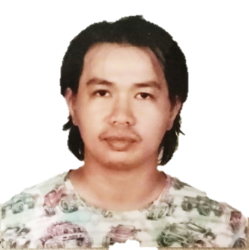
JANEL C. AGUILAR

POSITION DESIRED : Butcher / Meat Cutter / Boner

EMPLOYMENT HISTORY :
Leadman Butcher
A and E FROZEN PRODUCTS
Roxas Street, Bais City, Negros Oriental, Philippines
November 13, 2017 to Present
Duties and Responsibilities:
To perform butchering / meat cutting / deboning in the meatshop in particular;
PORK and BEEF:
- Prepare carcass (beef and pork) from the slaughterhouse for meat cutting
- Cut beef and pork carcasses into primal cuts
- Completing the full butchering and boning process on pork and beef,
- Cuts, Trims, Bones, Ties, and Grind Meats using butcher’s cutlery and powered equipment
- Slicing and processing product to meet specific orders including private processing.
- Weighs and Packs meat product for individual orders.
- Maintain clean and sanitize work and display area in the meat shop

RELEVANT TRAININGS AND SEMINARS ATTENDED:

BUGLAS INSTITUTE OF BUTCHERING & SLAUGHTERING CORPORATION (BIBSCORP)
Nesia Building, San Jose Ext, Barangay Taclobo, Dumaguete City, Negros Oriental, Philippines 6200
Telephone No. (035) 421-2822 / +63 917 791 0453
Email Address: bibscorp@gmail.com

FOOD SAFETY HANDLERS SEMINAR
City Health Office, LGU-Dumaguete City
Negros Oriental, Philippines

FIRST AID SEMINAR & TRAINING
Philippine National Red Cross
Dumaguete City, Negros Oriental
Philippines

EDUCATIONAL BACKGROUND:
College: Negros Oriental State University
Course: Associate in Industrial Technology
Year attended: 2012 - 2014

Secondary: Tanjay National High School
Year attended: 2007 – 2011

Elementary: Maralag Elementary School
Year attended: 2000 - 2006

PERSONAL INFORMATION:

Date of Birth : November 20, 1994
Place of Birth : Tanjay City, Negros Oriental
Age : 29
Sex : Male
Civil Status : Single
Height (cm) : 178 cm
Weight (lbs) : 154.32 lbs
Religion : Catholic
Contact Numbers: +63 912 515 0401
Email Address : janelaguilar69@gmail.com

REFERENCES:

Ephrime V. Alcala - Meat shop Owner
A and E Frozen Products
Roxas St., Bais City, Negros Oriental, Philippines 6206
+63 945 231 7486

Jee-ar Cabusog
Meat Cutter/Butcher
A and E Frozen Products
Roxas St., Bais City, Negros Oriental, Philippines 6206
2017-10-13 to Present
Contact Number : 09361281315

Dennis Morte
Meat Cutter/Butcher
A and E Frozen Products
Roxas St., Bais City, Negros Oriental, Philippines 6206
2017-11-13 to Present
Contact Number : 09950940949

Engr. Jose Ronnie A. Fortin – Training Instructor
BUGLAS INSTITUTE OF BUTCHERING & SLAUGHTERING CORPORATION (BIBSCORP)
Nesia Building, San Jose Ext, Barangay Taclobo, Dumaguete City, Negros Oriental, Philippines 6200
+63 917 791 0453

