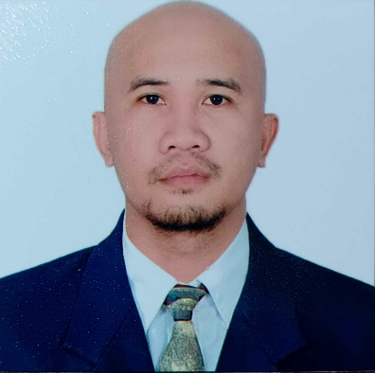
JOY CALANTAS PAPILLERO
+63 948 1956 897
Leon Llido St. Botanic Compound Brgy. City Heights
General Santos City, South Cotabato 9500 Philippines
PASSPORT NO: P5504715C
DATE OF BIRTH: January 01, 1990
EMAIL ADD: combo.joypapillero@gmail.com

Seeking a position as a butcher to begin my career in a high level professional environment.
To secure employment with a reputable company, where I can utilize my knowledge and skills to maximum by maintaining the value of integrity, honesty and character.

- EDUCATIONAL BACKGROUND:

Secondary:
School : Tampakan National High School
Address : Poblacion, Tampakan, South Cotabato
School Year : 2005 – 2006

- TRAININGS CERTIFICATIONS/ QUALIFICATIONS/ LICENSE

International English Language Testing System (IELTS)

Listening: 6.0
Reading: 5.5
Writing: 6.0
Speaking: 5.5
OVERALL BAND SCORE: 6.0

PROGRAM/ COURSE TITLE: MEAT SAFETY ADVOCACY SEMINAR FOR MEAT HANDLERS
Name of Awarding Authority: Department of Agriculture XII
Name of Training Institution: National Meat Inspection Services XII
Address: Purok 8, Poblacion Tupi, South Cotabato
Date of Training Period: February 29, 2024
Total hours of Training Period: 8 hours

DRIVER’S LICENSE
License NO: L05-17-002747
DL Codes: 1, 2
Valid Until: January 01, 2027

- WORK EXPERIENCE
COMPANY: Jeri’s Meat
Type of Company: Meat Shop
Employment Type: Full Time
Address: Aguinaldo Street. Purok 8, Poblacion Tupi, South Cotabato
Period: January 30, 2019 - Present
Position: Butcher/Meat Cutter/Deboner

Duties & Responsibilities

MEAT CUTTER/ DEBONER
- Receives, inspect, and store upon delivery to make sure meat quality.
- Record every carcass for storage and inventory.
- Monitoring, adjusting, trimming, and sharpening cutting and grinding
Equipment.
- Cutting, deboning, trimming, grinding, weighing and packing meat products
According to specification of customer's requirements.
- Prepare and arrange meat products into the display counter.
- Continuously clean the meat shop in accordance with the sanitary
requirements of the municipal regulation.
- Providing courteous, positive and efficient customer service, responding to customer inquiries appropriately.
- Tidy up the meat shop after closing time and pack unsold displayed meat to be put on the freezer.

- PERSONAL DATA
Birthplace: Carmen Magsaysay, Davao Del Norte
Birth Date: January 01, 1990
Civil Status: Married
Religion: Iglesia Ni Cristo (Church of Christ)
Citizenship: Filipino
Languages: English, Tagalog, Cebuano and Ilonggo

- CHARACTER REFERENCES

Mr. Jeri Anthony Leoncio
Position: Owner
Company: JERI’S MEATS
Address: Aguinaldo Street. Purok 8, Poblacion Tupi, South Cotabato
Contact No: 0917-328-4735
Email Address: jerianthony16@gmail.com

Ms. Shela Mae B. Sencio
Position: Administrative Personnel
Company: JERI’S MEATS
Address: Aguinaldo Street. Purok 8, Poblacion Tupi, South Cotabato
Contact No: 0970-889-2740
Email Address: smsencio05@gmail.com

