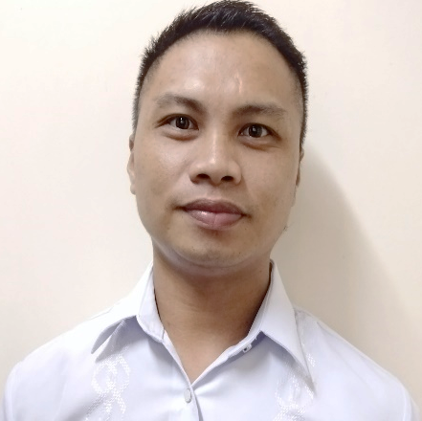
BERNARDO A. MANGACU
0164 Sitio Anilo Brgy. O’Donnell Capas, Tarlac
Mobile No.: 09308486893
Email add: bernardmangacu11@gmail.com

EDUCATIONAL BACKGROUND:

Tertiary : Basic Computer Literacy Program (TESDA) Tarlac
School Year (October 13, 18, 2008)

Secondary : O’Donnell High School
O’Donnell Capas, Tarlac
School Year: (2003-2007)

Elementary : Capas West Elementary School
O’Donnell Capas, Tarlac
School Year: (1997-2003)

WORKING EXPERIENCE:

Company : MC Muyot Pawnshop Services Inc.
Address : #030 Mabini Homesite Cabanatuan City
Position : WARE HOUSE OFFICER
Date : 2010-2017

Duties and Responsibilities
I am the recipient whenever someone Pawns things in the Pawnshop and I am also one who arranges the things that are Pawned in the Pawnshop.

Company : PHILMICO Animal Nutrition Corporation
Address : Tarlac City
Position : ARTIFICIAL INSEMINATION TECHNICIAN
Date : 2018-2019

Duties and Responsibilities
Artificial Insemination (A-I) Technician uses specific tools to insert semen into female animals to assist with impregnation in the breeding of livestock species an (A-I) Technician must understand Animal Anatomy to ensure correct placement of semen in the reproductive tract.

Company : FELIX PREMIUM MANUFACTURING CORP.
Address : Clark Freeport Zone, Pampanga Philippines
Position : PRODUCTION OPERATOR
Date : June to September 2022

Duties and Responsibilities
I used a shoe press to remove the wrinkles vamp and leveling the toe of shoes after that I clean my area if I have some extra time, I will help my co-worker and make sure all the things are Good.

Company : YOKOHAMA TIRE PHILIPPINES INC.
Address : Clark Freeport Zone, Pampanga Philippines
Position : MACHINE OPERATOR
Date : September 2022 to February 2023

Duties and Responsibilities
From the Buggy, I will take the Tires then pull them in the Tire mold then We I will check the QR Code of the tire’s then I operate the control machine to cook the tires after that the tires is ready to proceed by the QE staff.

PERSONAL DATA:

Date of Birth : July 11, 1990
Place of Birth : O’Donnell Capas Tarlac
Height : 5'4
Weight : 64 lbs
Civil Status : Single
Language Spoken : English, Tagalog, Pampango and Ilokano
Citizenship : Filipino
Religion : Iglesia Ni Cristo
Father’s Name : Perlito L. Mangacu
Mother’s Name : Soledad A. Mangacu
Driver License No. : C05-15001038
Passport No. : P9230653B

CHARACTER REFERENCE:

Benedict Mangacu
Minister
09455894774

BERNARDO A. MANGACU
Applicant

