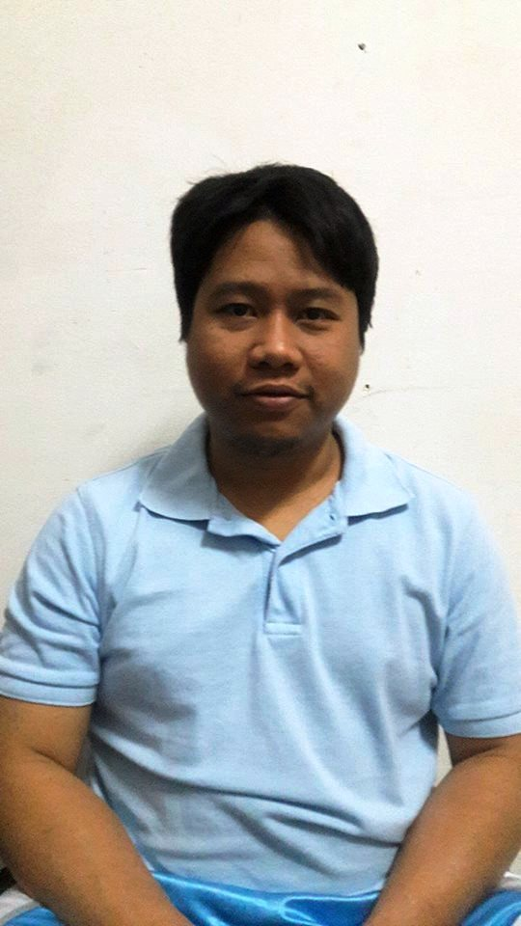
Address: 45 S. Cabahug St. Mabolo,
Cebu City, Philippines
Mobile num. +639155277706
K.S.A. num. +966540811153
ARIEL L. BALDO

POSITION DESIRED : PUMP TECHNICIAN/MECHANICAL FITTER

PROFILE : Experience in repair and assembly of Submersible
Pumps, Booster pump, Sewer pump, Fire pump
Have knowledge to install and repair of Valves,
Pressure switch, and Water level controls
Have knowledge to assemble and troubleshoot of
Motor control of Pumps and Building wiring
Have knowledge of basic plumbing works
Can work with less supervision and a team orient guy

PROFESSIONAL EXPERIENCED:

Company Name : Arabian Fal Company
Company Address : P.O Box: 88 Ras tanura-1941, K.S.A
Position : Pump Technician
Inclusive Date : October 2018 – Up to Present
Duties and Responsibilities
- Conduct routine inspections of Chiller pumps,
Booster pumps and Submersible pump
- Conduct preventive maintenance of pumps,
Greasing of motors change oil of pumps
- Repairing of pumps and motors, repairing of valves
- Installing of pumps and motors, gate valves,
Pressure relief valve, pressure switch
- Assist chiller team repairing chillers

Company Name : Al-Othman Agri Corp. / NADA
Company Address : P.O Box 1065, Al-Ahsa 31982, K.S.A.
Position : Pump Technician/ Korral Cool Technician
Inclusive Dates : March 01, 2014- October 2017
Duties and Responsibilities
- Conduct daily inspections of all vertical multi-stage pump, centrifugal pumps, booster pumps and slurry pumps
- Check, troubleshoot, and repairing of pumps
- Installing of pumps and fan motors
- Conduct preventive maintenance of pumps like, changing the lubrication oil, greasing the bearing of pumps and motors
- Conduct preventive and maintenance job of korralkool system
- Repair and troubleshoot of water pump controls

Company Name : Saudi Oger Ltd. (Aramco Project)
Company Address : Al Khobar, Ash Sharqiya, Saudi Arabia
Position : Pump and Instrument Technician
Inclusive Date : October 20, 2010 – October 07, 2013
Duties and Responsibilities
- Conduct daily inspections of all vertical multi-stage pump, centrifugal pumps, booster pumps and slurry pumps
- Check, troubleshoot and repairing of pumps
- Installing of pumps and fan motors
- Conduct preventive maintenance of pump like, changing the lubrication oil, greasing the bearing of pumps and motors
- Conduct preventive and maintenance job of korralkool system
- Repair and troubleshoot of water pump controls

Company Name : Eastman Industrial Supply Inc.
Company Address : AC Cortez, Mandaue City, Philippines
Position : Electro-Mechanical Technician
Company Specialization : Distributor of all Goulds Pumps/ABB Motors,
WEG Motors, LOWARA Pumps, and Motor Controls.
Inclusive Dates : July 2006 to October 2010
Duties and Responsibilities
- Assemble, troubleshoot, repair, testing and commissioning of Motor Controllers
- Installation, troubleshoot repair, testing and commissioning of
Fire Pumps, Booster Pumps, Deep well Pumps and Sewage Pumps including its accessories.
- Assemble and repair of all products of Gould Pumps

Company Name : Gotesco Marketing Inc.
Company Address : Subangdako, Mandaue City, Philippines
Position : Electro-Mechanical Technician
Company Specialization : Dealer of all Grundfos Pumps, US Electric Motors
Inclusive Dates : 2002 to 2006
Duties and Responsibilities
- Assemble, troubleshoot, repair, testing and commissioning of Motor Controllers
- Installation, troubleshoot, repair, testing and commissioning of Boosters Pumps, Deep well Pumps and Sewage Pumps including its accessories.
- Assemble and repair of all products of Grundfos Pumps

Company Name : Alpha Electrical Construction
Company Address : Lahug, Cebu City, Philippines
Position : Asst. Lineman
Company Specialization : Electrical Construction
Inclusive Dates : March to May 2001
Duties and Responsibilities:
- Installation of Electrical Meters
- Installation of service drop cable between the secondary line and customer meter

EDUCATIONAL BACKGROUND:

College : Bachelor of Science in Industrial Technology
Major in Electrical Technology
Name of University : Cebu Technological University
Inclusive Dates : 1999-2003
Location : Cebu City, Philippines

High School
Name of Institution : Abellana National School
Inclusive Dates : 1995-1999
Location : Osmeña, Blvd., Cebu City, Philippines

Elementary
Name of Institution : Mabolo Elementary School
Inclusive Dates : 1989-1995
Location : Mabolo, Cebu City, Philippines

PERSONAL PARTICULARS:

Age : 40 years old
Nationality : Filipino
Marital Status : Married
Date of Birth : November 11, 1982
Place of Birth : Mabolo, Cebu City, Philippines
Gender : Male
Language Spoken : English, Filipino, Bisaya
Height : 5, 2”
Weight : 158lbs

