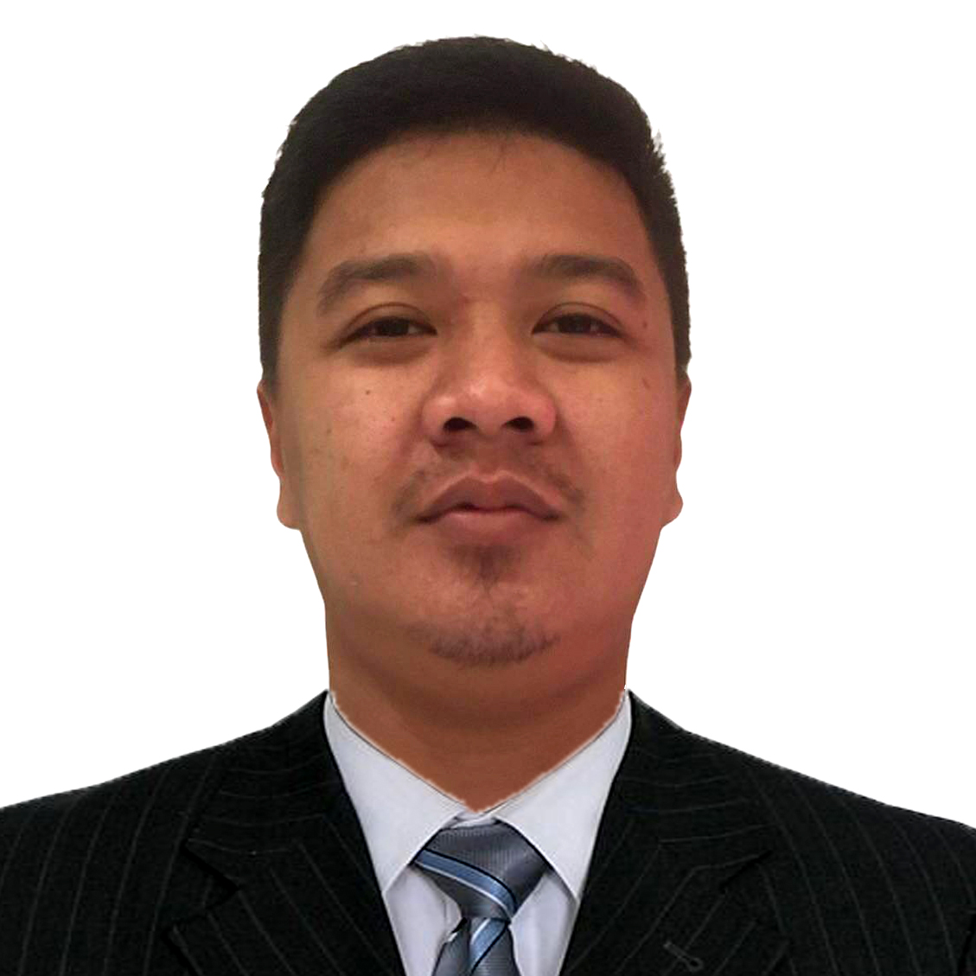

ERRONE CHRISTIAN F. REILLO
295 E. Rodriguez Ave. May-iba Teresa, Rizal
erronechristian24@gmail.com
09260834312

Objective
To secure a challenging position in a reputable organization to expand my learnings, knowledge and skills.

Personal Information

Date of Birth : July 25, 1991

Place of Birth : Morong , Rizal

Height : 5'7

Weight : 73kg.

Status : Single

Religion : Roman Catholic

Education

D' New Orleans Training Center PHILS. inc.
- Cainta, Rizal
Slaughtering Operations Swine NCII
April 26, 2023 - June 10, 2023

Our lady of fatima university
- Antipolo, City
Bachelor of Science in Business Administration
2009-2012

UNIVERSITY of the east
- Recto Manila
- 2007-2009
Tomas claudio memorial college
- Morong, Rizal
- 2004- 2007
saint agnes school
- Teresa, Rizal
- 1998--2004

Skills & Abilities
- Computer Literate (MS Word, Excel, Power Point)
- Communication Skills
- Clerical Skills
- Slaughtering Operations

CERTIFICATES
- SLAUGHTERING OPERATIONS NCII
- PRACTICING COVID-19 PREVENTIVE MEASURES IN THE WORKPLACE

Work Experience
SLAUGHTERER/BUTCHER
- Roblou Meat Product & Abattoir
Cainta, Rizal
- June 14,2021- July 4, 2023
- Operates restrainers and stunning equipment.
- Severs jugular veins of stunned animals to drain blood and facilitate dressing.
- Trims and removes head meat and severs animal heads.
- Slits open, eviscerates and trims animals carcasses.
- May slaughter livestock according to procedures required by religous customs.

LIAisON OFFICER
- Engr. Camilo Castrence Jr.
Cainta, Rizal
- June 2019 - March 2021
- Responsible to assist all permits and licenses requirements from pre-construction, construction, and operation annual requirements.
- Performs administrative and office support activities.
- Assist to follow up and pick up of checks every collection date.

SALES UTILITY CLERK
-SM Taytay ,Rizal
- May 2016 – November 2016
- Greeting customers as they enter the store.
- Working at the point-of-sale counter to process transactions.
- Assisting customers in locating products by going through the inventory.
- Suggesting new items to customers based on their selections.
- Building customer relationships.

Brand Ambassador
- Activation Machine Inc.
Pasig, City
-September 2012 – February 2014
- Works as the public face of a company or brand.
- Creating awareness for a company’s service or product.
- Interacting with customers to listen to their feedback and developing new ways to market products.

Character References

Alexis Sabile ENGR. CAMILO CASTRENCE JR.

Rublou- Trainor 09392900937

09471534741

I hereby that the above information is true and correct to the best of my knowledge and beliefs.

ERRONE CHRISTIAN F. REILLO
Applicant

