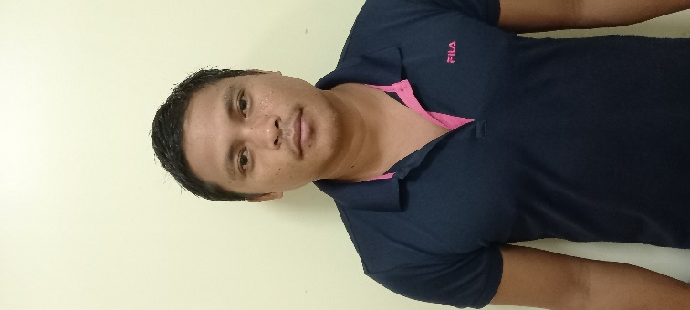
ADRIAN B. TAGUPA
6319 Guadalupe, Carmen, Bohol
Philippines
adrinz_tagupa@yahoo.com
Skype ID: Adrinz_tagupa

PERSONAL INFORMATION

Age: 33 years old
Birthdate: September 9, 1990
Birthplace: Katipunan, Carmen, Bohol
Height: 5’6”
Weight: 75Kg.

EDUCATIONAL ATTAINTMENT

Bohol Island State University
Bilar Campus, Zamora Bohol
Bachelor in Agricultural Technology
Batch 2015

WORK EXPERIENCE AND PROFESSIONAL TRAINING

KENMORE LIMITED
Top Floor Ela Beach Tower Port Moresby
NCD Papua New Guinea
Plantation Manager
February 13, 2023-Present

Duties and responsibilities

- Coordinate with other manager for the accommodation and costing of produce of beef herd consumption.
- Supervise employees to their daily routine work and schedule.
- Ploughing.
- Harrowing.
- Planting corn, Napier, sorghum, and signal grass for the pasture and cattle feed.
- Apply fertilizer, insecticide and Hebrides of corn, sorghum, signal grass and Napie.
- Do the monthly inventory of fertilizer, seeds, and insecticide and do orders from supplier.
- Farm machine operation like tractor, backhoe and loaders.
- Harvesting forage using flail harvester.
- To ensure all machinery and equipment are will maintain and service of farm equipment.
- Maintain the farm.
- Clearing of new paddock using bulldozer.

Mad bull limited
Bumbu road section 46 lot 22 Eriku lae
Morobe Province, Papua New Guinea
Livestock farmer/manager
July 20, 2019-April 10, 2022

Duties and responsibilities
- Managing livestock employees to their daily routine work and schedule.
- Mixing feed for livestock.
- Feeding livestock like pig, village chicken, ducks and goat.
- Stocktaking all livestock cattle, goat, pig, chicken and ducks.
- Castrate buckling, bull calf and piglet.
- Grading cows and doe for culling.
- Do kidding operation.
- Fence repair and maintenance.
- Check the health of livestock.
- Planting forage crop.
- Install and maintain electric fence.
- Ploughing.
- Harrowing.
- Planting corn.
- Apply insecticide and Hebrides of corn.
- Harvest and post-harvest operation for corn.
- Milling corn for feed.
- Drying and milling of copra for feed.
- Do the weekly inventory of my feed mix stock and orders from supplier.
- Incubating of native chicken egg.
- Slaughter pig, goats and cattle.
- Farm machine operation like tractor, backhoe and loaders.
- Service of farm equipment.
- Maintain the farm.

Johnson Farm
Cleghorn, Iowa 51014 USA
Internship Training
April 24, 2016 to May 21, 2017

Duties and responsibilities :( cattle)
- Feeding and take care of fathering cattle.
- Grinding corn and round bale hay for feed mixing.
- Install electric fence and battery shock fence.
- Daily check of shock fence.
- Fencing the pasture.
- Repair fence in the pasture.
- Operate pea loader, tractor loader to load feeds in the wagon.
- Chopping, raking and bailing corn stocks and alpha alpha for hay.
- Hauling round bail hay.
- Chopping silage and hauling to silage pit.
- Put hay beddings for cow ready for calving.
- Sorting cows.
- Calving.
- Castrate male calf
- Cleaning the barn.
- Cattle maintenance health and vaccine.
- Patrol in the paddocks.
Duties and responsibilities :( crops)
- Plowing and disking the field.
- Spreading manure.
- Fertilizer application for corn and soy beans.
- Spraying the weeds.
- Planting corn and soybeans.
- Harvesting operation for corn and soy beans.
- Hauling corn and soybean grains.
- Maintenance and repair of farm machinery.
- Plant alpha alpha and oats for forage.
- Spread fertilizer in the pasture.
- Operation of farm machinery and on road vehicle.

Mehadren Gay Farm
Ashdod, Israel
Farm Trainee (OJT)
October 2013 to September 2014

Duties and responsibilities: (CROPS)

- Planting fruits like oranges, citrus and avocado.
- Install and maintain drip irrigation.
- Harvesting avocado, oranges and pomegranate.
- We do land preparation.
- Seedlings monitoring.
- We do fertilizing management/application.
- Soil/crops spraying.
- We do pest management.
- Girdling.
- Maintaining and monitoring the growth of the crops and also the farm.

Bohol Island State University
Zamora, Bilar, Bohol
Cattle Technician-OJT
March 1, 2013- June 1, 2013

Duties and responsibilities :( Cattle)
- Carry out feeds and feeding the cattle
- Monitor the health and well-being of cows, bulls and steers
- Recognize and treat health problems in cattle
- Perform general farm duties
- Restrain and vaccine cattle
- Maintain equipment and buildings

UBAY STOCK FARM
Lomangog, Ubay, Bohol
Cattle technician-OJT
March 2012 to May 2012

Duties and responsibilities: (Cattle)

- Monitor the health and well-being of cows, bulls and steers.
- Recognize and treat health problems in cattle.
- Castrating of bull.
- Restrain and vaccine cattle.
- Maintain equipment and buildings.
- Perform general farm duties.
- Plant forage crop.
- Chop Napier grass for silage.
- Milking the cow.

ACHIVEMENT
TESDA Competency Examination Passer with the following Specialization
- Animal Production NCII
- Horticulture NCII
- Agricultural Crops Production NCI
AWARD
- Exemplary performance certificate in OIP.

