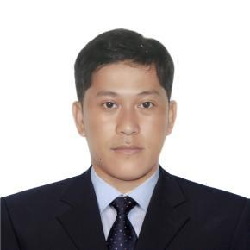
SAMSON A. SUSPENE
Rokytnice, Czech Republic
samsuspene5@gmail.com
CP No: (420) 601118115

POSITION APPLIED: WELDER(MIG/TIG/FCAW/SMAW) / FABRICATOR

EDUCATIONAL BACKGROUND:

Primary : Biga Elementary School
1988-1994
Secondary : Cavite Institute
1994-1998
Vocational : TESDA NCII (SMAW)
Oct.26, 2019 – Oct. 25, 2024

PROFESSIONAL EXPERIENCES:

April 11,2023 up to present Company:TVD TECHNICKA VYROBA, A.S.
Position: Mag/Mig Welder
Address: Rokytnice,Czech Republic

April 21,2021 - May 28, 2022 Company: GLOBAL MAXX CORP.
Position: GMAW Welder(Car Parts/Carbon Steel/(1mm-12mm)
OTC XD 350 / 500
Address: Maguyam, Silang, Cavite

Feb. 27, 2019 – Oct. 11, 2020 Company: DYNA MICRO PREC. TOOLINGS & FAB. INC.
Position: WELDER(TIG) (Stainless Steel/15mm)ARGO 350/500amp.
Address: Biga II, Silang, Cavite

Dec. 21, 2012 – Dec. 21, 2014 Company: KURAMOTO STEEL CO.INC.
Position: Welder/Fabricator(Carbon Steel/1-30mm)YAMATO
Address: Hiroshima Ken, Fukuyama Shi, Japan

December 3,2007 – Sept.7,2012 Company: MAENO GIKEN INC.
Position: Welder/ Fabricator(Carbon Steel/Stainless Steel/Aluminum
Steel/Galvanized Steel OTC XD 350-500/ARGO 350-500/(1.5-20mm)
Address: FCIE Complex,Dasmariñas, Cavite

I hereby certify that the above information is true and correct.

Samson A. Suspeñe
Applicant

