RAMY R. DALIDA
09298364059
(705) 491-0825
ramy_351972@yahoo.com
103 Lyle St. South, Grafton, ON K0K 2G0
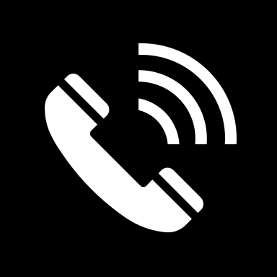
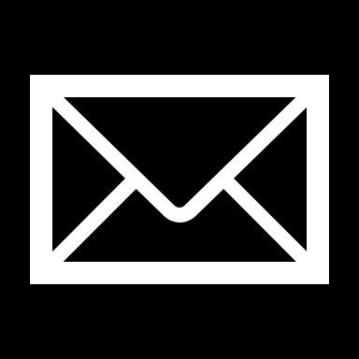
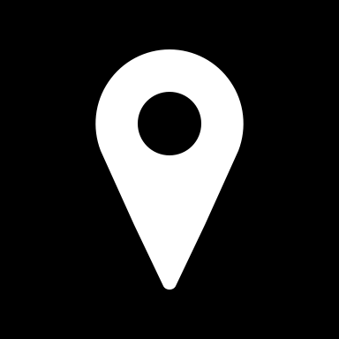

Professional Summary
Dedicated and accomplished professional with a diverse skill set and a proven track record of success for more than two decades of distinguished service as a government employee. Showcasing a versatile career spanning roles as a school principal, education program supervisor, and classroom teacher. Additionally, my expertise extends to the field of welding with a National Certificate II in 6G Welder (Shield Metal Arch Welding) and proficiency in Industrial Pipefitting. My commitment to excellence is further underscored by my experience as a Nursing Attendant 1, where I honed my caregiving abilities and gained valuable insights into the healthcare sector. Possessing both a Licensed Professional Teacher qualification and a Certificate of Eligibility for Nursing Attendant, I bring a unique blend of educational and healthcare expertise to any professional setting. My career journey reflects adaptability, versatility, and a passion for continuous learning, making me a valuable asset in diverse professional environments. I am eager to leverage my skills and experiences to contribute effectively to new challenges and opportunities in the ever-evolving landscape of education, welding, pipefitting, or healthcare.
Work History
School Principal IV September 19, 2022 – Present
Department of Education-Gov. Ferrer Memorial Integrated National High School

- Provide visionary leadership to the school community.
- Oversee the overall administration and management of the school.
- Develop and implement strategic plans and policies to enhance the school's performance.
- Work with teachers and staff to develop and update the school curriculum.
- Ensure that curriculum standards and educational goals are met.
- Foster a culture of continuous improvement in teaching and learning.
- Conduct regular evaluations of teaching staff and provide constructive feedback.
- Implement professional development programs for faculty and staff.
- Foster positive relationships with parents and guardians.
- Communicate effectively with stakeholders and address concerns promptly.
- Develop and manage the school budget.
- Allocate resources effectively to support educational programs and initiatives.

Education Program Supervisor October 17, 2018 – September 18, 2022
Department of Education – Schools Division Office General Trias City

- Formulates plans and policies relative to assigned areas of instruction.
- Supervises, coordinates, and evaluates projects/programs and activities.
- Prepares and evaluates plans concerning the assigned area.
- Provides leadership in the effective use of techniques/strategies in his assigned area of instruction.
- Develops and administers tests in pursuance of desired programs/outcomes to improve instruction in schools.
- Monitors classroom instruction and gives feedback for improvement.
- Initiates and coordinates in-service training in assigned fields and serves as a consultant or source person in those activities.
- Supervises the aspects of assigned instructional programs.
- Provides guidelines on matters pertaining.

School Principal I September 3, 2013 – October 16, 2018
Department of Education – Santiago/Cecilio M. Saliba Elementary School

- Develop and communicate a clear vision for the school.
- Provide leadership to staff, students, and the school community.
- Oversee day-to-day operations of the school.
- Manage budgetary and financial matters.
- Ensure compliance with educational policies and regulations.
- Monitor and evaluate instructional programs to ensure high-quality education.
- Enforce school policies and handle disciplinary issues.
- Promote a safe and positive learning environment for students.

Elementary School Teacher June 7, 1999 - September 9, 2013
Department of Education – San Francisco Elementary School

- Teaches elementary-grade pupils.
- Serves as demonstration teacher and consultant.
- Develops and/or implements innovative and functional teaching approaches and strategies every school year.
- Provides professional assistance to teachers like coaching and mentoring.
- Conducts instructional training programs in the school, district, or division.
- Facilitates learning in elementary/secondary schools through functional lesson plans, daily log of activities, and appropriate, adequate, and updated instructional material (print and non-print).
Nursing Attendant I July 25, 1994 – June 6, 1999
City Government of Manila - Ospital Ng Maynila Medical Center (OMMC)

- Collaborate with the nursing team to assess and monitor patients' vital signs, reporting any significant changes to the healthcare professionals promptly.
- Administer basic medical treatments and medications under the guidance and supervision of the nursing staff.
- Assist patients with activities of daily living, including bathing, grooming, and mobility support, fostering a compassionate and patient-centered approach.
- Adhere to all relevant policies, procedures, and guidelines to ensure compliance with healthcare regulations and maintain a high standard of patient care.

Educational Background

Doctor of Education Major in Educational Management 2022
POST GRADUATE | Philippine Christian University, Dasmariñas, Cavite, Philippines

Master of Arts in Education Major Educational Administration 2020
POST GRADUATE | Philippine Christian University, Dasmariñas, Cavite, Philippines

Bachelor of Science in Agriculture Major in Agricultural Education 1992
Dr. Emilio B. Espinosa Sr. Memorial College of Arts and Trade, Mandaon, Masbate, Philippines

Areas of Expertise

- Effective Communication | - Administrative Management | - Curriculum Development
- Leadership and Vision | - Facilities Management | - Educational Planning
- Computer Literacy Skills | - Supervision and Support | - Professional Development
- Collaborative | - Policy Implementation | - Budget Management
- Program Evaluation | - Professionalism | - Compliance and Regulation
- Problem Solving | - Resilience and Adaptability | - Interpersonal Skills
- Visibility and Empathy | - Positive Attitude | - Good Organizational
- Strategic Planning & Implementation | - Policy Development & Implementation | - Performance Metrics & Measures
Licensed and Certifications
National Certificate Level II in 6G Welder (Shield Metal Arch Welding)
Technical Education and Skills Development Authority (TESDA), Philippines

National Certificate Level II in Industrial Pipefitter (IPF)
Technical Education and Skills Development Authority (TESDA), Philippines

Licensure Examination for Professional Teacher
Professional Regulation Commission (PRC), Philippines

Certificate of Eligibility for Nursing Attendant
Civil Service Commission (CSC), Philippines

Certificate of Completion on Refresher Course in English
Certificate of Attendance on Basic Firs-Aid Training and Demo
School Emergency Management and Safety Training
Red Cross/DepEd/Municipality of General Trias, Philippines

Certificate of Completion on HSI Basic Life Support Training
International Academy Manila, Quezon City, Philippines

Certificate of Completion on Basic Occupational Safety and Health for Safety Officer 2
Certificate of Completion on Confined Space Entry
Safety Vectors Training Services Inc. Dasmariñas, Philippines

