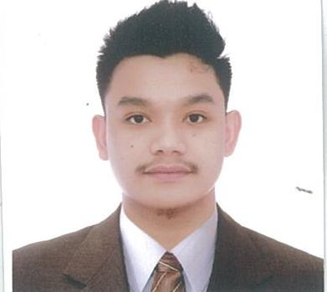
MARC CYRIL C. MANUEL

- 0870 Tibagan Caypombo Sta Maria Bulacan
- 09658712655
- Kurtcyler032521@gmail.com
Summary of qualifications  - Performed Refrigeration Assembly (HVAC)  - Performed Electrical Assembly for Food equipment  - Performed Troubleshooting for Equipment with complaint  - Communication Skills.  - Experienced in MIG Welding (GMAW)  - Experienced in TIG Welding ( GTAW)  - Experienced in SMAW Welding  - Installation and Troubleshoot of split type and window type A/C  TRAININGS AND SEMINAR ATTENDED  Workplace attitude and Values  2015 at Philippine Batteries Incorporated Training Room  Fire Watcher Training (DOH Accredited)  2022 Via Zoom (Online)  Root Cause Analysis  2023 at Philippine Batteries Incorporated Training Room |  | EDUCATION  Tertiary: Bulacan State University  Bachelor in Technology Major in Reftigeration and air Conditioning (RAC)  2013-2015  Secondary: Fortunato F Halili National Agricultural School  Guyong Sta Maria Bulacan  2008  WORK EXPERIENCE  - On the Job Trainee, Equipment Fabricator/Machinist/Finisher at RAMCAR Technology Inc. Sta. Maria Bulacan Phil’s  - Refrigeration of Food Equipment.  - Electrical of Food Equipment.  - Testing & Data Gathering of Food Equipment.  - Welding & Copper Brazing.  - RAMCAR Technology Inc., Sta. Maria Bulacan Phil’s.  Refrigeration Technician (June 08, 2015 – September 2020)  - Refrigeration of Food Equipment.  - Electrical of Food Equipment.  - Testing & Data Gathering of Food Equipment.  - Welding & Copper Brazing.  - Servicing Technician (October 2020 -Present  (2020-2021 Pandemic Days)  - Servicing & Maintenance of KFC/Tokyo Tokyo and Bigoli Kitchen Equipment  - Servicing & Maintenance of KFC/Tokyo Tokyo Refurbished Equipment (fryers).  - Customer Complaint Validation.  - Welding &Repair of Mechanical Assembly Customer Complaint  - Onsite Testing & Calibration of Food Equipment  - Commissioning &Load Testing of Food Equipment  references  Raymond L. Balaes Engr. Alvin B. Del Rosario  QA Team Leader QA Assistant Manager  Ramcar Technology Incorporated Ramcar Technology Incorporated  Contact No. 09661548476 Contact No. 09773306237  raymond.balaes@motolite.com alvin.delrosario@motolite.com

