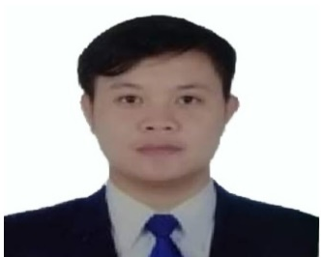
DAN PAUL A. VALDEZ
Address: #92 Maharlika Highway, Damortis, Rosario,
La Union Philippines
Email Address: @danpaulv4@gmail.com /
danpaulv9@gmail.com
Mobile No.: 09707052660/ 09165023193

PERSONAL INFORMATION:

Date of Birth: April 9, 1995
Place of Birth: Baguio City
Age: 28 years old
Gender: Male
Height: 162.56 cm
Weight: 60kg
Civil Status: Single
Citizenship: Filipino

EDUCATIONAL BACKGROUND:

Tertiary:
School Name: Colegio De Dagupan
Address: Arellano St. Dagupan, 2400 Philippines
Course: Computer Hardware Servicing – NC II
Date: June 2013 – April 2014

Secondary:
School Name: Damortis National High School
Address: Damortis Sto.tomas La Union
Date: June 2007 –April 2011

WORK EXPERIENCE

Company Name: Cofta Mouldings Corp
Address: No. 33LBICA, Lawang Bato, Valenzuela City, Philippines
Position: CNC Machinist (CNC Milling Machine Operator)
Date: September 2018 up to present

Duties and Responsibilities:

- Machining Injection Mold part using CNC Milling horizontal and vertical (3,4 and 5 axis)
- Cutting and bending and welding using CNC laserweld,CNC, bending,CNC laser weld
- Mold Assembly
- Tacking Molds using TIG Welding
- Drilling small holes using EDM Drill
- Cutting Hardened material using wirecut
- Manual/Macro CNC Programming
- Resurfacing plates using surface grinding
- Fabricating sheet metals bending, cutting, rolling, cone type and welding using CNC bending , CNC Laser cutting, CNC turret punch and CNC roboto welding
- Lifting mold and set-up using overhead cranes

Company Name: Human Link Management and Services
Address: 28 Industrial Road, Valenzuela City
Position: CNC Machinist (CNC Milling Machine Operator)
Date: April 2018 – May 2018

Duties and Responsibilities:

- Drilling parts of cylinder for mining
- Refacing plates
- Control measurements and tolerances
- Turning Cylinder using Conventional Lathe
- Spot Welding Cylinder cap

Company Name: GoldHeart Manpower & Training Center Inc.
Address: 2535 m. Delos Reyes Street, General T. De Leon, Valenzuela City
Position: CNC Operator (CNC Milling Machine Operator)
Date: September 2017 – February 2018

Duties and Responsibilities:

- Find and Cut raw materials using Hacksaw
- Set-up materials centering, alignment, run program-
- Control measurement and tolerance using vernier caliper, micrometer, boregauge etc.

Company Name: LGAIRE METAL MANUFACTURING (HVAC) 9SHEET METAL)
Address: #10 Fifth Street, Fortune Village 5, Parada, Valenzuela City
Position: Freelance Machinist
Date: December 2014 – December 2016

Duties and Responsibilities:

- Fabricating and Turning Bushings for Punch and Die Parts using lathe machine
- Bending sheets for louvers and dampers product using manual bending machine
- Cutting Sheets using Shearing Machine
- Refacing base plate using milling and shaper machine
- Layouting sheets

TRAINING CERTIFICATES:

Title of Certificate: MACHINING NC II (CERTIFICATE OF COMPLETION)
Issued By: Technical Education And Skills Development Authority (TESDA)
Date: April 12 - June 27, 2016

Title of Certificate: BRIDGING PROGRAM FOR CNC MACHINING (CERTIFICATE OF COMPLETION)
Issued By: Technical Education And Skills Development Authority (TESDA)
Date: March 20 – April 12, 2017

Title of Certificate: VALIDATION OF COMPETENCY ASSESSMENT TOOLS (WRITTEN TEST) FOR 5 AXIS CNC MACHINE OPERATIONS NC III (CERTIFICATE OF PARTICIPATION)
Issued By: Technical Education And Skills Development Authority (TESDA) and Standard Office
Date: May 29, 2017

Title of Certificate: CNC LATHE MACHINE OPERATING NC II (CERTIFICATE OF COMPLETION)
Issued By: Technical Education And Skills Development Authority (TESDA)
Date: April 17 – June 5, 2017

Title of Certificate: CNC MILLING MACHINE OPERATION NC II (CERTIFICATE OF COMPLETION)
Issued By: Technical Education And Skills Development Authority (TESDA)
Date: June 5 – July 18, 2017

Title of Certificate: ON THE JOB TRAINING
Issued By:
Date:

CHARACTER REFERENCES:

Name: JOSEPH JR. LUCI
Company: Coufta Mouldings Corp
Position: CNC Machinist
Contact Number: 093068755909

Name: RITCHIE TIONGSON
Company: Coufta Mouldings Corp
Position: CNC Machinist
Contact Number: 09167889046

Name: GLEN ANTHONY ABLES
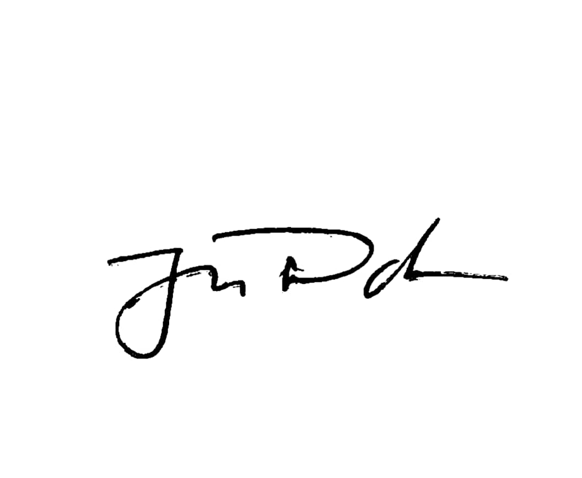
Company: Coufta Mouldings Corp
Position: CNC Machinist
Contact Number: 09707364555

Dan Paul A. Valdez

