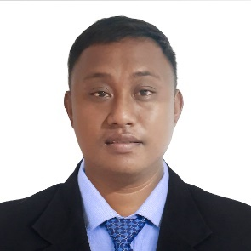
MARVIN PACCARANGAN CALLUENG
B11 L6 PAPAYA ST. DONA JOSEFA VILLAGE, ALMANZA UNO, LAS PINAS CITY
Contact No.# 0915 -1435516
Email: marvincallueng90@gmail.com

EDUCATIONAL BACKGROUND:

BACHELOR OF SCIENCE in CIVIL ENGINEERING
CAGAYAN STATE UNIVERSITY
Tuguegarao City, Cagayan, Philippines
2007 - 2013 Graduate

EMPLOYMENT RECORD:

SITE SUPERVISOR
April 2013 – Present
E.M. CALLUENG CONSTRUCTION
B11 L6 Papaya St., Dona Josefa Village, Almanza Uno, Las Pinas City, 1750

NOTABLE Construction Projects Supervised:
- Rusi Motocycle bldg. in Palawan, Isabela, Cagayan,Bulacan
- 5 storey residential/dorm bldg. in columbiast. Corner oxford
St. Cubao quezon city.
- Rusco motors bldg. In Palawan, Cabanatuan city nueva
Ecija and Binangonan rizal
- 2 storey residential bldg. in Enclave Alabang, daang hari
Almanza dos las pinas city.
- 2 storey apartment/ town house bldg. In L-de guzman st.
Marikina city.
- Bungalow w/ roofdeck in metro gate tagatay estate
- 2 storey w/ roofdeck church bldg. In greenwoods subdivision Pasig city.

Responsibilities:

- Supervision of daily activities in contraction site
- Handling of workers payroll and attendance
- Quality check of materials and equipment
- Purchasing of materials
- Coordination with project engineers, architects, clients, and suppliers

TECHNICAL SKILLS:

- General maintenance and repair of machines, mechanical equipment, and buildings.
- Welding and steel works.
- Basic Carpentry, Masonry and Plumbing works
- Cost Estimation of civil construction projects
- Able to use computer applications including MS Office apps and AutoCAD

PERSONAL DATA:

Profile: Male, Filipino, 32 years old, Married,
Baptist Christian
Birthday/Place: November 21, 1990 / Santa Maria, Isabela

CHARACTER REFERENCE:

Arch. Melissa A. Cabutin, UAP
Architect
Mobile No. +639156067286
E.M. CALLUENG CONSTRUCTION
Almanza Uno, Las Pinas City, 1750

I hereby certify that the above written information is true and correct through my belief and knowledge.



Marvin P. Callueng_____
Signature

