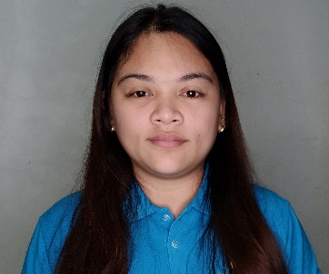
LOVELY JOY L. JIMENO
ADDRESS: Block11, Lot18 Tierra Nava Pob.3, Carcar City, Cebu
MOBILE NO.: +63 905 491 3035
E-MAIL: lovelyjoylabra@gmail.com
________________________________________________

OBJECTIVE:
To find a company that offers development for learning skills and opportunity for advancement in career and personality.

WORK EXPERIENCE:

• IMPLEMENTATION COORDINATOR
NCR Cebu Development Center, Inc.
7th Flr. Ebloc Tower 1, Cebu IT Park, Cebu City
December 2014 – December 2022

• SERVICE STAFF
Hot Tomato PTE LTD Singapore
Exchange Green #01-21, The Star Vista
April 2014 – October 2014

• EBOOK DESIGNER
Author Solutions, Inc.
6th flr. TGU Tower, Cebu IT Park, Lahug, Cebu City, Philippines
April 2011 – July 2013
- Task includes creating ebook file (.epub, .pdf, .mobi) using Adobe Indesign, Photoshop, Calibre, CSS

• PRODUCTION ASSOCIATE
Innodata Knowledge Services, Inc.
Subangdaku, Mandaue City, Cebu, Philippines
September 2009 – April 2011
-Textual editing and data processing

• OFFICE STAFF (On-The-Job-Training)
(Loan Department) Cebu CFI Cooperative
Capitol Site, Cebu City
October 2008 – March 2009

EDUCATIONAL BACKGROUND:

2018
Diploma of Professional Education
Cebu Normal University

2013
Foundation Diploma in Food & Beverages Operations
Rex College of Hospitality and Management
Sophia Rd, #02-07 Peace Centre, Singapore 228149

2009
Bachelor of Science in Information Technology
University of Cebu
Cebu, Philippines

CERTIFICATES, TRAININGS & ACHIEVEMENTS:

• Community Emergency Preparedness Programme (CEPP)
Issued by: Singapore Civil Defense Force
Date: 10 November 2013
Yishun Fire Station

• Best Ebook Designer (Q4) 2012
Author Solutions Inc.
6th flr. TGU Tower, Cebu IT Park, Lahug, Cebu City, Philippines

SKILLS:

• Posses excellent English verbal and written communication skills.
• Touch Typist
• Mastery of Microsoft Office programs (Word, Excel, PowerPoint)

PERSONAL BACKGROUND:

Gender : Female
Civil Status : Married
Date of Birth : January 14, 1989
Place of Birth : Cebu City, Philippines
Citizenship : Filipino
Religion : Roman Catholic
Height : 5’0
Weight : 62 kls

