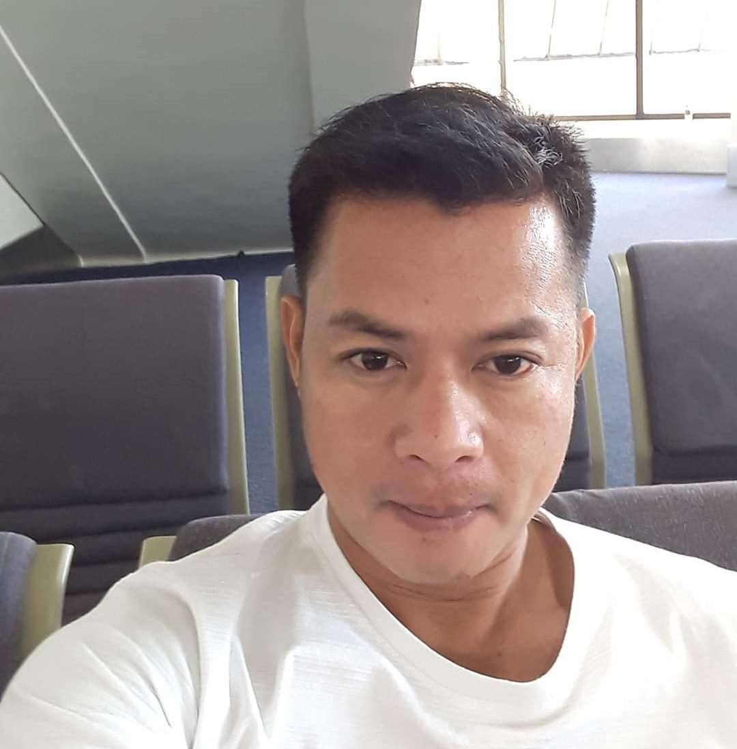

April Boy Bayola Dumlao
Position : Panel Beater/Auto Denter
Cell Number : +63 915 6820 280
Landline Number : 00966138198100
Email : dumlaoaprilboy37@gmail.com
Skype ID : dumlao38@outlook.com
Facebook Name/Email: dumlaoaprilboy37@gmail.com

OBJECTIVE:

I’ve been a panel beater and auto denter for 14 years. I am qualified for the position because I have panel beater experience and I want to learn more. I am a person who wants to share my knowledge and abilities with others.

SUMMARY OF QUALIFICATIONS:

- Panel Beater
- Welder mig/tig machine
- Gas Welder
- Aluminum Welder
- Fabricator

PROFESSIONAL EXPERIENCE (from Present to Previous)

Date : Sept 2023 till present
Position : panel beater
Company : mach1 panel and paint
Department : shop
Location : Victoria Australia

Date : November 2021 to august 2023
Position : Panel Beater/Auto Denter
Company Name : Almajdouie Company
Location : Saudi Arabia
Department : Dealership
Company Website/FB: Almajdouie Motors | Dammam | Facebook
Reason for leaving :

Job Description:
- Safety first
- checking of job card
- Execute the work in time given if there is time lapsed make sure to inform your leadman.
- griding, welding, etc. repair or replace the panel using special tools to make sure it will be the same as new.

Date : November 2020 to 2021
Position : Panel Beater/Auto Denter/welder
Company Name : Freelancer
Location : Philippines
Department : industrial
Company Website/FB:
Reason for leaving : The reason is that working abroad would allow me to support my family and working abroad has a lot of opportunities. I want to work with a company that gives a high salary because I want to be with my family by bringing them abroad.

Job Description:
- auto denter/welder
- contractual per vehicle repair panel or replace by way of fabrication.

Date : 2018 to 2020
Position : Panel Beater/Auto Denter
Company Name : Alkardawi garage
Location : bahrain
Department : garage
Company Website/FB:
Reason for leaving : The reason is that working abroad would allow me to support my family and working abroad has a lot of opportunities. I want to work with a company that gives a high salary because I want to be with my family by bringing them abroad.

Job Description:
- safety first
- checking of job card
- grinding, welding, etc. repair or replace the panel using special tools to make sure it will be the same as new.

Date : 2016 to 2018
Position : Panel Beater/Auto Denter
Company Name : Hussien Bien Muhammad alajabi
Location : Electric Road, Najran, Saudi Arabia
Department : industrial
Company Website/FB:
Reason for leaving : The reason is that working abroad would allow me to support my family and working abroad has a lot of opportunities. I want to work with a company that gives a high salary because I want to be with my family by bringing them abroad.

Job Description:
- dealing with customers as estimator and auto denter as well.

Date : 2015
Position : Panel Beater/Auto Denter/welder
Company Name : AGA & Son Const. & Development Company
Location : Manila, Philippines

Job Description:
- full welder using electrode

Date : 2011 to 2014
Position : Panel Beater/Auto Denter/welder
Company Name : Ghanthoot Transport
Location : Road Construction Section, P.O Box 30541, Abu Dhabi
Department : Construction company

Job Description:
- radiator technician
- change, check and fabricate the core of the radiator and weld as well.
- welding fabricator using mig and electrode.

Date : 2007 to 2011
Position : Panel Beater/Auto Denter/welder
Company Name : Own Workshop
Location : Cavite, Guimba, Nueva Ecija, Philippines
Department : shop
Company Website/FB:
Reason for leaving : The reason is that working abroad would allow me to support my family and working abroad has a lot of opportunities. I want to work with a company that gives a high salary because I want to be with my family by bringing them abroad.

Job Description:
- welder dealing with the customers.
- motor mechanic troubleshooting.

TRAININGS AND SHORT COURSES

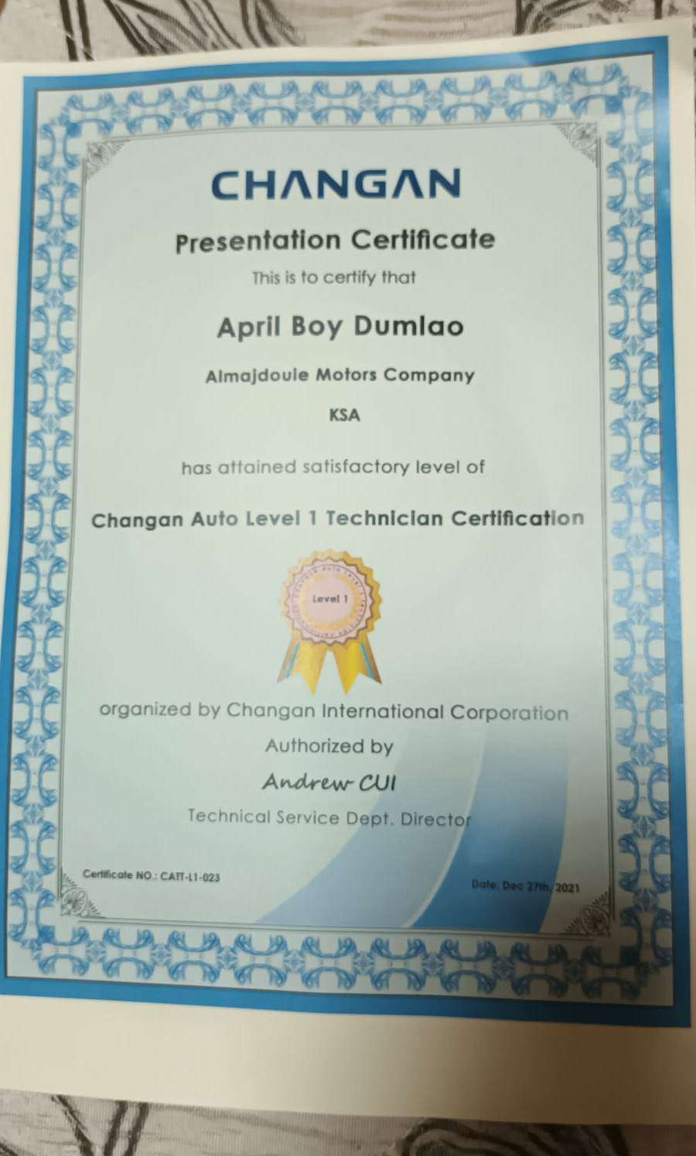
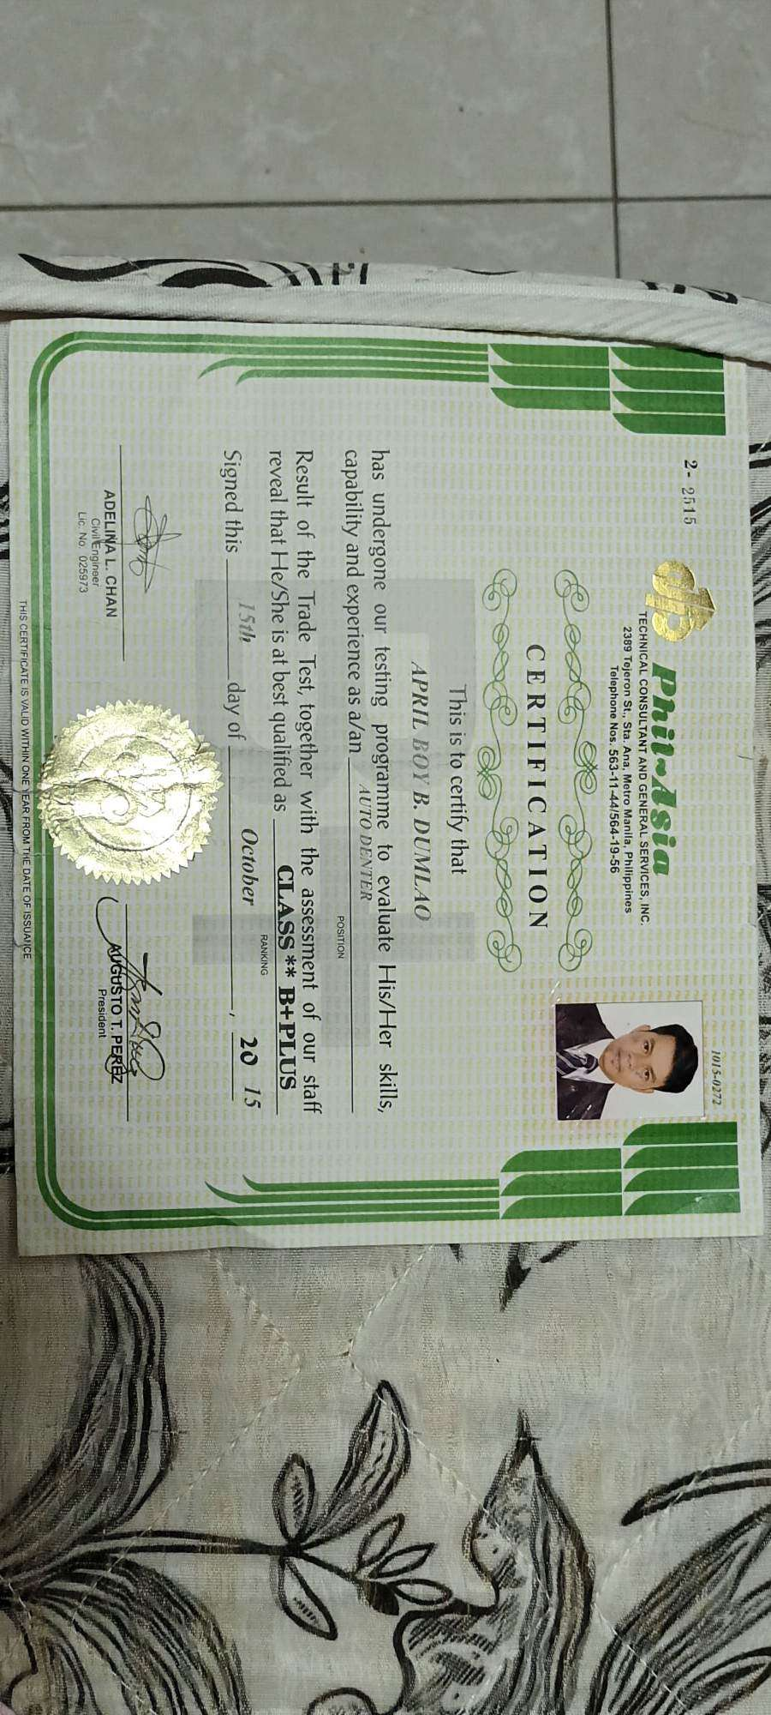

EDUCATIONAL BACKGROUND

Inclusive Date: Month&Year up to Month&Year
Course:
College School:
Location:

Inclusive Date: June 1998 to 2002
High School: Bartolome Sangalang National High School
Location: Barawid Street, St. John, Guimba, Nueva Ecija, Philippines

Inclusive Date: June 1992 to April 1998
Elementary School: Sta. Veronica Elementary School
Location: Sta. Veronica, Guimba, Nueva Ecija, Philippines

PERSONAL DATA
Date of Birth : April 7, 1985
Place of Birth : Guimba, Nueva Ecija, Philippines
Citizenship : Filipino
Height : 150 cm
Weight : 54 kg
Marital Status : Married
Religion : Catholic
Languages Spoken : Tagalog, English
Passport Number : P5917347B
Expiry Date : December 9, 2030

Driver’s License (Ph, Int’l etc) :
TIN (Tax Identification No.) : 621-764-134-000
PEOS Certificate No. : Poea-peos-0000395651-ps

