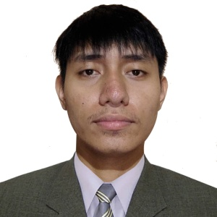
ANDRE C. FORMENTERA
Email : formenteraandrec@gmail.com
Mobile No. : 09970659430
Address : Prk.3 Cebuley, Gabuyan, Kapalong, Davao Del Norte, Philippines
CAREER OBJECTIVES

“To take up a challenging career and grows with honesty, loyalty, good relationship, and best performance and translate my experience, knowledge, skills, and abilities into value for an organization.”
WORK EXPERIENCE

MEAT CUTTER / DEBONER
BSV Meatshop / Davao Del Norte, Philippines
April 22, 2020 - 2023
- Cutting, grinding and preparing meats for sale.
- Cleaning and maintaining tools and equipment and ensuring displays and signage are accurate and attractive.
- Arrange cuts of meat and place them in an attractive manner in the display case so that customers will wish to purchase them.
- Weigh, label and price a variety of cuts of meat for on-demand selections by customers in an efficient manner that keeps customers satisfied.
- Receive deliveries of meat and inspect them to ensure that they adhere to the highest quality standards and are not expired.
- Prepare meat into forms ready for cooking using a variety of actions, including boning, tying, grinding, cutting and trimming to make it easier for customers.
- Rotate products to reduce the chance of any meat spoiling to reduce waste and loss of profits.
- Maintain and clean the meat preparation counter to reduce the risk of food contamination and adhere to food safety guidelines.
EDUCATION

DOÑA CARMEN SORIANO NATIONAL HIGH SCHOOL
School Year : 2017 - 2018
DOÑA CARMEL SORIANO ELEMENTARY SCHOOL
School Year : 2006 - 2012
TRAININGS

DRAGON RECIPE INC
Luna St. Zone Iii, Digos City, Davao Del Sur
December 2, 2023 - January 10, 2024
SKILLS

- Knowledge of animal anatomy
- Knowledge of meat cutting and techniques
- Ability to use knives and other cutting tools
- Knowledge of food hygiene and safety requirements
- Precision and physical strength
- Ability to lift heavy equipment
- Knowledge in food processing and safety
- Ability to stand for extended period of time
- Knowledge of following instructions and learn new techniques
PERSONAL INFORMATION

Birthdate : April 17, 2000
Age : 23
Status : Single
Gender : Male
Citizenship : Filipino
Weight : 65kgs
Height : 5’7”
Language : Filipino & English

