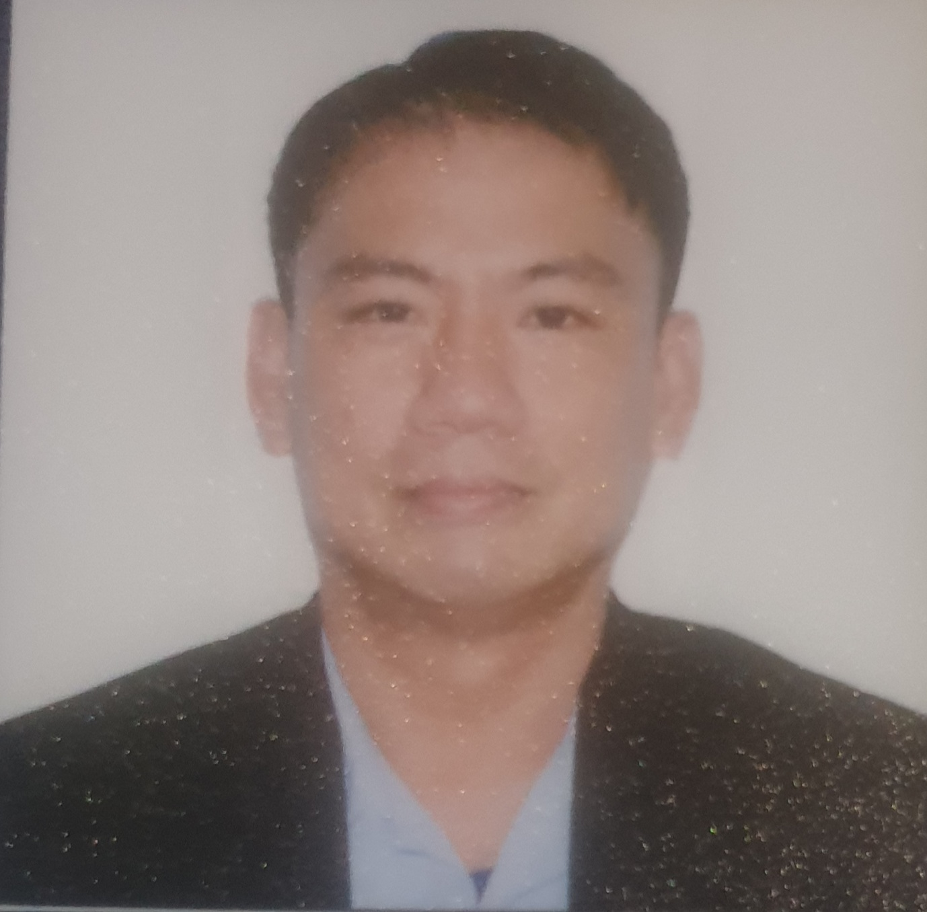
ARWIN DELAROSA ESTEBAN
#272 Lt. Col. Novero St. Caridad, Cavite City 4100
Contact # 09175231210 / #09996170369 / (046) 431-4231
E-mail address: winban4770@gmail.com
Position Applied: Metal Fabricator, Welder, Ductman,
Driver and Forklift Operator
Objective: To be able to make a positive and significant contribution to the Company’s
interest by being dedicated and trustworthy to the task assigned.

Personal Data:
Date of Birth / Age : April 7, 1970 / 52 yrs old
Place of birth : Cavite City
Gender / Citizenship : Male / Filipino
Religion : Roman Catholic
Height : 170cms.
Weight : 73kgs
Languages / Dialects : Filipino, English, Mandarin, Spanish & Korean
Passport Number : P9638643A
Expiration Date : Nov 20, 2028

Educational Backgrounds:
Cavite City Technical and Vocational School (2002, 2004, 2005)

Philippine School of Business Administration (1987-1989)
Bachelor of Science in Business Administration
Sampaloc, Metro Manila

Cavite National High School (1983-1987)
Cavite City

Work Experiences:
Equipment Operator
1Aviation
Ninoy Aquino International Airport Terminal III, Pasay City
February 21, 2022 – Present
- Driving and Operating Technical Equipment
- Responsible for Loading and Unloading Activities Safely
- Follow Safety Rules All the Time
- Checking Ground Support Equipment Before & After Use
- Follow the Instruction of the Supervisor
- Inform the Supervisor of any Problems
- Provide Assistance for Pushback / Tow Operation
- Providing Assistance in the Technical Worksheet

Ductman / Company Driver / Aircon Staff / Welder
Kyomon Engineering Services
Bacoor City, Cavite
February 22, 2020 – March 10, 2021
- Read & Interpret Engineering Blueprints or Sketches in Fabricating Equipment & Other Articles to decide where Ducts will go and their sizes
- Layout, Fabricate, Assemble, Install, and Repair Sheet Metal Products, such as Air Ducts, Drain Pans, & Control Boxes
- Safely transporting company staff as well as various products and materials to & from specified locations in a timely manner
- Assisting with the loading Performing Emergency & Repairs promptly & Efficiency
- Keeping daily logs & records of all maintenance functions.
- ng and offloading of staff products & materials.
- Ensuring that the company vehicle is always parked in areas that the permit parking in order to avoid towing.
- Keeping the company vehicle clean & properly maintained by performing regular washing, cleaning & vehicle maintenance.
- Reporting any accidents, injuries and vehicle damage to the management.
- Cleaning, Adjusting, and Repairing systems & performing warranty services

Duct Fabricator / Duct Fitter
Industrial Controls Corporation
Okada Manila, Parañaque City
June 22, 2016 – December 28,2019
- Read & Interpret Blueprints or Sketches in Fabricating Equipment & Other
Articles to decide where Ducts will go and their sizes.
- Layout, Fabricate, Assemble, Install, and Repair Sheet Metal Products, such as
Air Ducts, Drain Pans, & Control Boxes.
- Operating Fabricating Machines to Shears, Presses, Forming Rolls to Bend,
Block and form or Straighten Sheet Metals
- Use Scribers, Dividers, and Squares to Mark Dimensions on materials.
- Drill holes, Cuts, and Bend Sheet Metal by Hands or Using Power Tools.
- Applying, Remove and Repair Insulation on Industrial Equipment and Duct Works to Control Noise and Maintain Temperature.
- Cover, Seal, or Finish Insulated Surfaces or Access Holes with Canvass Strips, Sealant, Tapes and Cement.
- Jointing of Metal Products such as Stands, Hangers and other Metal Components.
Metal Fabricator / Welder/ Forklift Operator
NMSI Mobile Ship Repair, Inc. (JUSMAG)
Naval Station Pascual Ledesma, Fort San Felipe, Cavite City
December 15, 2011– May 17, 2016
- Fabricating and Constructing Metal Components
- Measuring and Marking out cutting and bonding lines
- Joins, Assembles & Fits Metal Parts such as Aluminum Steel Pipes, Tubes and Plates
- Cutting Metal Products with the Use of Power Tools, Gas Flames, Electric Arcs
- Maintains Safe Operations by Adhering to Safety Procedures & Regulations
- Set Up Machines at the Beginning of Shift to Ensure Proper Working Order
- Drilling Holes, Cutting Metals with Plasma Cutter or Torches & Power Tolls
- Deliver Metal with a Forklifts
- Read & Interpret Engineering Blueprints or Sketches in Fabricating Equipment and Other Articles
- Impart Supervisors and other workers and Complete Work Reports.
- Reporting any accidents, injuries and vehicle damage to the management.
- Cleaning, Adjusting, and Repairing systems & performing warranty services

Production Welder / Worker / Forklift Operator
Haedong ( Metal ) Guemsok
#560-6 Gajwa-dong, Seogu, Incheon, South Korea
June 14, 2007 – September 30, 2011
- Joins, Assembles, Fits Metal parts such as Stainless Steel Pipes, Tubes & Plates
- Being-in-Charge in Preparing and Setting up Necessary Tools and equipment for Welding Jobs
- Set Up Machines at the Beginning of Shift to Ensure Proper Working Order
- Perform Testing Procedure, Repetitive Jobs on Machines and Monitoring them Constantly to make Machines Works Properly and Efficient
- Perform Quality Control to Finish Products, Spare Parts and Comparing them w/ samples to Check, Whether the Specifications are Met
- Transport, Loading and Offload of Materials by use of Forklift & Pallet Jacks.

Metal Polisher / General Worker
Gun Joo Koflex
#438-2 Gwijeon-ri, Tongjin-Myeon, Gimpo City, Gyeonggi-do, South Korea
March 20- June 8, 2007
- Grind, Sand and Cut Objects.
- Polish and Grind Materials According to Specifications.
- Mark Cracks and Holes for Repair
- Test Work pieces by Air or Bubble Test for Leaks and Pinholes for Repair.

Baker
Jun Food Service
#7 Masan-ri, Yangcheon-Myeon, Gimpo City, Gyeonggi-do, South Korea
August 2005 – February 2007
- Preparing, Measuring, and mixing of ingredients into dough according to the recipe
- Constantly Check that the Correct Quantities are Produced for each Other
- Constantly Check of Items that are Needed for the Following Days Consumption and Inform the Operation Manager for Smooth Running of the Operation

Welder / Fabricator / Driver
E.P. Salonga Iron Works
#1425 J. Felipe Blvd., Caridad Cavite City
January 20, 2000 – May 21, 2005
- Weld Steel Windows, Steel Gates, Steel Trusses and Other Iron works
- Cutting Metal Products with the Use of Power Tools, Gas Flames and Electric Arcs
- Read & Interpret Blueprints or Sketches in Fabricating Equipment & other Articles.
- Safely transporting company staff as well as various products and materials to & from specified locations in a timely manner

Mig Welder
China Rebar Co. Ltd
#6, Ln 24, Sec.2, Chung-Hwa South Rd. Hsin-Wu Hsiang, Touyuan Hsien,
Taiwan R.O.C
June 1,1995 – May 29, 1998
- Weld & Cut Aluminum and stainless Steel Components using Tig, Mig, Arc Welding Procedures, Plasma Cutter, Gas Flames & Power Tools
- Operates Shearing, Bending, Power Press, Milling and Lathe Machines
- Assembles Components by Examining Connections for Correct Fit
- Read & Interpret Blueprints or Sketches in Fabricating Equipment & Other Articles
- Maintains Safe Operations by Adhering to Safety Procedures & Regulations
- Operates traveling or stationary Overhead Crane to lift, move, and position loads, such as machinery, equipment, products, and solid or bulk materials, using hoisting attachments, such as hook, sling, electromagnet, or bucket:
- Observes load hookup and determines safety of load.
Duct Installer / Fabricator
Al – Zamil Refrigeration Industries
P.O. Box 294, Dhahran Airport 31932, Kingdom of Saudi Arabia
May 26, 1990 – June 5, 1994
- Read & Interpret Blueprints or Sketches in Fabricating Equipment & Other Articles to Decide where Ducts Will Go and Their Sizes.
- Layout, Fabricate, Assemble, Install, and Repair Sheet Metal Products, such as Air Ducts, Drain Pans, & Control Boxes.
- Operating Fabricating Machines to Shears, Presses, Forming Rolls to Bend, Block and form or Straighten Sheet Metals
- Use Scribers, Dividers, and Squares to Mark Dimensions on materials.
- Drill holes, Cuts, and Bend Sheet Metal by Hands or Using Power Tools.
- Applying, Remove and Repair Insulation on Industrial Equipment and Duct Works to Control Noise and Maintain Temperature.
- Cover, Seal, or Finish Insulated Surfaces or Access Holes with Canvass Strips, Sealant, Tapes and Cement.

Welder / Ship Fitter
Philippine Naval Shipyard
Head Quarters Naval Shipyard, Fort San Felipe, Cavite City
June 26, 1989 – March 30, 1990
- Layout & Fabricates Metal Structural Parts, such as Plates, Bulkheads, Frames, & Braces Them in Position within Hull of Ship for Welding.
- Weld & Cut Steels by using Power Tools, Torch and Electric Arcs

Other Skills:
- Machinist
- Computer Literature (Proficient in MS Word, Excel, and Powerpoint)

Seminars / Trainings:
- MS Windows/ MS Office
July 23 – Nov 19, 2002
Cavite City Technical and Vocational School, Cavite City

- Computer Technician
July 23 – Nov 19, 2002
Cavite City Technical and Vocational School, Cavite City
- HTML Web Page Design
July 27 - Nov 24, 2004
Cavite City Technical and Vocational School, Cavite City

- Gas & Diesel Mechanic
April 6 – May 27, 2004
Naval Sea System Command, PN – Fort San felipe, Cavite City

- Machinist
April 8 – May 13, 2005
Naval Sea System Command, PN – Fort San felipe, Cavite City

- Basic Safety Training
March 30 – April 12, 2005
Philippine Nautical Training Institute – Sampaloc, Manila

- Excavator (Backhoe) Driving
November 7 – December 5, 2010
Korea Port Training Institute – Incheon, South Korea

- Forklift Driving
August 7 – September 11, 2011
Korea Port Training Institute – Incheon, South Korea

- Gas Tungsten Arc Welding
April 12 – April 26, 2013
Artdik Pacific Training Institute – Bacoor City, Cavite

Character References:
- Mr. Egildo “Misel” Bacolod
Proprietor
Misel Welding Shop & Contractor / Cavite City

- Mr. Roberto Bernal
Barangay Captain
Barangay 37M Csvite City

