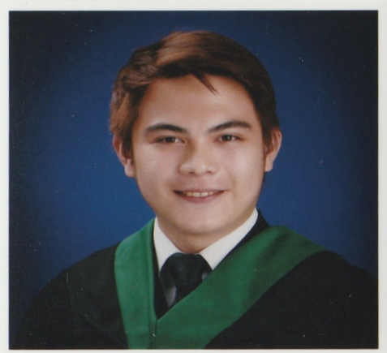

DON AUGUST QUINONES TAPAY
Blk 2 lot 8 Jovan street villa corrina subd. Barangay
Pasong tamo quezon city
09673347979
donaugusttapay080791@gmail.com

OBJECTIVE

A highly skilled and dexterous automotive technician is seeking a career in the corporate sector to provide well-rounded expertise in maintenance service, installation of components, and accessories of vehicles and engines efficiently for the accomplishment of organization goal and duties.

EDUCATIONAL BACKGROUND

TERTIARY
Bachelor of Science, Hotel & Restaurant Management
Colegio de San Lorenzo Quezon City
April 11, 2014

SECONDARY
Quezon City Academy
March 25, 2008

PRIMARY
Saint Anthony Academy of Quezon City
April 1, 2004

RELEVANT SKILLS

- Committed to high standards of food handling and hygiene.
- Ability to foster teamwork and manage conflict resolution.
- Strong ability to work in flexible shifts.
- Good people service skills.
- Reliable, punctual, loyal and hardworking.
- Focused on delivering an exceptional customer/guest experience in a professional matter.

JOB EXPEPIENCE
- Motorcycle and auto motive – zian custom
April 15 2019 – PRESENT
- Skilled mechanic
- Skilled welder
- Skilled fabricator
- Skilled wiring technician

- Casino dealer - Okada Manila
Nov 27 2016- Sept 27 2017
- Developed thorough knowledge of table games and dealt with thousands of hands of: 3 Card Poker, Lunar Poker, Craps and Bacarrat Commission.
- Quickly and accurately calculated customer winnings and kept the table active.
- Cultivated excellent relationship to customers, other dealers and casino employees.
•Casino dealer - resortsworld manila
sept 20 2017 to dec 29 2018

- Bellman/concierge - Bhotel quezon city Feb 15 2016- June 21 2016
  - good customer service
  - knowledge in this work
  - good communication skill

TRAININGS AND SEMINARS ATTENDED

- Housekeeping Procedures, Bed Making and Introduction To Food And Beverage Operations
The Manila Hotel
August 19, 2008

- Foresight Beyond Now, Access to Success, Mileage to Global Competition, Empowerment with Principles
University of Makati
September 12, 2009

- Hired Persona
Colegio de San Lorenzo Quezon City
November 23, 2012

- Successful Completion of the Supervised Work Experience
Puerto Del Sol Bolinao, Pangasinan
February 4-8, 2013

- Table Game Training for Bacarrat Commission, 3 Card Poker, Lunar Poker, Craps,
Money Wheel & Sicbo
Okada Manila
November 27, 2016 to January 21, 2017

AWARDS

- 1st place in Pizza live category during Toques and Checkered, Culinary and Skills 2014 Competition
Colegio de San Lorenzo Quezon City
February 12 2014

PERSONAL BACKGROUND

Height: 5’11
Weight: 185 lbs
Civil status: married
Citizenship: Filipino
Religion: Catholic
Father’s name: Domingo R. Tapay
Occupation: Architect / Contractor
Mother’s name: Edna M. Quinones
Occupation: Housewife

CHARACTER REFERENCE

Ma. Aissa Geen U. De Castro
HR and Admin Manager
DC Equimachines Corporation
0917 8577190

Mary Grace T. Quimson
Executive Assistant to the Resident Manager
The Manila Hotel
0927 958 8195

Victor Harry
PR Manager
Advocate Fashion Inc
0917 726 2512

