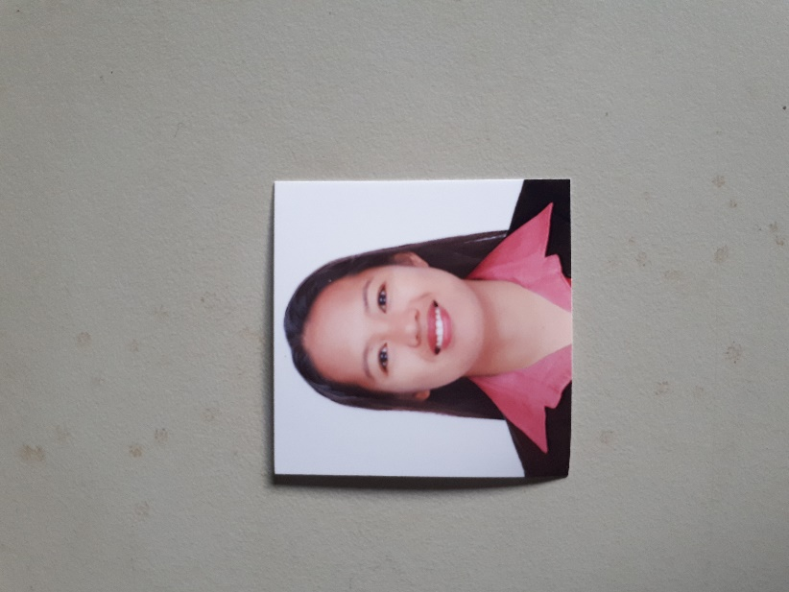
MARY ANN O. DE VERA
Panikian, Naujan, Oriental Mindoro Philippines
Contact No: 09354138244
Email: maryannolla@gmail.com

To be able to highly maximize my skills and sensibly utilize my knowledge by practicing my profession as Animal Technician, thereby optimizing my potential for professional and personal growth.

WORKING EXPERIENCE

THICK & THIN AGRI-PRODUCTS, INC (ATLAS NUTRITION)
Technical Specialist
#148 Bisita, Brgy. Duhat, Bocaue, Bulacan Philippines
June 4, 2019 – up to present

Duties and Responsibilities

- Farm monitoring including data collection and analysis.
- Medication and Vaccination of the herd.
- Daily Inventory of Herd and farm stocks
- Feeding animals
- Weighing and transfer from Nursery to Grow-out Section
- Cleaning pens and surroundings
- Responsible in feeding trials of the hogs inside the farm.
- Responsible for monthly reports and inventory.

VITARICH CORPORATION
Technical Staff
San Jose Rd. Sta Rosa 1, Marilao, Bulacan Philippines
August 7, 2015 – February 3, 2019

Duties and Responsibilities

- Monthly and Daily Inventory of the farm.
- Do the farm records
- Responsible for the calculation of farm feeds and other farm stocks.
- Medication and Vaccination of the pigs.
- Assisting of farrowing sows specially those first time sows.
- Handles the recording upon piglet expulsion to recording.
- Responsible for farrowing activities such as:
- Tooth clipping
- Tail docking
- Castration
- Ear Notching
- Weighing upon Weaning
- Feeding and Feed back
- Assisting in transfer of piglets from Farrowing to Nursery and sows to Breeding.
- Cleaning the emptied farrowing crates and pens after weaning.
- Handles farm trials including feeding and medication trials for hogs.

SUNJIN GENETICS CORP.
Farrowing Staff
Brgy. San Jose, Antipolo City, Rizal Philippines
May 1, 2014 – July 25, 2015

Duties and Responsibilities

- Transfer of Sows from Breeding to Farrowing vice versa.
- Assisting farrowing sows specially the gilts.
- Responsible in activities on the farrowing specially the first 7 days of piglets namely:
  - Tooth clipping
  - Tail docking
  - Ear notching
  - Tattooing
  - Fostering
  - Castration
  - Recording of newly born piglets
- Medication and Vaccination (Sows and Piglets)
- Feeding and Feed back
- Weaning and weighing of piglets
- Daily inventory of building handled.

EDUCATION:

Tertiary:
Bulacan Agricultural State College
Bachelor of Animal Science
San Ildefonso, Bulacan
2009 – 2013
Secondary:
Pedro V. Panaligan Memorial National High School
Comunal Calapan City, Philippines
2002 - 2006

Personal Background:
Born on March 7, 1989 in Oriental Mindoro, Philippines
159 cm tall and 57 kg in weight
Married to Mr. Melfren De Vera and a mother to Khalia Ameline and Mary Adeline
Fluent in English and Filipino
Knowledge in Swine and Research
Interest; movies and fictional books

Qualification:
With good communication skills
Open minded and have the initiative
Responsible and mature
Reliable and with good experience on swine farming

Character References:

Mary Ann V. Rabina
Former Secretary (Sunjin Genetics)
+1 (204)361-5565
maryann042092@gmail.com

Miriam Manuel
Manager Vitarich Corporation
San Ildefonso
09774673699

I hereby certify that the above information are true and correct to the best of my knowledge and belief.
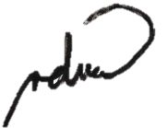

MARY ANN O. DE VERA
Applicant

