RANDHEL PASCUAL | 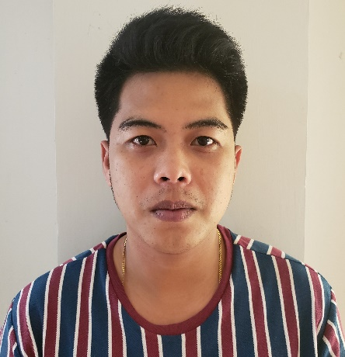
maddalero buguey cagayan
09086850076 ▪ randhelpas@gmail.com ▪

Objectives
To perform quality service with skill and knowledge and to learn more, willing to be trained as well.

Experience

- Construction – 2021-2022 REBCOR COMPANY
- OJT MECHANIC – MOTECH TUGUEGARAO CITY

Skills
- DRIVING
- WELDER
- MECHANIC
- COMPUTER LITERATE

Education

UNIVERSITY OF CAGAYAN VALLEY
▪ BACHELOR OF SCIENCE INDUSTRIAL TECHNOLOGY MAJOR IN AUTOMOTIVE
- ACCOMPLISH On the Job Training at SAINT FRANCIS AUTO PARTS & CAR CARE CENTER
(MOTECH TUGUEGARAO)

References
Rene Nolasco Pattung
(Shell buntun mechanic)
09750122759

Albert Bacud Castillo
(Motech mechanic)

