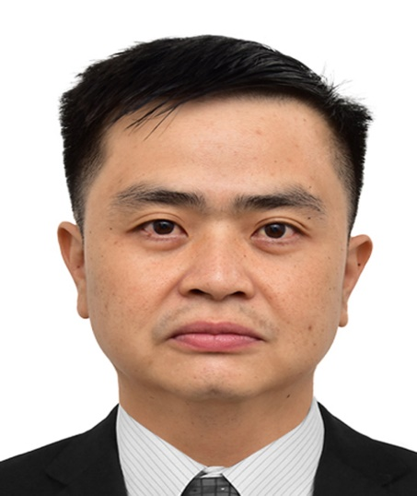
DAVE NERI MAASIN

Email address : dvmaasin978@gmail.com
Contact number : +639993959384
Skype ID : Dave Maasin

Viber : Dave Neri Maasin
09993959384

Whatsapp : Dave Maasin
+639993959384
Present Address : 43 Longines Street, Saint Charbel,
Tandang Sora, Quezon City. 1116

Basic Information:

Age : 43 y/o
Birthdate : September 12, 1980
Birthplace : Camp Phillips, Bukidnon
Religion : Roman Catholic
Nationality : Filipino
Height : 153 cm
Weight : 68 kg
Language Spoken : Filipino, English, Arabic

Personal Qualifications:

Philippine Licensure Examination for Nurses - Registration # 0353086

Educational Attainment:

College - Liceo de Cagayan University
Cagayan de Oro City

Course - Bachelor of Science in Nursing
March 20th of 2003

Career Reviews:

March 2004 - August 2007  (3 Years, 5 Months) | ER STAFF NURSE  MARIA REYNA HOSPITAL  CAGAYAN DE ORO CITY  - Monitored and documented data relating to patient’s care including assessment results, interventions, medications, patient responses and progress of treatments  - Assessed the condition of patients, ordering and evaluating diagnostic tests as needed  - Collaborated with other healthcare professionals and nursing staff to plan, manage, and assess patient treatments  - Discussed illnesses and treatments with patients and family members  - Provide direct quality care to patients and administered various medical procedures  - Transporting patients to referral hospitals.  - Assisting Doctors in Minor OR cases  - Providing ACLS/BLS care to patient

October 2007 - October 2019  (12 Years, 4 Weeks) | ACTING HEAD NURSE / CHARGE NURSE  FAMILY AND COMMUNITY MEDICINE  ARMED FORCES HOSPITALS SOUTHERN REGION  KHAMIS MUSHAYT, KSA  - Covering the care of FCM Patients.  - Follow and act in accordance with all HWD and PPG’s.  - Manage time effectively for the unit’s improvement.  - Exercise and demonstrate effective management skills.  - Recognize the units needs and voluntary initiate  appropriate actions.  - Use equipment and supplies in accost effective and  responsible manner.  - Responsible in new staff orientation.  - Maintain a hazard free and clean environment.  - Establish the goal and objectives of the unit.  - Provide departmental statistics as required.  - Participates in CQI and PS activities in the department.  - Assist in the nursing care standard and practice and  supports the head nurse and unit staff in implementation.  - Responsible for keeping updated studies course  development.  - Manages and Responsible for administering duties under the  supervision of the head nurse and nurse manager.  - Demonstrate abilities in the supervision and teamwork.
TRAININGS AND SEMINARS ATTENDED at AFHSR, Khamis Mushayt

Basic Life Support 19/08/2020
Advance Cardiac Life Support 17/09/2014
CQI and PS 16/04/2020
Drug Calculation 15/05/2020
Blood Transfusion 11/05/2020
Fire and Safety 15/04/2020
Infection Control 24/06/2020
Wound Management 17/06/2020
Lifting and Handling 15/05/2020
Disaster Preparedness 16/04/2020
Human Resource Orientation 16/04/2020
Annual Nursing Orientation 16/04/2020
Tracheotomy Care 08/08/2018
Oxygen Therapy 16/08/2018

March 2020 – June 2021  (1 Year & 3 Months) | CARE ASSOCIATE / CASE MANAGEMENT ANALYST  HINDUJA GLOBAL SOLUTION  Call Center / IT-Enabled Services / BPO  E-Commerce Plaza 1 Garden Road, Eastwood City Cyber Park, Bagumbayan, 1110 Quezon City, Philippine  - Handles enrollments for pregnant clients in Healthy Pregnancy Healthy Babies Program.  - Doing Follow up calls for maternity Assessment for enrolled members/ clients.  - Do patients/ clients assessments through phone interviews.  - Navigating members’ files/ cases for Case management program for complex and oncology members/ clients.  - Assisting clinical trials and authorization approvals for evicore.

October 2021 - PRESENT | FREELANCE NURSE VACCINATOR  RELIANCE UNITED  Williams St., cor. Mayflower St., Greenfield District  Mandaluyong City

November 2021 – PRESENT | FREELANCE NURSE VACCINATOR/NURSE SWABBER  PQHEALTHSHIELD INC.  Economia Road, Bagumbayan, Quezon City

April 25 2022- September 27, 2022 FIXED TERM STAFF NURSE
MAKATI MEDICAL CENTER
CPM, General Nursing 1
(Intensive Care Unit / Male/Female Medical Ward)
2 Amorsolo St. Legaspi Village, Makati City.

June 1, 2022- PRESENT HOME HEALTH CARE PLACEMENT, INC
STOLT NIELSEN
COMPANY NURSE
The Podium West Tower, 14th floor ADB Ave. Ortigas Center,
Metro Manila- Mandaluyong City, Wack-Wack Greenhills

Character References:

Mrs. SAVITHREE DEVI RAMSUNDER
NURSE MANAGER
Family and Community Medicine Center
Armed Forces Hospital Southern Region
PO Box 101 Khamis Mushayt, KSA
Contact # 0532863426
savithreeramsunder@yahoo.com

Dr. Captain MOHAMMAD YAHYA ASIRI
ABHA CENTER DIRECTOR
Family and Community Medicine Center
Armed Forces Hospital Southern Region
PO Box 101 Khamis Mushayt, KSA

Ms. Veronica Durias
Stolt Nielsen
Operations Manager
The Podium West Tower,
14th floor ADB Ave. Ortigas Center,
Metro Manila- Mandaluyong City,
Wack-Wack Greenhills

