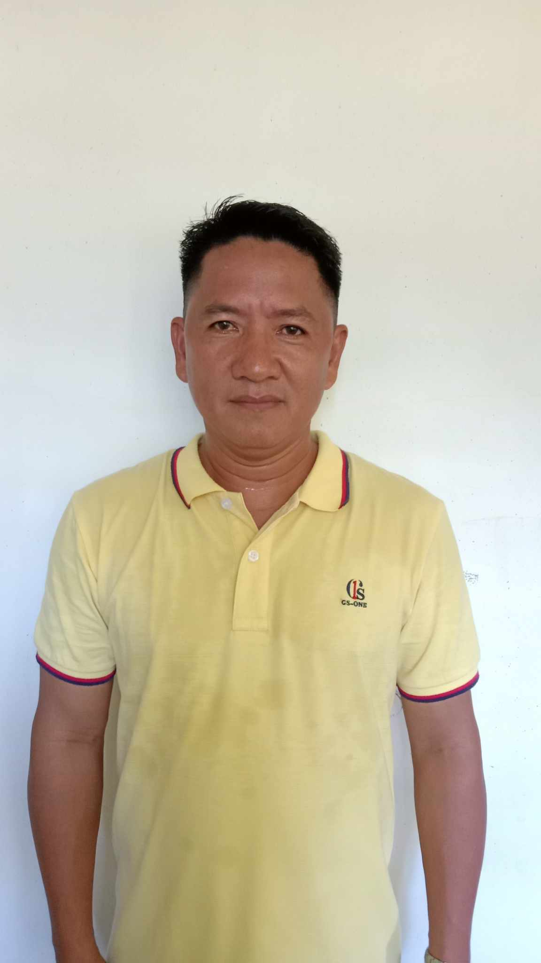

FRANCIS N. SALUDEZ
Brgy. Paleg, Dinalungan, Aurora
Whats app: 0948-471-0794
Email Address: francissaludez9479@gmail.com

OBJECTIVES:
To obtain a job within my chosen field wherein I can able to use my education, skills and experiences in a way that I and my employer are both benefited for future growth and advancement.

ACADEMIC BACKGROUND:

Graduate: Bachelor of Science in Agriculture
Major in Crop Science
Central Luzon State University (CLSU)
Science City of Muñoz 3119, Nueva Ecija, Philippines
April 15, 2003

SKILLS:

- Able to Operate Small Farm Tractors (45 hp and 90 hp)
- Able to Drive Light Vehicles
- Able to Perform Simple Computer Works

ELIGIBILITY:

Licensure Examination for Agriculturist (LEA)
Professional Regulation Commission
License Agriculturists - Registration No. 0001308
August 2, 2004

WORK EXPERIENCES:

Agricultural Technologist
Local Government Unit – Dinalungan, Aurora
Poblacion Zone II, Dinalungan, Aurora, Philippines
December 16, 2012 - Present

Sales Representative
Bulk Handlers Incorporated
Mabini, Batangas, Philippines
May 15, 2012 – November 30, 2012

Rice Sufficiency Officer
Philippine Rice Research Institute, Maligaya,
Science City of Muñoz, 3119 Nueva Ecija, Philippines
April 2010- October 2011

Agricultural Trainee
Young Filipino Farmers Training Program In Japan (YFFTPJ)
International Agriculture Exchange Association (IAEA) – National Agriculture and Fishery Council (NAFC)
Kashiai, Fukaya-Shi, Saitama Prefecture-Japan
March 2006- March 2007

TRAINING/SEMINARS ATTENDED:

Training Course on PalayCheck System for Rice R&D Provincial and Municipal Implementers
Department of Agriculture-Regional Field Office III, City of San Fernando, Pampanga
El Cielito Hotel, Baguio City
March 28-31, 2023

Farm Business School
Department of Agrarian Reform – Aurora Provincial Office
Brgy. Paleg, Dinalungan, Aurora
March 16, 2022 - June 15, 2022

Training on Aquaponics Technology
Provincial Government of Aurora
Poblacion Zone II, Dinalungan, Aurora
December 14, 2021

Training-Workshop on Farm Machinery Operation, Management and Enterprise Development
Philippine Center for Postharvest Development and Mechanization - Science City of Muñoz, 3119 Nueva Ecija
Azbahaen Leisure Farm and Resort, Brgy. Reserva, Baler, Aurora
October 21-22, 2021

Training for Work Scholarship Program-Driving NC II
Technical Education and Skills Development Authority – Provincial Training Center, Baler, Aurora
Burgos Extension, Brgy. 5, Baler, Aurora
December 11-29, 2020

Rice Pest Management Training for Agricultural Extension Workers of Region III
Regional Crop Protection Center, PhilRice Compound, Maligaya, Science City of Munoz,
3119 Nueva Ecija
September 26-28, 2017

Training and Assessment for Organic Agriculture Production (National Certificate II)
Agricultural Training Institute-Regional Training Center III, San Ramon, Dinalupihan, Bataan
Costales Farms, Majayjay, Laguna
March 20-24, 2017

Training on Grow-out Culture of Tilapia
Provincial Government of Aurora-Aurora Provincial Fisheries and Aquatic Resources Office
Poblacion Zone II, Dinalungan, Aurora
September 15,2016

Rodent Management Specialist Training Course and Socio-Economic Analysis of Different Control Methods in Region III
Regional Crop Protection Center, PhilRice Compound, Maligaya, Science City of Munoz,
3119 Nueva Ecija
Brgy. Sabang, Baler, Aurora
April 4- 8, 2016

Training on Good Agricultural Practices (GAP) for Rice
Department of Agriculture-Regional Field Ofice III, City of San Fernando, Pampanga
Amco Beach Resort, Brgy. Sabang, Baler, Aurora
November 20, 2015

Provincial Agriculture Climate Risk Assessment and Planning Workshop
Save the Children International
Carlito’s Inn and Restaurant, Brgy. Suklayin, Baler, Aurora
November 18-20, 2014

Small Grants Initiative Project Proposal Development Training and Writeshop
Australian Aid & Save the Children International
Carlito’s Inn and Restaurant, Brgy. Suklayin, Baler, Aurora
July 23-25, 2014

Coconut Based Multi-storey Cropping System
Agricultural Training Institute-Regional Training Center III, San Ramon, Dinalupihan, Bataan
L-Caji Resto Garden, Maria Aurora, Aurora
June 17-19, 2014

Climate Risk Assessment Facilitators Training
Australian Aid & Save the Children International
Carlito’s Inn and Restaurant, Brgy. Suklayin, Baler, Aurora
October 15-17, 2013

Training Course on Upland Rice-Based Farming System
Agricultural Training Institute-Regional Training Center III, San Ramon, Dinalupihan, Bataan
Philrice, Maligaya, Science City of Munoz, 3119 Nueva Ecija
June 18-20, 2013

Training on Audit Management
Provincial Government of Aurora-Provincial Cooperative Office
Aurora Cooperative Training Center, So. Setan, Brgy. Calabuanan, Baler, Aurora
August 1-2, 2012

Training on Internal Control cum Inventory System
Provincial Government of Aurora-Provincial Cooperative Office
Aurora Cooperative Training Center, So. Setan, Brgy. Calabuanan, Baler, Aurora
August 3, 2012

Training of Trainers (TOT) on Organic Vegetable Production
Agricultural Training Institute-Regional Training Center III, San Ramon, Dinalupihan, Bataan
ATI-RTC III Satellite Center, Sto. Niño, Magalang, Pampanga
July 11-27, 2012

Provincial Training of Trainers (TOT) on Organic Agriculture for Agricultural Extension Workers
Agricultural Training Institute-Regional Training Center III, San Ramon, Dinalupihan, Bataan
Azbahaen Leisure Farm and Resort, Brgy. Reserva, Baler, Aurora
January 9-13, 2012

Training of Trainors (TOT) on Small Scale Irrigation System (SSIS) and Dry Season Crop Production
Department of Agriculture – Food and Agriculture Organization – European Community
PhilRice Social Hall, CES, Maligaya, Science City of Muñoz, 3119 Nueva Ecija
September 20-October 1, 2010

Rice Specialist Training Course (RSTC) on the PalayCheck and Palayamanan Systems
Central Experiment Station, Maligaya, Science City of Munoz, 3119 Nueva Ecija
December 1, 2009 – April 29, 2010

Workshop on Research Methodologies
Central Experiment Station, Maligaya, Science City of Munoz, 3119 Nueva Ecija
April 5-9, 2010

Farmers’ Field School on PalayCheck System
Central Experiment Station, Maligaya, Science City of Munoz, 3119 Nueva Ecija
Brgy. Nipoo, Dinalungan, Aurora
December 2008- April 2009

Young Filipino Farmers Training Program In Japan (YFFTPJ)
International Agriculture Exchange Association (IAEA) – National Agriculture and Fishery Council (NAFC)
Kashiai, Fukaya-Shi, Saitama Prefecture
March 2006- March 2007
Pre-departure Orientation Course
Young Filipino Farmers Training Program In Japan (YFFTPJ)
Department of Agriculture – Eliptical Road, Diliman, Quezon City
February 25- March 10, 2006

Farmers Field School for Rice under Kasaganaan ng Sakahan at Kalikasan (KASAKALIKASAN) the Natonal Integrated Pest Management (IPM) Program
Provincial Government of Aurora- Municipal Government of Dinalungan
Brgy. Dibaraybay, Dinalungan, Aurora
November 21, 2003- April 2, 2004

Trainor’s Training on Corn Production
Aurora Provincial Agricultural Development Center, Brgy. Reserva, Baler, Aurora
January 26-27, 2004

PERSONAL DATA_____________________________________________________

Age : 43
Sex : Male
Citizenship : Filipino
Civil Status : Single
Height : 5’4
Weight : 67 kgs.
Birthday : September 4, 1979
Birthplace : Brgy. Bagtu, Maria Aurora, Aurora- Philippines
Language : Tagalog, Ilocano, English

REFERENCES:

MANUEL A. TORRES
Municipal Mayor
Local Government Unit-Dinalungan, Aurora-Philippines
CP# 0920-969-4415

ARNOLD B. NOVICIO
Provincial Agriculturist
Provincial Government of Aurora, Baler, Aurora- Philippines
CP# 0939-1769-2881

ROGELIO G. BUCASAS
Acting Municipal Agriculturist
Local Government Unit-Dinalungan, Aurora-Philippines
CP# 0917-137-4253

