Trixie C. Carse
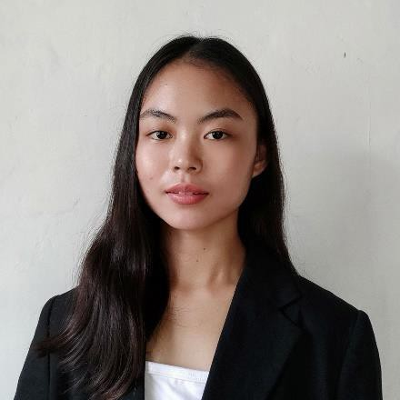82 General Luna Street, Brgy. III, Laur, Nueva Ecija trixiecarse1028@gmail.com
0905-750-7092

CAREER OBJECTIVE

To be able to work in a company where I can put my skill to effective use and prove myself and
others that I am capable of doing this job while still learning and growing with the company. In return, I
promise my commitment to be a valuable asset to your company for the period of my learning.

PERSONAL DETAILS

Age: 23 Language Spoken: English and Filipino
Date of Birth: February 6, 2001 Name of Father: Jayson M. Carse Place of Birth: Laur, Nueva Ecija Name of Mother: Marissa C. Carse Religion: Roman Catholic
Height: 5’3ft
Weight: 47kg
Civil Status: Single

EDUCATIONAL BACKGROUND

Tertiary School: Nueva Ecija University of Science and Technology
Bachelor of Secondary Education major in English (2019-2023)

Senior High School: PHINMA- Araullo University
Accountancy, Business and Management (2017-2019)

Junior High School: Saint Stephen Academy, Inc. (2013-2017)

Elementary School: Laur West Elementary School (2007 – 2013)

SKILLS

• English – Business Level Speaking, Reading and Writing
• Proficient in Microsoft Excel – Excel Scripting and Automations
• Proficient in Microsoft PowerPoint – Presentation Designing
• Working in Knowledge in Google Docs – Forms, Sheets, Slides, Docs, Classrooms, and Drive

WORK EXPERIENCE

TEACHING INTERNSHIP

School: NEUST- College of Education
Sumacab Este, Cabanatuan City, Nueva Ecija
August 2023-September 2023

School: San Josef National High School
Purok 1, San Josef Sur, Cabanatuan City, Nueva Ecija
October 2023-December 2023

ACADEMIC ACHIEVEMENT

Tertiary School: Nueva Ecija University of Science and Technology
Bachelor of Secondary Education major in English (2019-2023)
Honor Student 2nd Semester A.Y. 2021-2022
Outstanding Final Demonstration

Senior High School: PHINMA- Araullo University
Accountancy, Business and Management (2017-2019)
Grade 11: With Honor
Grade 12: With Honor

Junior High School: Saint Stephen Academy, Inc. (2013-2017)
Consistent Star Section
With Honor (2013-2014)
With Honor (Grade 10, 1st Quarter 2016)

Elementary School: Laur West Elementary School (2007 – 2013)
Grade 1-6: Consistent Honor Student

AFFILIATION AND LEADERSHIP BACKGROUND

2009-2013: Drum and Lyre Participant
2016-2017: Saint Stephen Academy, Inc.
Student Body Organization (SBO) - Public Information Officer
2016-2017: Leadership Awardee
2015-2016: Saint Stephen the King Parish
Youth and Campus Choir – Public Information Officer
2016-2017: Saint Stephen the King Parish
Youth and Campus Choir – President
2018-2019: PHINMA- Araullo University
Supreme Student Government (SHS) – Public Information Officer
2019-2022: Parish Youth Council Officer
2020-2022: Saint Stephen the King Parish - Media Ministry Coordinator (Founder)
2022-Present: Saint Stephen the King Parish - Music Ministry Assistant Coordinator
2019-2021: NEUST Chorale – Public Information Officer
2021-2022: NEUST Chorale – Section Leader
2022-2023: NEUST Chorale – Internal Vice President
2023: NEUST Chorale – Helping Hand Awardee
2023: NEUST Chorale – Assistant Technical Director
2023: NEUST Chorale – Leadership Awardee
2023: NEUST Chorale – Public Information Officer
2023-Present: Sangguniang Kabataan Councilor

EVENTS AND PROJECTS

2019: PHINMA-Araullo SHS. – Film Crew in Muni-Muni (Short film)
2022: PPCRV Volunteer (National Election)
2022: Panunumpa sa Katungkulan – Event Performer
2022: Himig ng Pag-ibig Performer
2022: NEUST Accredetation Program Performer
2022: Wowowin Christmas Chorale-lolling Grand Finalists
2023: SCUFAR III Sports and Cultural Festival Performer
2023: NEUST Cultural Show Performer
2023: Chorale Performer Featured in PTV4 & NCAA
2023: Pagbibigay Pugay sa mga haligi ng Pamantasan Performer
2023: Blessing and Inauguration of Peace Maker Performer
2023: Youth Leadership Summit spearheaded by PH LED Performer
2023: Saint Stephen the King Parish 85th Anniversary – Program Assistant Director & Festival ID Director
2023: Saint Stephen the King Parish Retro-Christmas Party– Program Director

TRAINING AND SEMINAR ATTENDED

2017: College of Immaculate Conception
Concurrent Session HIV/AIDS/Human Sexuality
2021: University of the Philippines Cebu
Integration of Social Media in the Teaching of Literature
2022: Cabanatuan Cathedral
Diocesan Youth Leader’s Formation
2023: Maria Assumpta Seminary, Cabanatuan City
Diocesan Seminar on Principles of Liturgy,
Guidelines on Liturgical Music and Spirituality of Liturgical Music Ministers
2024: The New Saint Nicholas of Tolentine Cathedral, Cabanatuan City
Liturhiya at Musika: The Diocesan Liturgical Music Formation Series No. 2

NEUST COLLEGE OF EDUCATION

2020: Turning Stress and Anxiety into Strength
2021: Positive Classroom Culture
2021: Negative School Culture
2021: Educational Leadership
2022: Student-Teacher Relationship: Setting Boundaries to Spread Peace

REFERENCES

Benjamin Torres
Adviser, NEUST Chorale
0975-323-3744

Zandrea Amor Cruz
Adviser, PHINMA – Araullo University
0997-275-5927

John Aivin Balquedra
Mathematics Teacher, NEUST College of Education
0945-881-5306

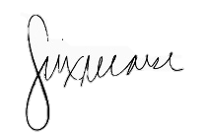
I hereby certify that the above information is true and correct according to my knowledge and belief.
TRIXIE C. CARSE
Applicant

