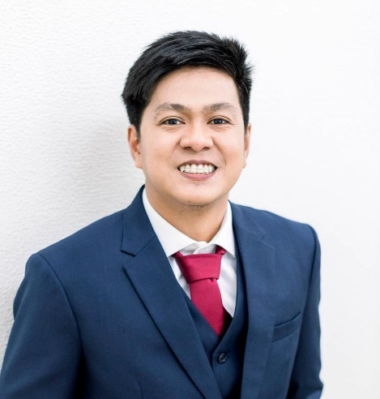
CARL FRANCYS P. MODELO, ME
Blk 1 Lot 77 Raymunda St. Millwoodville Subd. Brgy. Pulo, Cabuyao City, Laguna 4025 | (+63) 9127653877 | carl.francys@yahoo.com

Career Objective

Detail – oriented Mechanical Engineer with experience in design, manpower supervision, ocular site inspection, preventive and corrective machine maintenance, and machine troubleshooting. Operates, understands, and makes any needed adjustments to all blown film systems. Seeking to leverage my expertise as a Mechanical Engineer in your company.

Professional Profile

- Licensed Mechanical Engineer with experience as an Equipment Engineer, Production Engineer, and Project Engineer
- Knowledgeable in Material Costing
- Excellent analytical and problem-solving skills
- Excellent verbal and technical report writing skills
- Inspect equipment failures to diagnose faulty operation and recommend solutions
- Manage projects using engineering principles and techniques
- Proficiently operate and troubleshoot blown film machines and processes

Work Experience

PRODUCTION ENGINEER (BLOWN FILM TECHNICIAN)

San Miguel Yamamura Packaging Corporation – Rightpak Plant

Canlubang Industrial Estate, Calamba City, Laguna 4027

June 2021 – Present

Responsible for monitoring all extrusion functions to ensure that the line is running within required operating conditions.

Initiate timely line adjustments to correct quality issues, in accordance with operating procedures and/or troubleshooting manuals.

Ensures correct resin and additives formulations in accordance with the standard operating procedures.

Initiate maintenance work orders on machine parts that need to be addressed on future outages.

Ensures that production daily reports are complete and accurate to maintain trace ability.

Able to perform quality tests using test equipment and have a mechanical aptitude to solve inline issues.

PROJECT ENGINEER

Mayo Holdings and Constructions, Inc.

94 Milagrosa, Calamba City, Laguna 4027

October 2019 – May 2021

Performs ocular chilled water plumbing, sanitary and waterline plumbing, kitchen exhaust and air conditioner ducting installation inspections requested by some of our well-known mall clients in the Philippines.

Prepares project proposals by formulating project parameters and ensures precise material costing.

Ensures that the right materials are purchased and used in every project and ensuring compliance to safety regulations.

Provides direct planning for engineering activities which includes mechanical operations and engineering project management.

Directly report to project engineering manager for more efficient project methods and to maintain the profitability of the project.

Establishes plumbing leak testing methods to monitor the quality of the installation.

EQUIPMENT ENGINEER

Shin-Etsu Magnetics Philippines, Inc.

125 East Main Ave., Laguna Technopark SEPZ, Binan, Laguna

November 2018 – October 2019

Manages plan, controls, and organizes the planned preventive and corrective mechanical maintenance on machines and equipment in order to maximize their lifespan and ensure safety.

Conducts mechanical and electrical troubleshooting for defective production hydraulic and pneumatic machineries.

Assists the company contractors for the installations and relocation of hydraulic and pneumatic machines.

Assists Japanese Engineers for machines set-ups and installations.

Evaluates and recommends equipment improvements to improve availability, capacity, and performance.

Prepares technical reports to document equipment modifications and equipment maintenance procedures.

Technical Skills

Microsoft Office (MS Word, MS Excel, and MS Power Point) and AutoCAD design software

Knowledgeable in Machine Shop Machineries Operation (Lathe Machine, Power Grinder, Milling Machine, and Basic Hand Tools)

Project Management

Engineering

Education

MAPUA MALAYAN COLLEGES LAGUNA
Bachelor of Science in Mechanical Engineering (BSME)
Graduated on June 2018

