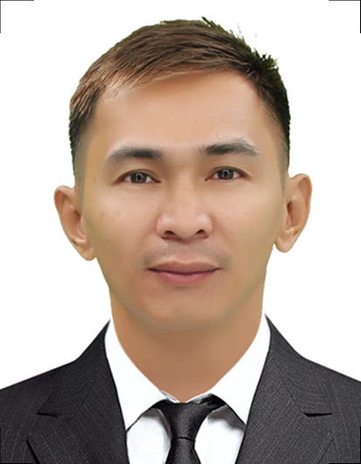
ROVIE G. QUITO
San Isidro, San Simon, Pampanga
Philippines, 2015
Mobile No.: 0965-190-7444
Email Add: roviequito@gmail.com

PERSONAL INFORMATION

Permanent Address : San Isidro, San Simon, Pampanga Philippines, 2015
Birthdate : November 17, 1987
Birth Place : San Simon, Pampanga
Height : 5’7 ft.
Weight : 130 lbs.
Sex : Male
Civil Status : Married
Religion : Roman Catholic
Nationality : Filipino

BENEFICIARY

Beneficiary Name : Marjorie T. Gamboa
Relationship : Leave in Partner
Permanent Address : San Isidro, San Simon, Pampanga Philippines, 2015
Tel. No. : 0936-797-9589

DEPENDENTS:

Father: Quito, Ronaldo Carlos Birthday: July 23, 1965
Birth Place: San Simon, Pampanga
Occupation: Carpenter

Mother: Guevarra, Vitaliana Tolentino Birthday: January 26, 1964
Birth Place: Masantol, Pampanga
Occupation: Housewife

BROTHERS / SISTERS

Brother: Quito, Ronaldo Guevarra Jr. Birthday: April 18, 1990
Birth Place: San Simon, Pampanga
Civil Status: Single
Occupation: Slaughter
Brother: Quito, John Paul Guevarra Birthday: March 30, 1995
Birth Place: San Simon, Pampanga
Civil Status: Single
Occupation: Operator

Brother: Quito, Patrick Guevarra Birthday: January 30, 2001
Birth Place: San Simon, Pampanga
Civil Status: Single
Occupation: Student

Sister: Dimacali, Michelle Quito Birthday: March 6, 1986
Birth Place: San Simon, Pampanga
Civil Status: Married
Occupation: Supervisor

EDUCATIONAL BACKGROUND

Elementary Year [From] - [To]
School: San Isidro Elementary School 1994-2000 Address: San Isidro, San Simon Pampanga Philippines

Secondary
School: Dela Paz - Libutad High School 2000-2004 Address: Dela Paz, San Simon Pampanga Philippines

EMPLOYMENT HISTORY

Position: Welder / Fabricator
Company: Goodwill Metal Corp.
Address: Quezon Road, San Isidro san Simon Pampanga, Philippines
Date: July 16, 2012 up to Present
Reason for Leaving: Presently Employed

Job Description / Duties and Responsibilities:
- Oxy-acetylene cutting of plates and pipes.
- Fitting and tacking of plates.
- Full welding job.
- Inspects completed welds for bead size and to determine structural soundness.

TRAININGS / SEMINARS ATTENDED

Training Center: NCII CERTIFICATE Issued on: August 08, 2018
Address: Sta. Ana, Pampanga Philippines Valid Until: August 27, 2023
Title: Shielded Metal Arc Welding (SMAW)
Certificate No. 18035402027368

SPECIAL SKILLS / INTERESTS

- Cutting or trimming metal objects to specified dimensions.
- Following custom directions.
- Noticing molten metal flow changes.
- Identifying piece joints.
- Adhering to safety practices.
- Inspecting parts and materials.

CHARACTER REFERENCES

Marlon Manalo Aquino
Supervisor
Goodwill Metal Corp.
Cel. No.: 0905-476-2912

Kaiselle C. Atun
General Manager
Farmridge By Desmond Farm
Cel No.: 0998-900-1033

Jomari Lion
Owner/Manager
J. Lion Funeral Services & Casket Manufacturing
Cel. No.: 0905-628-0824

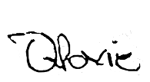

_________________________
Applicant’s Signature

