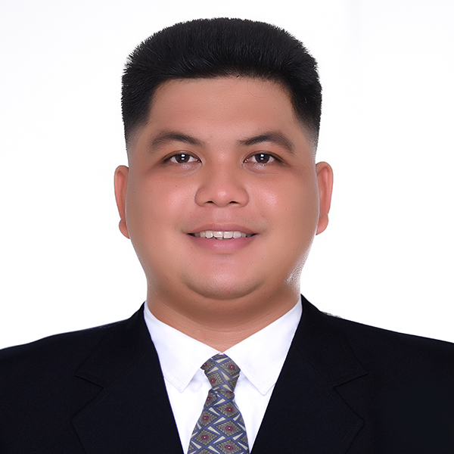

Jerome Barte Bagu

TECHNICIAN

Contact

Sorosoro Ibaba, Batangas City jeromebagui@gmail.com

09266249266

Skills
- Able to read P&ID and Electrical drawings
- Ability to use electrical and power tools
- Ability to use mechanical tools.
References

Mr. Barry F. Sollesta Assisstant Manager Zenith Foods Corp.
CIP 1 Canlubang Calamba, Laguna O9O88892183

Mr. Paul Villavicencio
Assistant Manager
Zenith Foods Corp.
CIP 1 Canlubang Calamba, Laguna O9916923568

Objectives
To obtain a position that is both challenging and rewarding that will allow me to utilize my instrument, control and mechanical skills; as well as to be part of a team that works with safety as priority without losing focus on quality and accuracy.

Work Experience

PMFTC Inc. (Phillip Morris International)

August 16, 2022 – Up to present

Process Operator

- Ensures to provides the production target output and operates the equipment in good condition.
- Perform machine start up and shutdown checklist before the production starts and during shutdown figure
- Ensure that double block and bleed valve are in good condition.
- Check the pressure of all tanks and make sure that the Safety relieve valves calibration dates are updated.
- Ensures that all equipment is in good condition and well maintained.
- Always perform 5s and defect handling.

Zenith Foods Corporation

Jan. 1, 2019 - Apr. 10, 2022
Engineering Technician
- Perform preventive maintenance, predictive maintenance and condition monitoring regularly
- Perform corrective maintenance when necessary
- Cleans regularly all mechanical equipment and controls.
- Lubricates mechanical parts. Replace defective parts when necessary. Dismantle and send to outside repair shops whenever necessary rehabilitates mechanical parts when necessary.
- Prepares written reports and/or immediately refers to the supervisor any abnormalities observed on the equipment
- Prepares and submits ISO monitoring and maintenance activities report and checklist
- Accomplishes all periodic monitoring forms and checklists. Submits to supervisor for checking and information
- Provides mechanical, technical services necessary for the installation of production, utility and other equipment support
- Gathers equipment specification such as models, serial no. power rating, etc. Complies all necessary data and prepares master list which will be used in preparation of preventive maintenance program and equipment history.

Samsung Electro Mechanics Philippines, Corp.

Oct. 17, 2016 - Nov. 26, 2018
Facilities Technician
- Monitoring and operates turbo chiller, cooling tower, MAU, AHU and exhaust fan
- Monitoring of Air compressor and Air dryer
- Ensure the temperature; humidity and pressure cleanroom are in the right specification
- Weekly transferring of turbo chiller, cooling tower and pumps
- Do monthly preventive maintenance of machines.

Atlantic Gulf & Pacific Company of Manila Inc.
Ichthys Onshore LNG Facilities Project
Feb. 1O, 2015 — May 15, 2O16
Electrician

- Installation and fabrication of support cable ladder at perforated tray
- In charge cable glanding, cable termination and cable dressing as per termination drawing details
- Installation of device
- Closing the punch list item.

Powertrunking System Inc.
Refinery Master Plan — 2 Petron Project
Dec. 26 2013 — May 22, 2014
Instrument Technician

- Loop checking and continuity testing of instrument based on ILD
- Termination of cable from remote instrument building panels to junction box and instruments
- Downloading of program of field bus transmitter
- Troubleshooting
- IR testing.

Education

- Batangas State University

Gov. Pablo Borbon Campus II
Alangilan, Batangas City

Bachelor of Industrial Technology
Major in Instrumentation and Control Technology
2009-2013

Seminars Attended

- Basic Thermography and Refrigeration & Air
Conditioning Operation and Maintenance

Impedanz Review, Training and Consultancy Calamba, Laguna
March 9, 2O19

- Atlas Copco Compress Air Reliability & Efficiency Seminar
Atlas Copco Philippines
Laguna Techno Park
November 25, 2O16

