lady lynne e. uy
St. Therese Subdivision, Visayan Village Tagum City. 09152144799
uyladylynne@gmail.com

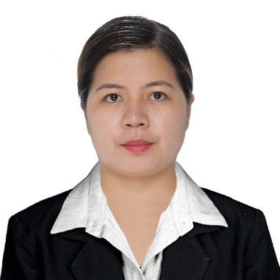
Experience

02/2020 – present

nurse II, department of health- DAvao center for Health Development
Community Health Nurse, Covid Nurse, Public Health Asssociate

07/2013 – 06/2019

Bookkeeper/ accounting clerk, Commodity lending investor, inc.
Responsible in keeping all books of account and cash flows balanced.

Education

06/2011- 10/2011

bachelor of science in business administration major in marketing, university of mindanao/ tagum city, davao del norte
Studied for one semester and earned 18 units of the said course.

04/2009

bachelor of sceince in nursing, arriesgado college foundation, inc./tagum city, davao del norte
Graduated and passed the board exam for nursing on the same year

Skills
- Bookkeeping  - Community Nursing  - Basic Computer skills | - Hardworking  - Self-motivated  - Honest

