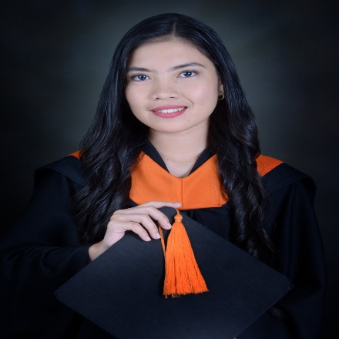
KATE A. BAUTISTA
Address: Butansapa, Mogpog, Marinduque
Email Address: Bautistakate1612@gmail.com
Contact Number: 0997-398-3725

CAREER OBJECTIVE
To acquire valuable knowledge and skills to complement those that I have learned from school in an actual job environment so as to contribute to the growth of the company with quality service, real sense of responsibility and commitment.

PERSONAL INFORMATION
Birth Date : June 21, 1999
Birth Place : Muntinlupa city
Status : Single
Nationality : Filipino
Religion : Roman Catholic
Height : 156 cm
Weight : 45 kgs.

SKILLS

- Microsoft Office Proficient
- Good oral and written communication skills
- Bilingual in Filipino and English
- Quick learner
- Task-oriented
- Responsible
- Work with dedication and determination
- Willing to do extra work to gain valuable experience

EDUCATIONAL ATTAINMENT
- 2015 - 2020 Bachelor of Science in Civil Engineering
Marinduque State College
Tanza, Boac, Marinduque

- 2011 - 2015 Butansapa National High School
Butansapa, Mogpog, Marinduque

- 2005 - 2011 Butansapa Elementary School
Butansapa, Mogpog, Marinduque

ABLE TO
- Ability to work individually, in-group
- Ability to work under pressure
- Meet given deadlines

ON THE JOB TRAININGS

- Completed 240 hours in Municipal Engineering Office
Marketsite, Mogpog, Marinduque

- Completed 120 hours in General Physical Facilities Office
Marinduque State College
Tanza, Boac, Marinduque

TRAINING

- Construction Occupational Safety and Health (COSH), Certified Safety Officer II
- LCM + HIRAC, Certified Safety Officer III

WORK EXPERIENCE
- Company : Sunwest Inc.
Address : Bangbangalon, Boac, Marinduque
Position : Cost Control Engineer
Date : December 9, 2021 – to present

REFERENCES
Engr. Katherine Mangol Engr. Kristel Jane Macunat
CE III CE II
Sunwest Inc. Sunwest Inc.
Phone Number: 09274166572 Phone Number: 09074666620
Email Address: katherinemangol@gmail.com Email Address: macunatkristeljane@gmail.com

Engr. Janeth Quarteros
CE
Sunwest Inc.
Phone Number: 09703322400
Email Address: janethquarteros30@gmail.com

I hereby certify that the above information’s are true and correct.

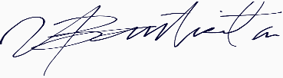

KATE A. BAUTISTA
Applicant

