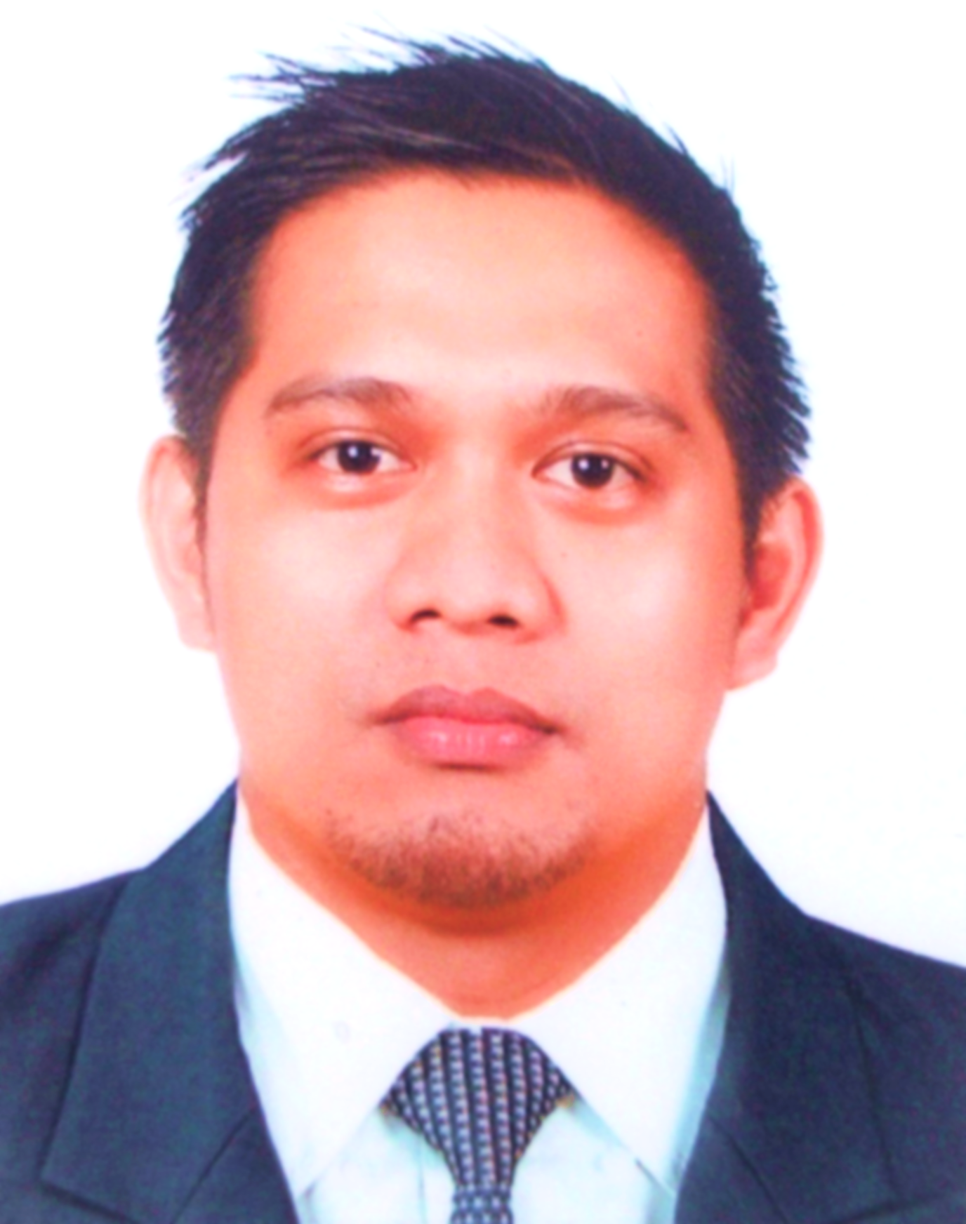
C U R R I C U L U M V I T A E O F
MELCHOR P. QUIROS III
Himaao, Ilaud, Pili
Camarines Sur 4418, Philippines
+639933235631
mpquiros3@ymail.com

PERSONAL INFORMATION:

Age : 40
Date of Birth : August 7, 1982
Civil Status : Married
Gender : Male

EDUCATIONAL BACKGROUND:

Bachelor of Science in Secondary Agricultural Education
Central Bicol State University of Agriculture
March 2003

Major in General Science
Central Bicol State University of Agriculture
1999-2003
Best in Practice Teaching

LICENSURE:

Philippine Licensure Examination for Teacher 2004
PRC License no. 0841643
PRC Board Rating 77%

PROFESSIONAL EXPERIENCE:

BUTCHER HEAD/ CHEF DE PARTIE 2
Royal Caribbean Cruise Line
1050 Caribbean Way, Miami, Florida, USA
May 2015-present

BUTCHER/ GRILL MAN
Reem Al Bawadi, Restaurant
3236 Jeddah, KSA
November 2013-February 2015

PIZZAMAKER/COOK
Lulu Hypermarket
E19 Sultan Bin Zayed, Abu Dhabi, UAE
November 2009-January 2012

PIZZAMAKER/COOK
Philippine Pizza Incorporated (Pizza Hut Philippines)
Araneta Center, Cubao, Quezon City, Philippines
May 2007- February 2009

VOLUNTEER TEACHER
V.Bagasina Sr. Memorial High School
Himaao, Pili, Camarines Sur
February 2004-January 2007

Job Description and Responsibilities:

Attends daily production meeting with the production chef and executive chef
Conducting daily meeting with the team before the start of the operation regarding meal count, production changes, target production and updates from the Executive chef
Placing daily order of meat needed based on the menu matrix for crew mess, speciality restaurants, and dining room.
Follow and monitor the budget of the station not exceeding to the given budget to avoid variances and directly reports to the executive chef regarding meat availability
Involve in daily production of meat using bandsaw machine, portioning of meat to the desired cuts such as fillet, steak, cubes, minced or ground.
Properly monitoring the staff is following the company standard of receiving and storing of meat products
Train the team of proper use of butcher shop equipment such bandsaw machine, burger machine, meat mincer machine and Tinna Thawing Machine
Conducts proper training on knife skills use, care and safe keeping thus to avoid accidents during and after operation
Monitor that all the fridges and freezers used inside the butcher shop is working, thermometers are checked, correct entry of daily logs, reports to the maintenance if certain equipment not working properly
Keeping the working are clean and sanitize all the time before, during and after the operation following USPH (United States Public Health) standard
Making sure that the team is aware of knowledgeable regarding the HACCP
Follows company rules and policies on behaving towards fellow crew, work ethics by reporting on time and wearing the proper uniform

REFERENCES:

mr. larry z. clidoro
Sous Chef
Royal Caribbean International
Paranaque, Metro Manila
09397874382

DR. CHARLIE P. NACARIO
Professor IV, CBSUA
San Jose, Pili, Camarines Sur
09120357228

GJERGIO ELIZE
Sous Chef
Italianissimo Restaurant
Abu Dhabi, United Arab Emirates
gjergjelezi@icloud.com

I hereby certify that the statement, data, information and documents stated and attached herein are the factual truth to the best of my knowledge.

MELCHOR PARRO QUIROS III
Applicant

