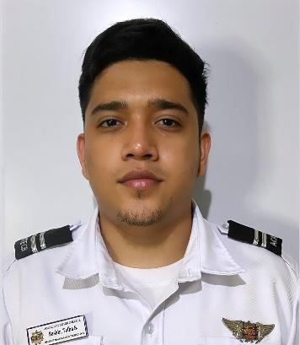

TALHA S. BASHIR

#34 General Trias St., Purok 6 Banggot, Bambang, Nueva Vizcaya, Philippines
Age: 26
Email: sambashir1515@gmail.com
Mobile #: +639196670273

OBJECTIVE:
To be able to work in a company where there is a high degree of challenges and a lot of opportunities to maximize my knowledge and skills as a trainee

SUMMARY OF QUALIFICATION AND SKILLS
- Extremely motivated and passionate about whatever I chose to do
- Strong interpersonal skills
- Equally effective working independently and in coordination with others
- Computer literate, knowledge of safety precautions
- Can work under pressure
- Attention to detail
- Communication
- Highly Organized

EDUCATIONAL BACKGROUND
College: ACATECH Aviation College – Baguio City
Associate in Aircraft Maintenance Technology (2021-2024)

Secondary: Lamo National High School (2011-2014)

Elementary: Mabasa Elementary School (2005-2011)

TRAINING AND SEMINARS

Maintenance Training Program &
On-the-job Training
ACATECH Aviation Service
Pasay City

Airframe & Basic Structural Repair Skills
ACATECH Aviation College
Baguio City
June 6-July 28 2023

Fire protection seminar
ACATECH Aviation College
Baguio City
October 1,2022

Drug symposium
ACATECH Aviation College
Baguio City
November 5,2022

WORK EXPERIENCE
- Bartender-Waiter at KS Treasure Restaurant, Johor Bahru, Malaysia (November 2020-May 2022)
- Bartender at Tanba, Japanese Restaurant, Johor Bahru, Malaysia (November 2019January 2020)
- Bartender-Waiter at Kung Fu Noodles, Johor Bahru, Malaysia (2019-2020)
- Trainee Barista-Waiter at Tropique Café and Restaurant, Johor Bahru, Malaysia (January 2019-November 2019)
- Bartender at Naughty Nuris, Sutera Utama, Johor Bahru, Malaysia (2017-2018)
CHARACTER REFERENCE
Benson Chia Pauline Uy
Chef Manager
Malaysia Malaysia
Mobile #: +0104020530 Mobile #: +60197908157

AMIEL NEMENZO
Head of Training
ACATECH Aviation College
Facebook: AC Nemenzo

I hereby certify that the above information is true and correct to the best of my knowledge and belief.

TALHA S.BASHIR
Applicant

