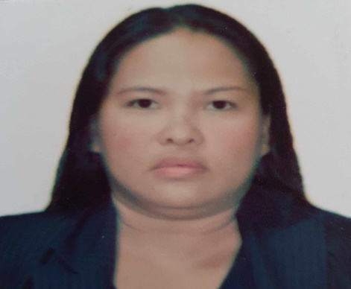
AIZA L. LUMICTIN
Valencia City, Philippines +63981-1303654/ aizalumictin@gmail.com

OBJECTIVE
Well trained worker who seeks an employment under a solidified company in which I can utilize my skills and experience in slaughtering and butchering. Seeking an opportunity to work as a butcher/slaughterer with a company that establish hard work and dedication.

SKILLS

• Ability to use hand tools, stand or work for extending periods, lift heavy items, and work in cold environments.
• Knowledge of meat preparation techniques and cuts.
• Strong communication, task management, customer service skills.
• Able to work well in a team.
• Willingness to learn.

WORK HISTORY

SLAUGHTERER Large Cattle & Swine
(Volunteer Worker) November 10, 2023- Present

Valencia City Abattoir – P7 Patag Bagontaas ,Valencia City

• Slaughter livestock using stunning device.
• Skin, clean and trim carcasses.
• Manual removing of excess hair from dehairing machine and opening of tendon ready for gambrelling.
• Opening the brisket, removes viscera and other inedible parts of carcasses.
• Final washing of carcasses.

BUTCHER May 2020 – October 31, 2023

Ejong & Elena Barcenas Meatshop – Panabo City, Philippines

•Wrap, weigh, and price cuts of meat.
• Prepare special cuts of meat ordered by customer.
• Cut, trim, tie, grind and debone meats such as cara-beef, beef, pork and chicken to prepare in cooking form.
• Record quantity of meat received and keep records of meat sales.

PRODUCTION OPERATOR May 01, 2010 – April 2020

HPOI Corporation – Lapu- Lapu City

• Conducts final appearance inspection of all coated and non coated lens using microscope.
• Loads lenses for reliability at designated oven and unloads at the same at pre determine time according to specs.
•Encodes lens data and provides reliability results for use in production.
•Assembles tray loaded to coat rack panels and deliver it to coating machines.

PRODUCTION OPERATOR September 12, 2006 – April 2010

Pentax Cebu Philippines Corporation – Nozomi Fortune Services Incorporated

• Line assembly of camera production (digital and DSLR). Soldering, screwing, repairs camera defects.

EDUCATIONAL ATTAINMENT

• Secondary Education
San Isidro Institute (March 2004)

CERTIFICATE/TRAININGS

• IATF 16949:2016 Interpretation Training
• ISO 9001:2015 Interpretation Training
• Material Handling Orientation
• Cervical Cancer Awareness
• Drugs and Substance Abuse Seminar

