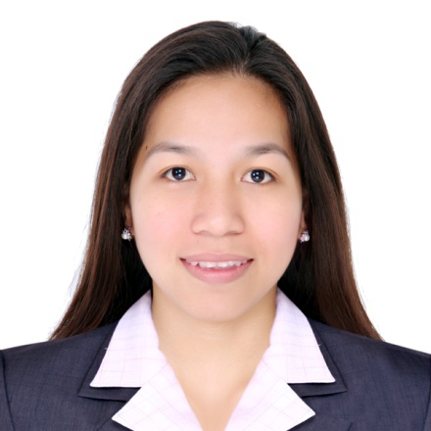
GLERIDAD D. PREJOLES
038 TAGA DAANGLUNGSOD, KATIPUNAN
ZAMBOANGA DEL NORTE
CONTACT NUMBER: 0909-106-6078
EMAIL ADD: lettygler1515@gmail.com

OBJECTIVES

Seeking for a position wherein I can utilize all the knowledge, trainings, and further developed and applies as well my skills that I have gain from my previous work.

SKILLS

- Flexible and multi-task in a given situation.
- Goal-oriented person.
- Strong customer service

EXPERIENCE

(VICENTE T. LAO CONSTRUCTION-Nov.2, 2016-July 15, 2021)
- Admin and Accounting Clerk- plotting for payroll
-supervision of all staff and manpower
-preparing disbursement voucher, liquidation report
-preparing fund allocation
-purchasing
-updating sss, philhealth and pag-ibig of all manpower and staff.
2. Warehouse-In-Charge- preparing withdrawals of all items inside the warehouse
-preparing delivery report, receiving report and requisition report
-doing monthly report of all pending request for budget
-fuel inventory
-preparing stock card of all items/inventory

(DUE EAST CONSTRUCTION & EQUIPMENT, INC.-July 19, 2021 up to present)
- Admin and Accounting Clerk- plotting for payroll
-supervision of all staff and manpower
-preparing disbursement voucher, liquidation report
-preparing fund allocation
-purchasing
-updating sss, philhealth and pag-ibig of all manpower and staff.
-scheduling of mobilization of trucks(in/out)
2. Warehouse-In-Charge- preparing withdrawals of all items inside the warehouse
-preparing delivery report, receiving report and requisition report
-doing monthly report of all pending request for budget
-fuel inventory
-preparing stock card of all items/inventory

TRAINING & SEMINAR
- Warehousing Seminar at VTLC Main Office, Km 12 Diversion Road Panacan, Davao City
- Fire Drill Training at VTLC Irasan Sub-Office, Roxas, Zamboanga Del Norte

EDUCATIONAL ATTAINMENT

(ANDRES BONIFACIO COLLEGE)
College Park, Dipolog City, Zamboanga Del Norte
Bachelor of Science in Accounting Technology
2009-2013

CHARACTER REFERENCE

- Can provide upon request.

