JUNE-2022- DEC -2023
ROOFING COMPANY
INDUSTRIAL ELECTRICIAN
KM 49 BRGY, INOCENCIO TRECE MARTIRES . CAVITE

AMC ALMERS MANPOWER CORPORATION
- Maintain, troubleshoot of AMS Panel and Rollforming machine,combi-lift,uncoiler,Crane 15tons,5tons etc.
- Improvise Motor Controller for Rollforming Machine and uncoiler,crane 15tons ,5 tons.
- Perform Mechanical Skills in Mechaniacl ,electrical and pneumeatic And Hydraulic Troubleshooting and repair of Production Machine.
- Improvement for plc and AMS Controller tripledeck or 3 machine and 2 machine controlled in 1 amscontroller or plc
- Use variety of hand and power tools ,electric meters and material handling equipment in performing Duties.
- Repair and Reprogram of semiconductor PLC And AMS CONTROLLER XL200/XL270, RAS TURBOBEND controller Machine.
- Comply of Safety regulations and clean work areas.
- Troubleshoot and reprogram VFD, DELTA,SCHNEIDER And Inverter VFD.
- Manage and train and monitor team members and team leads.
- Prepare reports and update for upper management.
KM 49 BRGY, INOCENCIO TRECE MARTIRES . CAVITE
JANUARY 2023 – MARCH 2024
ROOFING COMPANY
ELECTRONIC TECHNICIAN

UNITED STEEL TECHNOLOGY INC
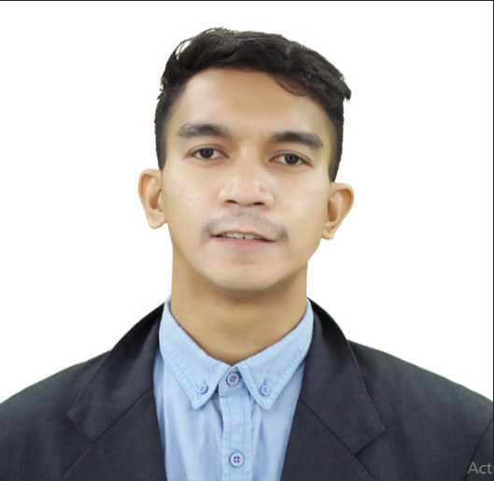
Skills :
- Programming and Repair Of PLC Controller ,VFD,AMS Controller
- Setup Parameters of PLC,AMS Controller
- Know in Pneumatic And Hydraulic and CAD ,PLC And AMS Controller
- Know how to Read Schematic Diagram Electrical/Electronic Diagram
- Know How to Repair Electronic and Electrical Component
- Know how to operate Different kind of Machine
- With Computer Literate and CD,PHOTO EDITOR AND VIDEO EDITOR ,MICROSOFT .
- Reviews and analyze the performance of various procedures at a company and makes recommendation for improvements
SKILLS:

- Profound ability to work well in team
- Good Communication and Customer Service skill
- Collect and analyse data chart progress and implement solution
Abilities:
HMR PHILIPPINE INC.
Dr Arcadio ,Sucat Paranaque City
AUGUST 2017 –JUNE 2023
- Maintain, troubleshoot , and Repair of all electronic - Electrical And Computer based
- Provide Emergency and Unschedule Repairs of production Equipment and performs Schedule Maintenance Repairs of Production Equipment During Machine Service
- Perform Mechanical Skills in Mechaniacl ,electrical and pneumeatic And Hydraulic Troubleshooting and repair of Production Machine.
- Perform regular preventive Maintenance on Machine Equipment and plant Facilities
- Use variety of hand and power tools ,electric meters and material handling equipment in performing Duties.
- Comply with safety regulations and maintain clean work areas .

Experience:
SAN VICENTE NATIONAL HIGH SCHOOL-BAGUIO CITY
EDUCATION :
Certificate NC2 14150302005482
TESDA-CAR BAGUIO
C#:09691809555
Addres: Summercrest Brgy Sahudulan tanza cavite

ENTERIA, NELSON REY B

