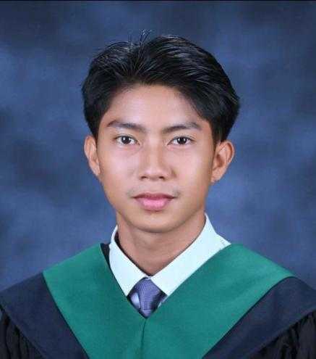
PROFESSIONAL OBJECTIVE

Seeking a challenging opportunity where I can put my skills and ability to work well in your establishment, allow me to grow personally and professionally while learning new skills and expertise.


09051305365
Purok Ilang-ilang, Brgy Calaocan, Alicia, Isabela
Ferdzserna@gmail.com

FERNANDO JOSE M. SERNA
Applicant

I hereby certify that the above information are true and correct according to my knowledge and beliefs.

SKILLS & INTEREST
- Excellent Communication
- Positive Work Ethic
- Knowledge of Soil
- Knowledge of Cultivation
- Fast learner
Nickname: Ando
Age: 23 years old
Gender: Male
Birthday: August 2, 2000
Place of Birth: Cauayan City
Civil Status: Single
Citizenship: Filipino
Religion: Roman Catholic

- Tobacco sorter and Tobacco collector

- Welder
Universal Leaf Philippine Inc.
Purok 7, Nappaccu pequeno, Reina Mercedez, Isabela
(July-September 2021)

Serna Welding and Machine
- Present)
Employment History

Engr. Sean L. Agbanlog
Director of BAT Program
Isabela State University- Cauayan Campus

Noel Baweg
Supervisor
Universal Leaf Philippine Inc.

References

Isabela State University - Cauayan Campus
Batch 2023

Bitas, Maharlika Highway, Cabanatuan City

- Bachelor of Agricultural technology
(Major in Crop Production technology)

- Senior High: Midway Maritime Foundation Inc.

FERNANDO JOSE M. SERNA

Education

