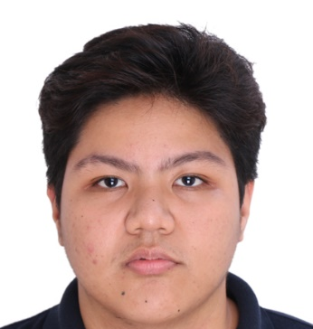
Kloie Cruz
553 M. De Guzman St., San Jose, Rodriguez Rizal
+639051627406
kaloy.cruz29@gmail.com

Objective:

To grow professionally and personally, and acquire challenging opportunities where I can utilize the skills attained for the success of the company

Employment History:

Position: Encoder
Company: J.P. Sioson General Hospital
Address: Quezon City, Philippines
Date: March 2016 – October 2018

Job Description/ Duties and Responsibilities:
- Verifying the entered data and comparing it in to the source
- Preparing files that needs encoding into the computer and making sure that the entered data is properly encoded in a timely manner
- Inventory and auditing of supplies
- Additional assistive management on the assigned department

Position: Nursing Aide/Assist
Company: Marikina Valley Medical Center
Address: Marikina City, Philippines
Date: September 2019 - May 2021

Job Description/ Duties and Responsibilities:
- Addressing chief of complaint of the clients
- Providing patient care and assisting in their activities of daily living
- Providing good moral behavior when in triaging clients
- Preparing the necessary supplies and equipment for the client’s treatment
- Responsible for taking vital signs and reporting any changes on the condition of the client

Position: Nursing Aide
Company: J.P. Sioson General Hospital
Address: Quezon City, Philippines
Date: September 2022 - November 2023

Job Description/ Duties and Responsibilities:
- Addressing chief of complaint of the clients
- Providing patient care and assisting in their activities of daily living
- Providing good moral behavior when in triaging clients
- Preparing the necessary supplies and equipment for the client’s treatment
- Responsible for taking vital signs and reporting any changes on the condition of the client

Skills:

- Positive work attitude and habits that demonstrates resourcefulness, initiative, dependability, team player and willingness to learn
- Advance computer knowledge (Word, Excel and Powerpoint)
- Ability to adapt and be flexible with the tasks assigned for work
- Ability to work within structured and highly regulated environment;
- Organized, fast learner and prefers quality over quantity results.

Educational Background:
Mount of Mercy Caregivers Academy, Inc.
Caregiver NC II (May 2017)

Our Lady of Fatima University
Bachelor of Science Major in Medical Technology (3rd year Undergraduate 2015)

Character Reference:
Mark Jethro Jubilado (Human Resource Associate) 09671189818 smite.creatio@gmail.com
Mercy Del Rosario (Chief Nurse/Curriculum Instructor) 09999021173
Elizabeth Anne Pias (Nurse Staff) 09156261373

