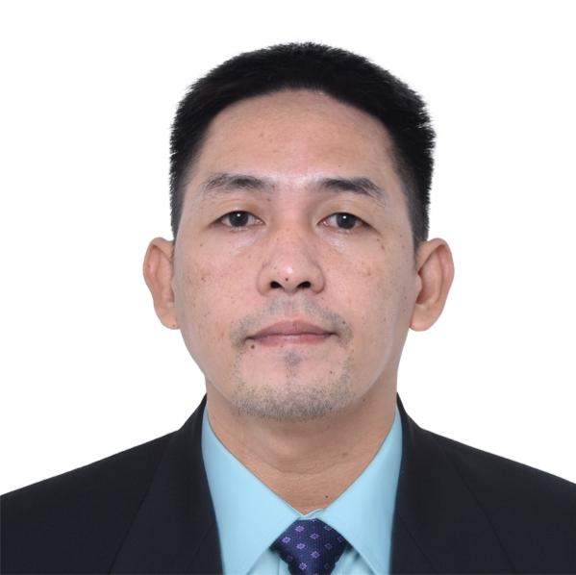

BLADEMER F. PAULY
Blademerpauly21@gmail.com
Skype ID: live:.cid.db8ba30ce28188d7
WOOD LABORER / MACHINE OPERATOR

Birth Date | : | February 21, 1985 |  | Birth Place | : | Infanta, Quezon
Age | : | 38 |  | Nick Name | : | Blad
Height | : | 5’7 |  | Civil Status | : | Married
Weight | : | 75 kg |  | Gender | : | Male
Passport No. | : | P4332350C |  | Religion | : | Roman Catholic
Date Issued | : | June 05, 2023 |  | Driver’s License | : | D06-12-009441
TIN No. | : | 304-591-842 |  | Pag-ibig No. | : | 1030-0179-2783

EDUCATIONAL INFORMATION
Education | School Year | School Name and Address | Course
College | 2002 – 2006 | Northern Quezon Cooperative College | Bachelor of Science in Commerce Major in Management
High School | 1998 – 2002 | Infanta National High School | High School
Elementary | 1992 – 1998 | Tonggohin Elementary School | Elementary

EMPLOYMENT INFORMATION

Company : SCAD SERVICES (S) PTE. LTD.
Address : Block 23 Phase 4 Expansion CEZ Rosario, Cavite
Position : Technical Specialists
Date : Year 2006 – Up to Present
Contact Person : Mr. Joey Ricasa
Contact No : 09923779839

Duties and Responsibilities
- Establish production line for wood working processes.
- Experience all stages of wood working process.
- Set up, operates shaping, sanding, planer, and wood length and width cutting machine.
- Produce and test wood products such as flooring, doors, and cupboard and dressers cabinet.
- Perform painting using manual spray of laminated material.
- Operates flow Coater machine for front painting.
- Checking of wide belt sanding and level sander machine.
- Daily checking of side polishing and front polishing machine.
- Perform assembly of cabinet boxes.
- Checking of body press machine by ensuring the fitting of boxes for unit Kitchen assembly.
- Verify dimensions using caliper and meter tape.
- Replace of blade when it’s getting dull and ensure tighten of loosen bolts and nuts.
- Monitor the function of the machine during operation for sound and vibration.
- Put all safety guards and signage’s.
- Checking of air supply and air regulator and vacuum function for sawdust.
- Checking of preventive checklist of every machine within the line.
- Replace operator on operation in case of absence.
- Provide accomplishment report of the line after end of the shift.

Machines
- Moulder Machine (Shen Ko)
- Double End Tenoner (Yasuda / Hein / Shonai)
- Rip Saw (Amitec)
- Cross Cut Saw (Amitec)
- Miter Saw (Makita)
- Radial Arm Saw (Chia Sung)
- CNC Machine (WD MAX)
- Edge Bander (Marunaka)
- Widebelt Sander Machine (Amitec)

List of Tools/Equipment/Materials handled
- Spray paint gun  - Nail Tucker  - Air Driver  - Air Driver  - Battery Drill  - Tucker Gun  - Air Sander  - Hand Saw  - Meter Tape  - Caliper  - Weighing scale | - Plywood  - Spruce  - Melamine  - Finewood  - Lamination Sheet  - Rubber Wood  - Matoa Wood  - Medium Density Fiber  - Particle Board  - Hot melt Glue  - PUR Glue
TRAININGS & SEMINARS
Date Attended | Training / Seminar Title | Presided / Conducted By
November 20-21, 2008 | Industrial Calibration | Arthur Lucas C. Cruz
March 06, 2010 | Corporate Culture: Filipino Values in the Workplace | Adelaida L. Inton

LANGUAGES/DIALECTS
 | Speak | Read | Write
Filipino |  |  | 
English |  |  | 
CONTACT DETAILS

Mobile No.: 0991-579-5761
Facebook Account: Blademer Flora Pauly
Present Address: Purok 3 Brgy. Tejero General Trias Cavite

BLADEMER F. PAULY
Applicant

