Jim Boy S. Labrador



0927-737-8587
lgs.staffjimboy@gmail.com

629 Rodriguez Street, Brgy. 134 M. Dela Cruz, Pasay City.

- Good communication skill
- Oriented in Microsoft Office
Application
- Flexible and Adaptable on
Changing environment
- Willingness to Learn
Tertiary:
Bachelor of Science in Business Administration major in Marketing Management
Innovative College of Science and Technology
Year Graduated: 2016

Secondary:
President Diosdado Macapagal Memorial National High School
Year Graduated: 2010

Birthday : August 11, 1994
Age : 29
Gender : Male
Weight : 76
Height : 5'3
Civil Status : Single
Nationality : Filipino
Religion : Catholic
Language Spoken: English and Filipino
CAREER OBJECTIVE

To share my skills, ability knowledge and experience in your company, learn and explore that will bring to us in success.
C O N T A C T

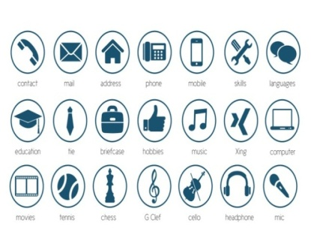
TRAINING & SEMINAR ATTENDED

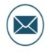
LEADERSHIP TEAM BUILDING
San Antonio, Gloria, Oriental Mindoro
Year: 2014

WEB FRONTEND DEVELOPMENT
Ernesto Umali Gymnasium
Poblacion, Bongabong, Oriental Mindoro
Year: 2014

2nd BUSINESS SUMMIT
Divine World College of Calapan
Calapan City, Orientl Mindoro
Year: 2015

S K I L L S

CAREER HISTORY

ON THE JOB TRAI LGS STAFF MANAGEMENT SERVICES INC.
HR/Recruitment-Trainee (600hrs.)
October 2015-February 2016

LGS STAFF MANAGEMENT SERVICES INC.
Recruitment Officer/HR
April 6, 2016-April 15, 2019

LGS STAFF MANAGEMENT SERVICES INC.
Senior Recruitment Officer/HR
April 15, 2019-present
REFERENCES
E D U C A T I O N
Mr. Ai Henry Pantaleon Ms. Princess Rocel Lopez
Recruitment Officer Area Supervisor
0921 624 5583 0915 850 6449

I hereby certify that all the given information above is true and correct upon my knowledge

JIM BOY S. LABRADOR

