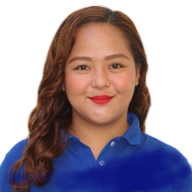
MARDI-VIS D. MALANA
malanamardivis@gmail.com
Mobile: +639207309846

Objective
To get an opportunity where I can make the best of my potential and contribute to the organization’s growth.
To help achieve the company goals with my dedication and determination.
Personal Data
Sex : Female
Birthday : March 31, 1995
Birthplace : Naguilian,Isabela
Civil Status : Single
Citizenship : Filipino
Language Spoken : English and Filipino

Family Background

Father : Fernando A. Malana
Occupation : Laborer
Mother : Marlyn D. Malana
Occupation : Housekeeper

Educational Attainment

Elementary : San Roque Elementary School 2001-2007
High School : School of Saint Joseph 2007-2011
College : Isabela State University Echague Campus 2011-2015
: St. Paul University 2016-2019

Work Experience
DSWD Region (Enumerator)
CBMS (Supervisor)
Local Government Unit Employee
I hereby certify that the above information are true and correct to the best of my knowledge.

MARDIVIS D. MALANA
Applicant’s Signature

